Contents

Review framework 1

Person–Environment Fit 2

Organizational Socialization 6

Job Search 8

Regulatory Focus & Regulatory Fit 11

Personality 14

Goal Orientation Theories 17

JD-R theory, Burnout, Engagement 21

Challenge-hindrance stressor framework 25

Recovery from work 30

Leadership 35

Ethical Leadership 40

*Destructive Leadership 45

Perceived Organizational Support 51

Psychological Contract 54

Job Embeddedness 59

CET vs. SDT in Pay for Performance 62

Workaholism 67

Psychological Empowerment 71

Impression Management 76

Organizational Politics 82

Ostracism and Incivility 87

Creativity 91

Voice & Silence 94

Job performance variation in short timeframes 97

Aging Workplace 100

Gender stereotypes 105

Racio-ethnic Differences through lens of justice 110

*Discrimination 112

*Individual Work-Family Boundary Dynamics 116

Work-Life Balance 121

Alternative Work Arrangements 125

I-deals 127

Employee Vigilante Behavior 132

Theory 135

Theoretical Necessity vs. Theoretical Sufficiency 137

Social Exchange Theory 138

Social Identity Theory 139

Organization Theory 142

Institutional Theory 143

Construct Clarity 144

END 145

# Person–Environment Fit

**Definition & Conceptual Clarification**

Van Vianen (2018) P–E fit = compatibility between person attributes (e.g., values, needs, abilities) and environmental attributes (e.g., supplies, demands, organizational values).

~~Evolution: Early work emphasized selection/socialization and largely static views of fit. Over time (last ~15–20 years) scholars pushed dynamic/temporal perspectives, refining measurement (e.g., polynomial regression, profile methods) and unpacking mechanisms (values–supplies, needs–supplies, demands–abilities).~~

**3 key propositions**

Fit is more powerful predictor than either personal or environmental attributes.

Outcomes are optimal when compatible, irrespective of levels.

Discrepancy reduce positive outcome irrespective the direction (excess or deficiency).

**Different Dimensions**

Complementary fit: person-job fit, person-vocation fit

Supplementary fit: person-organization fit, person-supervisor fit, person-team fit.

* Supplementary vs. complementary fit: Supplementary = similarity (e.g., shared values); complementary = attributes that complete one another (e.g., person abilities meet job demands).
* Perceived vs. calculated fit: Two measurement logics — subjective/perceived fit (global impression) vs. calculated discrepancies/profile similarity. They are only moderately correlated and often show different relations to outcomes; measurement choice matters for inference.
* Levels of analysis: individual, team, org (and temporal: situational vs. baseline).

**Differentiation from other theories / theoretical foundation**

Person-vocation fit: Theory of vocational personality types (RIASEC; Holland, 1985), but small effect size (because lack of robust methodology to test in multiple domains; and people can adapt to the job through job crafting when misfit).

Person-job fit: Theory of Work Adjustment (Dawis & Lofquist, 1984): **satisfying** job is the outcome of individual and environmental adjustment for compatibility; stress and burnout as negative outcomes.

Person-organization fit: assessed via value congruence (which is stable over time); outcome is performance & turnover, organizational commitment & identification, perceived support. Oppose to P-O fit theory is the Attraction-Selection-Attrition framework (A-S-A; Schneider et al. 1998) with emphasize on organization attributes that can attract people, being selected by people, and people will likely to stay; But no studies have found direct evidence for ASA cycle (between-person design).

Person-team fit is used to examine deep-level attributes and predict more individual level outcomes (e.g., job satisfaction, OCBs); social categorization theory is used to examine surface-level attributes and predict team-level outcomes (e.g., team functioning, coherence, and team performance).

Person-supervisor fit is drawn on similarity attraction hypothesis, and the outcome is LMX, trust in supervisor.

**Key assumptions**

People have an innate need to match with the environment. This assumption is valid and established in many other theories, such as need-to-belong theory, self-consistency theory, self-affirmation theory, self-identification theory, social comparison theory etc.

**Key debates / discussions**

(1) Conceptualization & Operationalization issue: Perceived fit & discrepancy (Cable & DeRue, 2002) vs. Calculated fit

Perceived fit limitations: (1) it is unknown about what attributes are selected to combine; (2) it may reflect a direct affective response of satisfaction rather than cognitive comparison; (3) measuring either fit or misfit alone is insufficient because they represent different mechanism (approach vs. avoidance) and predict different outcomes.

Calculated fit: profile similarity index based on *subjective* fit (personal) and *objective* fit (environment) and present in algebraic, absolute, or quadratic difference. Limitations are: ignore the direction (i.e., excess or deficiency), cannot test theoretical assumption (need), oversimplify the multidimensional phenomenon to a single index.

**Polynomial regression and surface plot analysis**

This method takes personal attributes (need for structure) and commensurate environmental attributes (structure in the job) into consideration. It presents the response surface with both congruence and incongruence lines, so it can tell us technically whether misfit is symmetric or asymmetric, and whether high–high combinations are more beneficial than low–low ones (think about the three propositions).

Limitations of this method: (1) require larger sample size; (2) more trigger multicollinearity issue; (3) inflate type 1 error rate.

However, the prior findings relying on polynomial regression in P-J fit advanced the propositions. First, regarding proposition 1, although compatibility is more important than either the personal or environmental attributes, the findings indicated organizational attributes are more independent on personal outcomes and the fit-outcome relationship depends on the contents and combination. Regarding proposition 2, when there is congruence, there is a fit irrespective of the level. However, the prior findings indicate that the outcome is more optimal at a higher level. For lower level fit, it is more like a nonloss (vs. gain at higher level). Lastly, regarding proposition 3, the deficiency and excess are equally harmful. But the findings indicate that deficiency is more harmful.

**Future research**

We do not know how fit perceptions are formed and what they encompass and what are cognitively combined and compared. It is possible that some people, in their cognitive processing, compare the wrong personal and environmental attributes or over-emphasize on some attributes that are actually less relevant. This wrong process may inflate or deflate the deficiency and excess of misfit.

There should be a gap between what people wish to fit and what they can adapt (e.g., through job crafting). They may overestimate or underestimate their abilities too. So we can study if and how such an over- or under-estimate moderate the fit-outcome relationship.

Future studies can examine what environmental and personal factors can mitigate the experienced misfit (e.g., individual capability and external support for job crafting).

What about for gig workers where the algorithm is not transparent and hard to identify? For example, for food deliverers, the algorithm will dynamically adjust the delivery order and time limit, which can make newcomers feel fit but experienced workers feel misfit. And even, due to intransparency, workers cannot know if it is fit or misfit. Is there a system-fit? How algorithms shape the environment as certain or uncertain? Do gig workers feel they have the algorithm control and related job crafting skills?

How about P-O fit but P-Team misfit? Can relatively buffer each other?

Is fit a stable match (a person’s fixed trait matches the environment), or is it a dynamic process that changes as people/contexts evolve? Static view simplifies selection-based policies; dynamic view highlights agency, adaptation, trajectories. Recent evidence shows meaningful within-person variation (daily/weekly) that predicts short-term outcomes. So far, the P-E fit only captures the static view, addressing question of “who is more fit”. But, if fit is dynamic, then only longitudinal studies can address the question of “when and why does the same person feel more or less fit”. The P-E fit needs to explain how fit changes. If it is dynamic, then misfit is normal and fit trajectory is worthy of investigation. Empirical remedies: More ESM/daily diary, latent growth modeling, and experiments testing interventions (e.g., onboarding training) to identify causal mechanisms of fit change.

Value of fit for performance vs. attitudes (is fit always “good”).While fit reliably predicts attitudes (satisfaction, commitment), its relation to performance is mixed and context-dependent. Overemphasis on fit in selection may reduce diversity, creativity and lead to groupthink.Some argue too much supplementary-fit (homogeneity) can harm innovation; complementary fit or heterogeneity on certain dimensions may be optimal. This nuance is often under-examined. Empirical approaches to resolve: Examine interactions between fit and team/task complexity, use experimental designs to test creativity/innovation outcomes under high similarity vs. diversity conditions.

**Common theoretical frameworks**

Social identity theory: P-O fit (value congruence) 🡪 organizational identification 🡪 organizational commitment, performance, OCBs, and turnover

Job demands-resources model: P-J fit (ability-demand in/congruence) 🡪 stress / resources 🡪 burnout, engagement; Or core self-evaluation buffer the misfit effect.

Conservation of resources: misfit / incongruence 🡪 job crafting 🡪 resources gains

Self-determination theory: P-J fit 🡪 enhanced perceived competence 🡪 performance / engagement

**Connection with ostracism**

Ostracism is conceptualized as an outcome of *low perceived interpersonal or organizational fit*.

Misfit → social rejection cues → perceived ostracism; conversely, strong PO fit buffers against exclusion.

Mechanism: value incongruence and identity misalignment reduce belongingness, triggering ostracism responses.

Implication: monitoring dynamic fit helps preempt social exclusion.

# Organizational Socialization

**Definition**

Organizational socialization is a process of reducing the stress of uncertainty for newcomers so they may feel confident and able to successfully contribute to their new organizations (Berger & Calabrese, 1975).

Socialization is assessed as the extent to which one has a clear sense of their roles and can demonstrate a working knowledge of the organization’s history, language, and people (Chao et al., 2012).

**Different Conceptualization**

Berger & Calabrese (1975): represented a degree of understanding of the work context (i.e., the organizational culture, politics, etc.) that reduced role stress and subsequently burnout.

Kleinman et al. (2002): socialization as an indicator of organizational learning, arguing that access to team members facilitated increased knowledge about the work environment and a sense of social support that reduced burnout for new employees.

**Measures**

Role clarity (role conflict and ambiguity) are indicators of effective socialization.

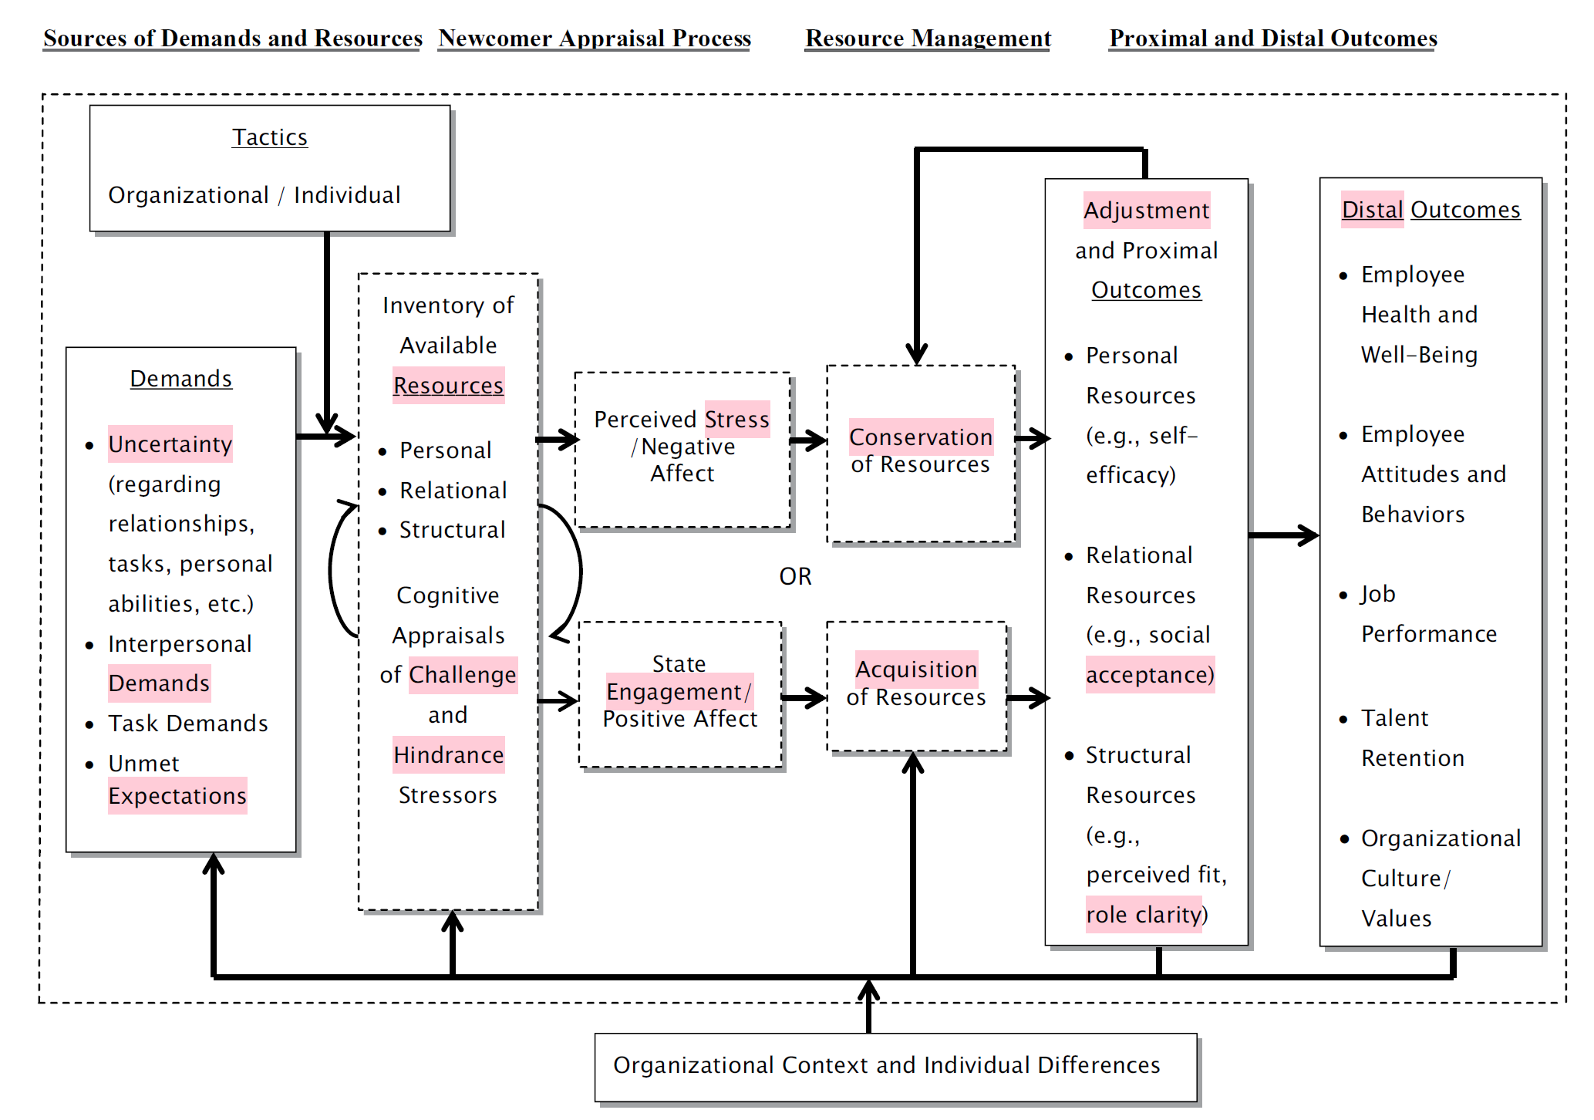

**Uncertainty**

associated with new tasks, roles, and social relationship is stressful (role ambiguity and role conflict).

**Individual tactics**

Proactive and adaptive behaviors; sense making; relationship building; positive framing; seeking feedback;

**Organizational tactics**

Content (collective, formal), context (sequential, fixed), and social tactics (serial, investiture)

Newcomer training; building work-related resources (tools needed to do work; information about the job) and social-capital resources (social events, supervisor support, team building activity);

**Personal resources / characteristics:**

Resources that influenced by the tactics, and/or can influence the use of the tactics, and/or enhance role clarity, reduce strain

Mastery belief, self-efficacy,

proactive personality, big five personality, need for closure, need for control, need for feedback, tolerance for ambiguity, learning goal orientation,

**Relational resources**

Mentor, perceived supervisor/coworker support, similarity with coworkers and supervisor, leader-member exchange,

**Structural resources**

P-O fit (dimensions)

**Future research**

Longitudinal: socialization process unfolds over a period of 1 year. Examine the trajectory of stress as experienced by newcomers.

Context: Some work groups may be characterized by more aggressive, competitive relationships among veteran employees

# Job Search

**Definitions**

It is a highly autonomous, self-regulated, goal-directed, and proactive process. Two key activities: social networking and interviewing.

**Dimensions of job searching**

Intensity (effort), predictors are: openness to experience, agreeableness, trait self-regulation, employment commitment, better attitudes toward job search, job search self-efficacy, financial need, social pressure.

content (high quality activities), Job search *behaviors* for content may be preparatory vs. active; *source* can be formal (job post) vs. informal (friends, family), such as referrals and advice about job search; *strategies* can be focused, exploratory, and haphazard. Planning, monitoring progress, evaluating interview performance.

persistency (evolution over time), within-person approach (changes in job search, affect, and motivational constructs); predictors are negative affect cumulation (apathetic, frustration), achievement approach orientation (personal growth, mastery but not achievement avoid), core self-evaluation, perceived progress.

**Differentiation from other theoretical foundation**

Other related theoretical perspectives include:

theory of planned behavior (attitude, subjective norm, perceived control 🡪 intention 🡪 behavior),

affective event theory,

goal-setting theory (goal specificity, difficulty, commitment, and feedback),

self-efficacy theory,

expectancy theory (expectancy, instrumentality, valence),

self-determination theory (autonomy, competence, relatedness),

**Social networking**

Strong vs. weak (acquaintances and referrals) ties

Strong ties produce more job offers while weak ties produce more interview offers and job leads.

There is mixed finding regarding whether it is useful to spend more time on networking. While some found that networking intensity is positively related to job offers and employment attainments, some found null effects.

Proximal networking benefits (emotional and instrumental support, reassurance, problem reformulation, referrals to others, legitimation, validation); but more distal benefits such as reemployment, career success require broader and more engaged web of relationship.

**Interview Behaviors**

Techniques: Self-focused (self-promotion: image creation and image protection) vs. Other-focused (ingratiation) vs. Defensive (justification, apologies)

Non-verbal behaviors (eye contact, smiles, gestures) can be assessed by manual coding from video-taped interviews.

**Context and job search**

Environmental factors (geographical region (rural vs. urban), country (US vs. Belgium), unemployment insurance system), social pressure, labor market shortage, unemployment rate, employment situation of job seekers (career gap vs. graduating student vs. employed)

**Bias**

Race/ethnicity (human capital hypothesis vs. hiring discrimination hypothesis); surname manipulation, e.g., replacing Chinese name with American sounding name, whitened resumes resulted in higher callback rate.

Age, age discrimination in Employment Act 1967, work experience requirement is a age discrimination? Preference for younger vs. employment gap

Criminal record, Ban the Box policy, can only request until later stage in hiring process.

Unemployment status, some states and cities (e.g., Oregon and New York City) have pass legislation to protect unemployed job seekers.

Bias can be studied through resume correspondence method.

**Intervention**

JOBS program by Uni. Michigan, teaching job searching skills, building social and emotional resources. Positive outcome are self-representation, self-efficacy, job search skills, goal-setting, proactivity

**Future research**

Prior studies are only interested in reemployment as dichotomous outcome, but neglect the number of offers, interviews, reemployment speed and quality. Those are important progress indicators.

The relationship between networking intensity and job search success needs to further unpack, in terms of different network characteristics (e.g., network size, composition, pattern of social connection, networking behaviors).

Any dark side of networking? Favoritism?

Gig work economy? Differ in job search strategies, targets on different jobs (part-time?)

How about rejection and job search failure? How people vary in coping and appraising this experience

# Regulatory Focus & Regulatory Fit

**Definition of Regulatory focus theory**

Evolution: departed from the class hedonic principle that people are motivated to maximize their pleasure and minimize pain.

Regulatory focus theory suggests people have two distinct self-regulatory systems in pursuing goals: one is promotion focus, and the other is prevention focus.

Promotion (Prevention) focus: presence and absence of positive (negative) outcomes, focusing on ideal aspirations and personal growth (responsibilities and security).

**Propositions of Regulatory focus**

The regulatory focus operates at three distinct and independent levels of self-regulation: System (end-state preference) vs. Strategic (general means) vs. Tactical (specific option, e.g., either more or less risky stock).

**Definition of Regulatory fit theory**

Regulatory fit occurs when there is match between the manner of goal pursue and the self-regulatory orientation of the goal pursuit.

Key extension: Regulatory fit theory is not restricted to regulatory focus orientations, but fun vs. urgence vs. importance orientation.

**Propositions of regulatory fit theory**

Two means to create fit or nonfit: eager vs. vigilant means.

Fit feelings can strengthen engagement and positive attitudes of doing such a thing (sense of rightness).

Regulatory fit can expand from individuals, groups, to cross-cultural nations, such as groups with all promotion-induced members, it can be a result of either an intragroup (i.e., adjustment, collective identify development) or intergroup process (social categorization). It is believed that China and Japan are more predominant prevention focus; whereas US and Italy are more predominant promotion focus.

For individuals with a promotion or prevention focus, the choice of a more or a less risky option is not just about pursuing an eager or vigilant strategy but a tactical decision in the service of an overarching motivation to *make progress or maintain a satisfactory status quo*, respectively.

When making decision, people have different reference point, which allows for subjective value determination, such as social comparison reference point, and arbitrary anchor reference point. There is no neutral 0 reference point.

**Research themes in Decision making**

commit errors vs. avoid committing errors  
In system and strategic level: Individuals with a promotion focus are more willing to commit errors (false positives; eager strategy) but individuals with a prevention focus preferred to avoid committing errors (conservative vigilant strategy).

For groups, the manipulation is that groups in promotion condition showed a bias toward saying “yes” and groups in prevention condition showed a bias toward a more conservation tactics of avoiding saying “yes”. Then, group members will be instructed to work together and exchange viewpoints in order to reach an agreement. Findings: under time pressures, regulatory focus did not affect group decision. Groups with a promotion-focus relied more on global and innovative information than groups with a prevention focus who counted on a more limited amount of information.

For regulatory **fit**, the choices employees make to engage in eager or vigilant behaviors when they pursue their goals are affected by the motivational cues in their environment, such as complexity in decision making. Individuals’ regulatory focus concern will drive their choice of information to pay attention to.

idea generation speed, number and quality:   
For regulatory **fit**, it will be 2*2 conditions. First, participants will be either in two focuses, and then assigned to either eager or vigilant strategies. So, they can be either fit or nonfit. Findings: the number of ideas and their quality for groups in the fit condition were lower than those produced by the groups in the nonfit conditions who persisted longer in idea generation (brainstorming task), because the sense of rightness will produce more satisfaction.

**Research themes in Messaging**

Regulatory focus framing influences the message’s effectiveness. The poison pill that would *increase* shareholders’ value (a promotion gain frame) produced a more positive stock market reaction than stating that it was necessary to *ensure* shareholders’ value (a prevention nonloss frame). Prevention-focused people will be more attentive to the negative feedback while promotion-focused people are more motivated by positive feedback.

In a relatively stable market, having a CEO with a prevention orientation was associated with better performance. Under volatile market conditions, however, better performance was associated with a CEO who exhibited a promotion focus rather than a prevention focus.

**Research themes in People Management**

Promotion orientation was positively associated with speed of *execution and production maximization*, but negatively associated with *accuracy and compliance to the rules*. In contrast, prevention orientation would be associated with safety concerns and willingness to avoid accident and injury, but lower productivity because of taking extra time to avoid mistakes.

When the leaders and follower in a pair share the same chronic regulatory focus, they are more likely to endorse favorable appraisals of their partner and favorable perceptions of the quality of their relationship.

Rietzschel (2011) found that both *idea generation and idea promotion* were stronger for teams with a collective promotion focus than teams with a collective prevention focus.

Hamstra et al. (2011) propose that a leadership style centered on change and new opportunities for growth supports goal pursuit using eager methods (fits), whereas a leadership style centered on keeping the business going effectively and efficiently supports goal pursuit with vigilant methods (fits).

When a team is organized by function, members have a narrower, more interdependent and more specialized scope. In contrast, when a team is organized by division, members in a team have a broader scope of action and work more independently. Dimotakis et al. (2012) propose that a divisional structure favors speed of execution, which serves promotion goals that fit promotion-oriented tasks. In contrast, a function structure favors cooperation and quality, which serves prevention goals that fit prevention-oriented tasks.

**Research themes of entrepreneurship**

There is a different focus motivation that entrepreneurs should adopt to maximize their chance of success during that phase (Brockner et al. 2004). And if entrepreneurs lack the preferred focus for a particular phase, they can partner with someone who has that focus.

# Personality

**Importance**

The Big Five and the six-factor HEXACO model is important in providing a useful organizing structure, such that evidence about the empirical relationships between measured personality traits and outcome variables could focus on constructs, rather than on measures with idiosyncratic labels for similar constructs.

However, small sample sizes, poor criterion measures (outcome), and personality measures that are reliable at the factor level, but not at the refined facet level, may have conspired to obscure important facet-level findings.

**Criticism on Big Five structure:**

(1) method bound, drawn based on CFA or other common variance analysis, but it can be due to the sameness of variable sets rather than “true” structure.

(2) lack individual difference,

(3) do not reflect relationship between factors very accurately (cross-loading),

(4) do not reflect or inspire enough attention to personality facet that *underlie broad factor,*

(5) limit the understanding and development of cluster of facet (why some traits are included or excluded), lot of clusters and variables are not covered, e.g., honesty (fairness, humility, honesty, Machiavellian), interpersonal (considerate, prejudice, supportive), intrapersonal (egotism, absorption, narcissism), interests (RIASEC).

(6) limit the development of synthetic validity application,

(7) consist of factors with relatively low construct validity (distinctiveness of the facets).

**Debate / Controversy**

Universality of Big Five structure: The person-descriptive sentence conclude Big Five are biologically based human universal, whereas lexical approach tends to find poor similarity of factors across culture and language. The person-descriptive approach catalogs all the ways people describe others—including traits, states, roles, and evaluations—whereas the lexical approach focuses specifically on trait adjectives within that catalog to identify the fundamental dimensions of personality.

Broad vs. Narrow construct: Narrow predictors provide higher validity for narrow criteria vs. Broad predictors predict broad criterion with moderate validity (Cronbach & Gleser, 1957). Complex measures are needed particularly when it can be hardly distilling complex behavior into simpler components (e.g., limited powers of observation, decomposition, recall, and component weighting). Yet, narrow predictors can establish synthetic validity.

Determinants: (a) being unable to match the breadth and content of the predictor with the criterion very closely, (b) not having enough time to measure the range of desired constructs reliably, and (c) being constrained by traditional validation models that can be usefully replaced, revised, or extended.

More vs. Fewer facets: Similarly, there is no consensus about how many facets need to be included for each factor (Costa & McCrae, 1992, 6 facets; Saucier & Ostendorf, 1999, 3~4 facets).

Placement of facet: some constructs are included in some scales but not in other scales. For instance, Consta & McCrae (1992) place warmth in the extraversion factor, but Saucier & Ostendorf (1999) place it in agreeableness factor.

**Other related models: HEXACO**

HEXACO fix-factor model: honesty-humility, emotionality, extraversion, agreeableness, conscientiousness, and openness to experience. Validated in other languages: Greek, Croatian, Turkish, and Filipino.

HEXACO =/= Big Five. Emotionality in HEXACO refers to vulnerability, sentimentality, fearfulness, anxiety, and emotional dependence. These are components of neuroticism and agreeableness in Big Five. HEXACO does not include anger component which is part of the Big Five neuroticism factor. HEXACO covers social adroitness, self-monitoring, Machiavellianism, narcissism, altruism, modesty, fairness, and greed avoidance, which are not covered by Big Five.

It is unknown whether HEXACO provides stronger validity or overall R2 than Big Five when predicting workplace outcomes, because extant findings are compromised by common method bias issue where studies generally use self-reported job performance, or self-reported behaviors or traits.

Limitation: HEXACO still lacks a number of variables.

**Other related models: Abridged Five Dimension Circumplex Models**

Circumplex model is proposed to address cross-loading issue. So, constructs correlated more strongly and positively with each other are situated closer together within the circle. Constructs that are correlated weakly or negatively with each other are situated farther apart or at the diametric opposite sides of the circle.

Abridged Five Dimension circumplex model consists of the same factors and facets of Big Five. For example, conscientiousness is paired with agreeableness closely along the axis.

Strength of circumplex model: it allows facets to correlate with all other factors when such correlation exists. Shortcoming: it can only consider two factors and related facets at a time, but cannot accommodate the complexity of three factors and their respective facets in a straightforward manner.

**Other related models: Nomological-web clustering approach**

This approach cluster the facets in a broader nomological network instead of their content similarity or factor loadings. Facets share the same set of nomological neighbors when they have same underlying causal mechanism, similar psychological bases, with similar individual-difference variables, environment, and criterion measures, interacting similarly with other variables (moderating and mediating in the same way)

**Future Research Directions**

Extend existing organizing personality frameworks (the Big Five model, HEXACO) to include nonhierarchical structures as well as loosely hierarchical structures of traits.

Examine and understand the nature of compound personality traits that are composites of more specific personality traits or facets. This can be done through person-center analysis, such as latent profile analysis.

# Goal Orientation Theories

**Definitions**

Goal orientation theory explains how people differ in **what type of goals** they prefer to pursue and how they interpret success/failure.

Dweck & Elliot (1983): learning goal orientation (increase competence or master of new things) vs. performance goal orientation (gain favorable judgment of their competence and avoid negative judgment). Learned helpless.

John Nicholls (1984) developed a two-factor model: task orientation (develop competence relative to their ability; self-referent standard) vs. ego orientation (validate competence relative to abilities of others; other-referent standard) (Robert, 2012).

Goal orientation in trait vs. state: engaging in adaptive or maladaptive behavior in an achievement setting is contingent on the characteristics of a situation (Dweck 1986). The terms disposition or individual difference to describe assessment of one’s characteristic goal orientation profile. Second, goal orientation also occurs as a state condition that can be influenced by contextual information.

**Evolution of goal orientation**

Binary (Bandura & Dweck, 1985): a single-item question: either a learning or performance goal orientation.

Two-factor model: Nicholls et al. (1989) – Motivational Orientation Scale 🡪 task vs. ego orientations.

Three-factor model: VandeWalle (1997): learning goal orientation, performance-prove goals orientation, and performance-avoid goal orientation. Elliot & Church (1997): mastery-approach achievement goal, performance-approach achievement goal, and performance-avoidance achievement goal.

Four-factor model: Elliot (1999): mastery-approach, mastery-avoid, performance-approach, performance avoid factors.

**Antecedents**

Implicit theory of belief – believing that intelligence is increasable may pursue learning goal.

Effort-ability belief - individuals make about the relative importance of effort and ability as determinants of successful performance. Believing that effort is the more important determinant of performance may pursue learning goal orientation.

Effort use perception – perceptions about the meaning of exerting significant effort to achieve high performance (Ames 1992). Believing exerting significant effort is constructive behavior will pursue learning goal orientation. VS. someone perceive the need to exert significant effort could signal a lack of ability because an individual with high ability would not have to exert so much effort to succeed.

Knowledge acquisition speed belief – believing learning is a gradual process (vs. either quickly or not at all) will pursue learning goal orientation.

Personality – conscientious and openness to experience are to learning goal orientation.

Trait anxiety – performance approach goal orientation

**Research Gap in antecedents**

We do not have valid and evidence-based intervention that can enhance one’s dispositional goal orientation profile.

For many antecedents discussed above, causality is lacked.

**Moderators**

Perceived ability and self-efficacy: when confident, both goal orientation become stronger; when unconfident such as encountering performance setback, performance goal orientation is related to maladaptive response pattern.

Task complexity – when task is easy, performance goal orientation people outperform. When task is difficult, performance decreases among performance goal orientation people.

**Mediators**

Learning (vs. performance) goal orientation 🡪 more (vs. non-significant) intended effort / job search effort / persistence 🡪 reemployment.

Learning goal orientation 🡪 content goal skill development & skill refinement 🡪 end-of-course presentation scores. Performance prove (vs. avoid) goal orientation 🡪 content goal of comparing well to others (vs. avoiding negative evaluation) -/-> final presentation score (path b, ns).

Learning goal orientation 🡪 more positive feedback-seeking behavior & lower perceived cost of feedback-seeking behavior / perceived usefulness of negative feedback / buffer to negative feedback 🡪 improved test performance

Learning (vs. performance) goal orientation 🡪 deep-level (vs. surface-level) learning strategy 🡪 final exam performance

Learning goal orientation 🡪 more metacognitive activity / training transfer

Performance-approach (avoid) goal orientation 🡪 undermined working memory 🡪 performance accuracy

Mastery (vs. performance) goal orientation 🡪 reciprocity (vs. exploitation) orientation with others & more (vs. less) concerned with other’s welfare

**Research gap in mediator**

The reference point is not clear.

**Consequence / Distal outcome**

Both learning and performance orientation 🡪 increased job performance

Learning (vs. performance) goal orientation 🡪 positive (vs. negative) in-role job performance & positive (vs. ns) innovative job performance

Learning goal orientation 🡪 more OCBs; Performance goal orientation 🡪 more cheating

Learning (vs. performance) goal orientation 🡪 perceive changes as challenges (vs. threat) appraisal & positive (vs. negative) cultural adjustment

Learning goal orientation 🡪 positive affect, satisfaction, engagement 🡪 positive wellbeing; Performance goal orientation 🡪 anxiety and low interest 🡪 negative wellbeing

Learning (vs. performance) goal orientation 🡪 challenge (vs. threat) appraisal 🡪 transformational (vs. transactional) leadership

Key to think about: Performance goal orientation may be reluctant to exercise extra effort when they believe it is enough to overperform than others or gain positive judgment (or avoid negative judgment). Performance goal orientation people may tend to appraise the challenges as threat instead of opportunity.

**Future research**

Conceptualization and Operationalization need to be further enhanced to ensure conceptual coherence, predictive power, and construct validity. E.g., when should it be two- vs. three- vs. four-factor model?

~~GO as starting point of motivation vs. recursive cycle?~~

~~The authors suggest a reciprocal causal sequence — a feedback loop: Trait-like Goal Orientation (stable tendency; “default mode”) 🡪 State Goal Orientation (momentary motivational mindset activated by context) 🡪 Self-regulation during goal pursuit (effort, strategy use, emotion regulation) 🡪 Performance and feedback (success/failure information) 🡪 Attribution and learning processes 🡪 Feedback to update state and possibly trait GO. Thus, GO is part of a recursive self-regulation cycle, not a fixed starting point. But there can be a potential tautological issue.~~

# JD-R theory, Burnout, Engagement

**Definition**

Maslach & Jackson (1981): Burnout = emotional exhaustion + depersonalization (unfeeling, detached, or callous) + professional efficacy

Schaufeli et al. (1996): Burnout = emotional exhaustion + cynicism (distant, negative, or indifferent attitude) + professional inefficacy

Maslach & Leiter (2008): Engagement is the opposite of burnout

Shaufeli et al. (2002): Engagement = vigor (energy, mental resilience, effort, persistence) + dedication (involved, significance, enthusiasm, challenges) + absorption (concentrated, engrossed, time)

**Differentiation**

Job satisfaction: hedonic work-related wellbeing connoting pleasure, satiation, and calmness. Work engagement: eudemonic work-related wellbeing connoting pleasure, enthusiasm, excitement, and energy.

**Antecedents of burnout**

Job demands: role ambiguity, role conflict, role stress, workload, job insecurity,

Neurotic, extraverted, agreeable, conscientious, emotional stability, emotional intelligence,   
**Consequence of burnout**

Ill-heath, insomnia, headache, respiratory and gastrointestinal infection, diabetes, mortality, cardiovascular disease, impairment of immune system, anxiety, depressive disorder, back and neck pain, mood disorder, alcohol abuse,

Absenteeism, personnel turnover, job performance,

**Antecedents of engagement**

Autonomy, social support, feedback, task significance, job control, task variety, organizational justice, developmental resources, pleasure

Personality, self-efficacy, optimism, self-esteem, resilience, proactivity, emotional intelligence,

**Consequence of engagement**

Creativity, affective commitment, work-to-family facilitation, happiness,

Job performance, job embeddedness, OCBs, job commitment, job satisfaction,

**JD-R theory**

Integrates job stress and motivational perspective; explains how job demands and job resources influence job performance through employee well-being (health impairment and motivational process), and how employees use proactive as well as reactive behaviors to influence job demands and job resources (Bakker & Demerouti 2017).

Job demands: physical, social, psychological, and organizational aspects of the job that require sustained physical, cognitive, and emotional effort and are therefore associated with certain physiological or psychological cost.

Job resources: physical, social, psychological, and organizational aspects of the job that have motivating potential, that are function in achieving work goals, that regulate the impact of job demands, and that stimulate learning and personal growth.

**9 Propositions**

Job characteristics can be modeled using two distinctive categories, namely job demands and job resources.

Job demands and resources instigate two different processes, namely health impairment process (deplete resources + lead to burnout), and motivational process (satisfy needs + foster engagement)

Job demands and resources have a multiplicative impact on employee well-being, namely buffer (weaken job demand) and boost (amplify job resource) hypothesis.

Personal resources (e.g., optimism, self-efficacy, and resilience) have a reciprocal relationship with job resources. (access more resources)

Personal resources moderate the impact of job demands on employee well-being. (buffer / boost)

Employees proactively optimize their own job demands and job resources via job crafting.

Work engagement can instigate a gain cycle of proactive work behaviors (job crafting 🡪 work engagement 🡪 more resources 🡪 optimal job demands).

Job demands and strain may lead to maladaptive self-regulatory cognitions and behaviors (self-undermining).

burnout can instigate a loss cycle of maladaptive behavior of self-undermining 🡪 burnout 🡪 more job demands 🡪 more strain

**Differentiation from other theories**

Two-factor theory (Herzberg, 1966): hygiene factor vs. motivator

job characteristics theory (Heckman & Oldham, 1976): skill variety, task identity, task significance, autonomy, and feedback 🡪 experienced meaningfulness, experienced responsibility for outcomes, and knowledge of actual result 🡪 motivation & performance;

job demands-control model (Karasek, 1979): demand x low job control 🡪 stress 🡪 health problem

the effort-reward imbalance model: high effort but low reward is the major source of stress 🡪 health problem

conservation of resources theory

Common ground in assumption: certain physical, social, or psychological facets of the job and the organizational environment influence employee well-being and may indirectly affect employee health, behavior, and performance.

**Research themes on JD-R model**

Person x situation approach: personality (between) and job demands and resources (within); between-person factor moderate the daily effect of JD-R on wellbeing and outcomes. ESM on burnout and engagement, self-undermining

Multi-level JD-R theory: employees nested in teams, which in turn, nested in organizations; job enrichment HR practice, transformational leadership

New proactive approach: self-initiated and participatory action aimed at changing the environment and oneself; job crafting, proactive vitality management, playful work design,

Work-home resources model: spillover theories; job/home demands and resources 🡪 time, mood, and energy 🡪 deplete/replenish job/home demands and resources 🡪 withdrawal / engagement behaviors & performance

**Limitations/criticisms**

Cannot distinguish job demands from job resources; absence of job demands does not make work more motivating. Cognitive demands are linked to both work engagement and burnout.

Is coping behavior a personal resource?

**Future research**

JD-R intervention studies: job resource building, relaxation and role-related interventions, interpersonal soft skills interventions

Team-level approach: *emotional contagion* (mimic and synchronize feelings of burnout and engagement) and *reciprocity*; *team burnout* *emergence*,

Workload 🡪 exhaustion may be buffered by work autonomy and autonomy at home

# Challenge-hindrance stressor framework

**Definition**

Challenge stressor: promote the work accomplishment and personal development; E.g., job responsibility, time pressure, workload, job complexity

Hindrance stressor: prevent, interfere with, constrain, or thwart the accomplishment of job tasks or the opportunity for achieving work goals; e.g., role conflict, role ambiguity, job insecurity, organizational politics, resource inadequacies, administrative hassles, interpersonal conflict

**Propositions**

Both hindrance and challenge stressors 🡪 increase physical and psychological strain because stressors are taxing and require energy and effort to address; But they have opposite relationship with employee outcomes.

Hindrance stressors 🡪 low job satisfaction & more job search and voluntary turnover

Challenge stressors 🡪 high job satisfaction & less job search

Hindrance stressors have stronger effect than challenge stressors because of negativity bias (i.e., more salient, more attention, higher arousal, more skewed negative interpretation, greater differentiation, complex and extreme emotion harder to distinguish).

Countervailing vs. Complementary effects: the net overall effect of challenge stressors depends on the positive direct effect relative to the strength of the negative indirect effects through *strains* (and other mediating mechanisms).

Countervailing = challenging stressor positive effect offset the negative effect of strain

Complementary = hindrance stressor negative effect boost the negative effect of strain

~~In cases where the positive direct effects of challenge stressors are stronger, we expect that the total effect will be positive. However, in cases where the indirect negative effects are strong, the total effect may be nonsignificant (or possibly negative). Challenge stressors may not always have positive net effects on outcomes, because such effects will materialize only when the positive effects of these stressors through motivation, job attitudes, emotions, or other mechanisms are strong enough to outweigh the deleterious effects of these demands through strains.~~

**Criticism on CHSF**

It is not clear whether challenge and hindrances stressors should be *conceptualized* as (*a*) overarching categories that contain several individual unidimensional stressor constructs or (*b*) higher-order constructs that are made up of multiple first-order subdimensions constructs or (c) higher-order constructs that are formed by multiple, first-order subdimensions which combine to produce the meaning of the higher-order construct (Podsakoff, 2007).

The hypothesized benefits of challenge stressors have materialized less consistently. I.e., challenge stressors do not always have their expected positive relationships with functional outcomes.

Challenge stressors may be appraised as hindrance stressors in some circumstances.

**methodological issue**

Most scales (with the exception of LePine et al. 2016) do not contain measures of stressors that are typically included in these stressor categories. Some of the indicators included in scales may not measure these constructs. E.g., not clear whether work difficulty (LePine et al. 2004) or skill demands (Rodell & Judge 2009) are valid measures of job complexity.

a lack of support for the two-factor structure of some of the measures of challenge and hindrance stressors unless (*a*) items are dropped from the scale, (*b*) error covariances among indicators are freed up (extraneous factors are present), or (*c*) item parcels are used

relied on cross-sectional design, cannot determine if they are cause or consequence in causality (lack of experiments and within-person research design)

**Other related theories**

Yerkes-Dodson Law (1908): curvilinear relationship between psychological arousal and performance.

Distress–Eustress Model (Tan & Yip, 2018): bad vs. good work stress

Transactional Theory of Stress (Lazarus & Folkman 1984): Primary appraisal (determining the demands as either positive challenge or negative threat) 🡪 Secondary appraisal (availability of coping resources and efficacy of potential responses) 🡪 Threat appraisal (potential for harm or loss and elicit negative emotional responses that drives coping responses aimed at emotion regulation) or Challenge appraisal (potential for growth or gains and elicit positive emotion stimulating goal achievement or opportunity gains) & problem- vs. emotion-focused coping

**Challenge stressors are appraised as hindrance when**

Low general & domain self-efficacy, low core self-evaluation belief, stress-is-debilitating mindset (intolerance to uncertainty, pessimism), low trait resilience,

high magnitude, intensity, and severity of the stressors, cannot separate stressors into their positive and negative aspects, unpredictable stressors,

abusive leadership, low organizational support

**Conceptualization of work demands**

(a) Work demands contain individual-level constructs.

overarching categories containing several types of work demands, each work demand represents a separate unidimensional construct;

Advantage: no requirement for common cause, no need for interchangeable, and no need for same antecedent or consequence.

Limitation: (1) not consistent with the conceptualization; (2) if only few stressors include, not clear why they are exemplar of category rather than representative of individual construct. (3) Highly predictive but low explanatory power: obscure how, why and when lead to the outcome. (4) when it is measured by survey, evaluators can be biased by halo effects, that is, it is unclear whether the stressors do actually covary, or whether this is merely an illusory perception of covariation.

(b) Reflective conceptualization

challenge and hindrance stressor are higher-order construct made up of multiple, reflective first- order subdimensions; first-order subdimensions are correlated; changes in higher-order construct will be represented by changes in the first-order subdimensions

Advantage: removal of subdimension does not alter the meaning of the higher-order construct;

Limitation: but it is hard to imagine *all* subdimensions are conceptually the same or interchangeable, highly correlated and have the same antecedents and consequences (nomological network). E.g. job insecurity vs. organizational politics

(c) Formative conceptualization

the higher-order construct are formed by multiple, first-order subdimensions which combine to produce the meaning of the higher-order construct; the effect of each subdimension on higher-order construct is independent from others, do not need to be highly correlated, but removal of one subdimension can alter the meaning.

Advantages: first-order subdimensions do not need to be highly correlated; and do not need the same antecedents and consequences

Limitations: it needs extra theoretical and statistical evidences to carefully justify the selection of the first-order construct to form that higher-order construct; there can be *multicollinearity* issue.

**Expand the set vs. Construct proliferation**

Determinants: 1) function in potential goal achievement or thwart in goal achievement; 2) conceptually distinguishable from the existing ones; 3) how they are appraised, if positive on challenge then should negative on hindrance; 4) positively related to strain; 5) empirically distinguishable from the existing ones.

**Future research**

further integration of the CHSF with extant theory:

With transactional theory of stress:   
(1) primary and secondary appraisals vs. how employees perceive and respond to challenge and hindrance stressors. (sequential vs. parallel)   
(2) unclear hindrance appraisal vs. threat appraisal (potential to result in loss, constraints, and harm, and elicit negative emotions).   
(3) whether intraindividual phenomena (appraisal) vs. chronic and enduring features at workplace. (e.g., whether and how employees appraise and cope with hindrance and challenge stressors similarly or differently depending on preceding events, contexts, and individual differences) (between vs. within)

With JD-R model: (1) the extent to which challenge stressors would be classified as job demands or resources; (2) job resources as buffer on the effects of challenge and hindrance stressors on strains; (3) challenge stressors boost the motivational process of job resources.

With COR theory:   
(1) considering how various resources (i.e., personal, relational, and structural/contextual) affect stressor appraisals, strains, and coping strategies (strengthen vs. attenuate)   
(2) further test the assumption that resource loss associated with challenge and hindrance stressors is more *impactful* than any resource gain that may be associated with overcoming these stressors [resource loss is more impactful than resource gain];   
(3) identify which resources are invested into coping, as well as which resources are returned (or lost) as a result of successful (or unsuccessful) coping.

Cross-cultural implications

measurement invariance (meaning and interpretation of challenge and hindrance stressors in cultures, mean levels, and strength of effects); theoretical mechanism, and boundary conditions

**Implication for practitioners**

Change the experience of stressors; change the way in which stressors are appraised (increase self-efficacy); change the responses to the stressors (building social support).

# Recovery from work

How workers use their nonwork time to undo the negative impact of stressful work.

**Definition**

Recovery refers to “unwinding and *restoration* processes during which *a person’s* *strain level* (that has increased as a reaction to a stressor or any other demand) *returns to its pre-stressor level*” (Sonnentag et al. 2017).

**Theoretical framework**

*Effort-recovery model (Meijman & Mulder, 1998):* facing high demands at work will lead to load reactions, which are experienced as physiological (e.g., increased cortisol levels) and psychological (e.g., fatigue) strain symptoms.Recovery occurs when these load reactions stop being triggered and the individual can return to their baseline state.

When the employee is not exposed to further demands after the end of the work shift, load reactions are alleviated and strain symptoms decrease (i.e., recovery occurs).

When demands continue to be present or mentally represented or when strain levels remain elevated due to other stressors, *no recovery can take place* and the employee returns to work for the next shift in a less than optimal state. As a consequence, load reactions *accumulate* over time.

*COR theory (Hobfoll, 1998):*

working under high demands threatens employees’ physical and emotional resources. To restore these resources that suffered during a demanding workday, employees will *invest additional resources* (e.g., time, exposure to satisfying experiences) that help to replenish the resources needed for the return to work.

**Themes of Recovery Process: activities + experiences 🡪 wellbeing & feeling of recovery**

Activities: Low vs. High duty (taking care of child, doing housework) profile X Intrinsic motivation; Active (physical activities) vs. Passive (watching tv) leisure activities

Cyber activities 🡪 high in psychological detachment but bedtime procrastination, low sleep quality and vitality

Sonnentag & Fritz (2007) recovery experience = psychological detachment + relaxation + mastery + control (*separate* constructs or an overall *composite*)

psychological detachment from work (refraining from work-related thoughts and gaining mental distance from one’s work during nonwork time; low negative affect-arousal)

relaxation – calm body and mind and experiencing low sympathetic activation (e.g., through meditation and breathing; low positive-affect arousal)

mastery – experience of growth and gaining resource that can be reinvested to work (e.g., coping with challenges and undergoing learning experience; high positive-affect arousal but no other affective states)

control – certain degree of self-determination and agency (what to do + how to do during nonwork time)

recovery experiences are related to better well-being and more favorable affective states at bedtime and at the start of the next morning.

Newman et al. (2014) DRAMMA framework = detachment-recovery, autonomy, mastery, meaning (gain something important in life), and affiliation (feeling of interpersonal connectedness)

**Outcomes**

Wellbeing and affective states: High (vigorous, energetic) vs. Low (calm, relaxed, serene) Positive-affect arousal; High (tense, anxious, irritated) vs. Low (exhausted, depressed, tired) Negative-affect arousal

Emotional wellbeing: distress, strain, anger, anxiety, fatigue, exhaustion, depressed mood, rumination,

Physical wellbeing: sleep quality, cortisol level

Spillover effect: spouse’s emotions

Motivational outcomes: work engagement (energy 🡪 vigor); general self-efficacy

Behavioral outcomes: task performance, OCBs, proactive behavior,

**Key Findings**

First, *between*-person differences in well-being and engagement are relatively *stable* over time. Second, it might be that recovery activities and recovery experiences only matter when demands are *high*. Third, in the *long run*, not all recovery activities and recovery experiences may be equally important for everyone; only those that actually *match* one’s preferences will unfold their benefits (i.e., personal-break fit). Finally, study design issues, particularly *timing* of measurement points, may play a role (e.g., one-year time lag may be too long).

**Antecedents of recovery process: XX 🡪 strain 🡪 recovery process (activities, 4 experiences)**

JD-R model: job resources (supervisor and coworker support) / demands (work overload, time pressure)

Negativity bias: negative (+) vs. positive affect (salient & enduring)

CHSF: hindrance (+) vs. Challenge stressor

Performance, OCBs, job satisfaction (-)

Work-family conflict: using job-related smartphone (+)

Personality: emotional stability, narcissism (+)

Goal orientation: learning (-) vs. performance (+) goal orientation

Climate that supports health and microbreak autonomy

**Microbreaks vs. Energy-management strategies vs. Vacation**

Microbreaks good for momentary recovery of energy;   
Private (reading, listening to music, web surfing) vs. Public (conversing with colleagues);  
Physical (going for a walk, stretching ) vs. Emotional vs. Social (lunch with colleagues)

Relaxation activities (progressive muscle relaxation, deep breathing, mindfulness)

Energy-management strategies (e.g., building personal & job resources, establishing network ties) cost energy and arouse stress when used but benefit over time.

Person-break fit: Break activities that are suited to individual preferences are particularly restorative.

Vacation refers to extended and uninterrupted periods of respite from work; the effects of a vacation on employee well-being are small and fade out relatively quickly.

**Recovery in specific groups and cultures**

Age and gender were uncorrelated with psychological detachment.

Cross-cultural differences: legal differences between countries (number of vacation days, maximum working hours per week etc); culture about spending time with family

**Interventions to improve recovery**

Almen (2020): 10-days intervention (proactive recovery activities and relaxation techniques such as progressive muscle relaxation) 🡪 reduced perceptions of stress, tension, and burnout symptoms, anxiety, and depression *post intervention and three months later*

One-day session vs. module

work-life boundary training, mindfulness training, workload interventions, work-break interventions,

**Future research**

Long-term outcomes (limited, and findings are preliminary) and other-reported outcomes; more within-person research (ESM)

Recovery is a process that happens within work-and-rest cycles. ESM; day-to-day basis; studying time spent on recovery activities and analyzing the occurrence and intensity of recovery experiences.

Profile analysis: different activities satisfy different recovery experiences (DRAMMA); people are using different combinations of recovery activities, where a profile comprising physical activities and social activities 🡪 highest level of recovery perception.

*Theme 1: changing boundary between work and life;*

How does the social context (e.g., family and friend networks) impact employee recovery? How individuals make trade-offs between resource drain and resource generation in positive and negative cycles of recovery between work and life domains?

How do teams recover together (Team-level relaxation, e.g., team happy hours)? What differences underlie in-person versus virtual team recovery? Are there threshold effects beyond which team-level recovery is inhibited? What are the short- and long-term impacts of team-level recovery activities and experiences?

*Theme 2: changing nature of technology*

How does technology impact and be leveraged to aid the recovery process?

*Theme 3: changing nature of employment arrangement*

How do new employment contracts affect the recovery of employees? Such as collective portfolio of temporary positions instead of single career, alternative work arrangements, gig economy with freelance or contract workers that hold short-term, task-based, and time-bound roles.

How can recovery be supported for unskilled, shift, and precarious workers? Such as those who primarily work outside of regular daytime hours; and precarious workers, reflecting nonstandard or temporary employment workers who are typically denied the rights of permanent employees

# Leadership

**Definition**

Leader: an individual who has a unique degree of status or authority with which to alter the behavior of others toward *mutually agreed upon objectives* (Pfeffer 1977).

Leading: a social influence process in which an individual(s) attempt to *motivate* followers toward a common purpose (Vroom & Jago, 2007), including directing followers’ attention toward a common purpose, and influencing them to initiate action, and maintain effort in their pursuit of the common purpose (Latham & Pinder, 2005).

Not all behaviors enacted by leaders is leading; leading behavior should be legitimate but not necessarily be formally designated.

Leading behavior can be studied as either one behavior that tends to unfold in a single sequence of actions (e.g. speaking on Monday meeting vs. admitting mistakes), or clusters of different behaviors that unfold in different settings (e.g., a single meta-construct representing multiple behaviors).

**Leader vs Leading**

Study of leaders is largely drawn from the social cognitive, identity, diversity, and personality traditions. It relates to questions such as which people emerge as leaders, how they are categorized, and how they are evaluated—each of which depends on viewing leaders as individuals who have *stable* attributes.

Study of leading (i.e., the process of leadership) primarily draws from the tradition that focuses on antecedents and consequences of discrete behaviors, such as giving feedback to employees. Researchers focus on how behaviors influence a target’s psychological states (both cognitive and affective) and, in turn, the target’s behavior.

Conceptual clarification: Causal relationship vs. Contingent relationships between leader and leading 🡪 Leader and leading are distinct levels of analysis. They influence each other in **multiple** ways.

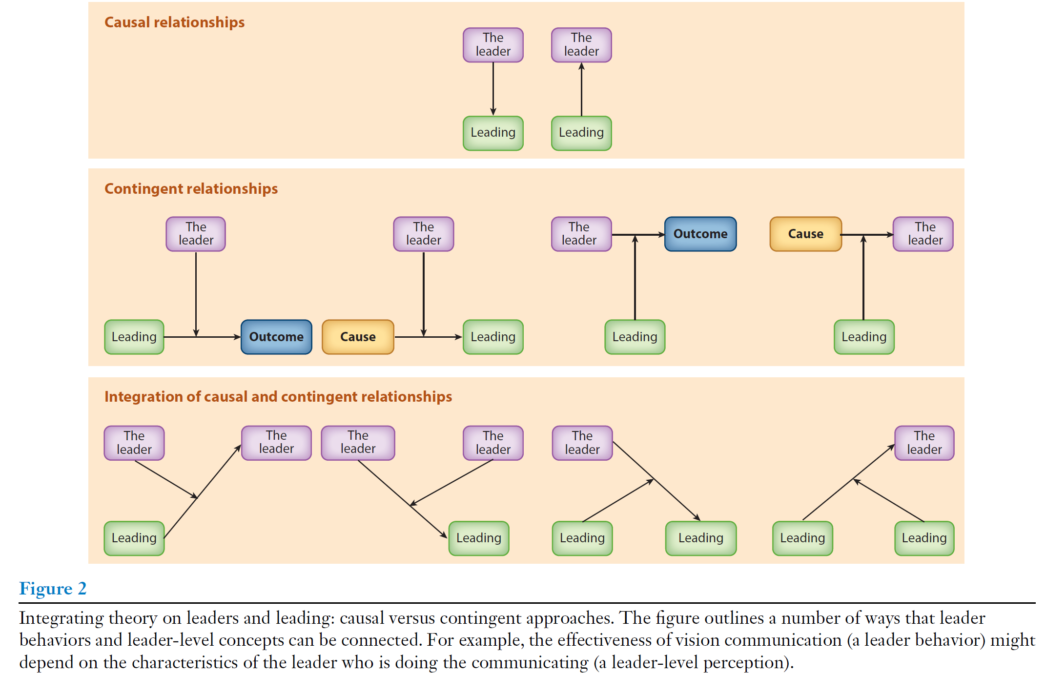

**Themes**

Leader as IV: leaders have superior power to influence followers; Dark side of leader personality (e.g., narcissism, Machiavellianism) 🡪 leader effectiveness; male vs. female leader; extroverted and conscientious leader … intelligent leader (curvilinear)

Leader as DV: leader emergence, leader evaluation, leader wellbeing, leader effectiveness, leader selection, leader discrimination

Leading as IV: directing attention, initiating action, and maintaining effort

Splitters: (1) establishing common purpose through communication and ritualistic behavior (i.e., vision communication: communicating limited number of values vs. a long list of values); (2) Help followers initiate action toward a common purpose (e.g., encourage to establish subgoals); (3) Motivate followers to persist (e.g., i-deals, giving followers responsibility, showing concern, recognizing their effort)

Lumpers: [adjective] leadership, e.g., authentic leadership, transformational leadership (10 item behaviors); empowering leadership (24 item behaviors); ethical leadership (38 behaviors); humble leadership (9), paradoxical leadership (self-centeredness with other-centeredness, treating subordinates uniformly while allowing individualization, and maintaining decision control while allowing autonomy (Zhang et al. 2015); servant leadership (28)

Leading as DV: leaders are not merely born but can be made—an assumption that has long been questioned but was recently given strong support. On-site training vs. virtual training 🡪 vision communication (crafting more image-laden visions)

**Related theories**

social identity theory of leadership (Hogg, 2001): leaders are more likely to emerge when their attributes (values and preferences) align with followers’ expectations. Similarly, follows also evaluate the leader’s effectiveness by comparing their self-concept and their general understanding of what a leader is and should be.

Role congruity theory (Eagly & Karau, 2002): Leadership emergence depends on fit between gender roles and leader roles.

Leadership categorization theory (Lord et al., 1984): People carry mental *prototypes* of leaders, and they judge new leaders by matching them against those prototypes. If the person fits the prototype → they are perceived as a good leader. If they don’t fit → people see them as less effective, even if their actual behavior is good. This may explain why minority leaders experience discrimination. People have *cognitive schemas* about effective leaders based on leaders they have encountered *elsewhere*, such as personal experience and history textbooks.

Network-based theories: leaders emerge when managers are in more centralized network, occupying a central role in the network, and endorsed by others as leaders.

Attribution theory: leadership effectiveness not by what leaders have done, but the organizational outcome and performance (Meindl, 1995).

Glass cliff effect: women (and sometimes other minority groups) are *more likely* to be placed in leadership roles during times of crisis, instability, or high risk of failure—situations where the chance of negative outcomes is greater. Then, leadership can be blamed on the candidate later (Scapegoat theory).

**Criticism**

For most of the existing scales on leadership, many items are not central to leading functions, such as influencing, and motivating followers toward common purpose.

For lumped theories, they may be (1) highly predictive but will often obscure to explain why, how, and when leading impacts key outcomes. (2) When employees rate the leaders on multiple dimensions, they may be biased to halo effects that it is not clear whether these behaviors actually do covary or whether evaluators merely perceive an illusory covariation. (3) unclear how to tease apart the distinction between traits vs. styles, orientation and foci as they have all been used to capture similar ideas; (4) if behaviors do covary, they should have a common cause that is omitted by scholars.

**Future research**

Curvilinear effect of big five traits;

Leading as DV is less studied. Prior studies primarily focused on vision communication, but ignoring other behaviors that are indicative of the three core criteria of leading.

False-negative: topics that technically fall within the domain of leading but were not labeled as such by the study authors. False positive—concepts that are labeled leadership even though they only meet the criteria of leading to a negligible degree.

Respecifying lumped conceptualization leading to conceptualizations of leaders, such as implicit theories and trait-based theories, that explain as much variation in their perceptions of leader behavior as leader behavior itself. Perceivers will be inclined to “see” in that leader other behaviors associated with good leadership that might not objectively be there. Directly correspond to personality traits that reflect a person’s overriding behavioral dispositions.

Repurposing the lumped conceptualizations of leading, such as the dependent variables in main effect models, so we do not need to explain the mechanism.

Reason for mis-specification of lumped: etymology; intuition (it is easier to think about the phenomenon of leadership at the level of the leader than the level of behaviors); and convention.

Unobtrusive methods such as **content analysis** (e.g., video, audio, or text coding) can be particularly effective for assessing leading as long as the observable manifestations of the behaviors are well-defined.

# Ethical Leadership

**Definition**

Brown et al (2005): “the demonstration of *normatively appropriate conduct* through personal actions and interpersonal relationships, and the *promotion of such conduct to followers* through two-way communication, reinforcement, and decision-making.”

De Hoogh & Den Hartog (2009) take a social influence perspective and define ethical leadership as the process of influencing the activities of a group toward goal achievement *in a socially responsible way.*

**Purpose?**

Perceived normative appropriateness vs. ethical intention and purpose of behavior.

According to Kanungo (2001), in order to be ethical, leaders must engage in virtuous acts and refrain from those that harm others, and acts must stem from altruistic rather than egotistic motives.

However, this is difficult to evaluate, as motives underlying behavior may be mixed.

**Evolution**

(1) Mainstream leadership research focuses on transformational and charismatic leadership initially. But later scholars realized that authentic transformational leadership assumes that people act on altruistic value for the good of their group, organization, or society, and concern for the collective outcomes can compete with morality (such as the rights of others beyond the group are not reflected in leader’s values and decision).

(2) the existing cases of unethical leaders that fuel the advocacy of ethical leadership.

**Measure conceptualization**

Overarching category - Brown et al. (2005) Ethical leadership scale (10 item behaviors, such as allowing voice, acting fairly, rewarding ethical conduct); Yet behaviors may have different antecedents and consequences.

Reflective conceptualization: De Hoogh & Den Hartog (2009): stressing responsible power use (acting with fairness, respect, and integrity; making principled choices; being trustworthy; and do not practice favoritism);

Limitation: (1) not all dimensional behaviors are conceptually related to being ethically focused; (2) scales are rooted in qualitative work on what perceiver (followers) think of as being part of ethical leadership, but not on actor’s (leader) perspective; (3) not ensuing consequences as ethical.

**Other related leadership**

Transformational leadership: communicating an inspiring and idealized vision of the collective future with which followers can identify. Both leaders care about others, are role models, and act consistent with their principles. But ethical leadership do not articulate future or vision often while transformational leaders do not always emphasize fairness, morality, and ethics.

Transactional leadership: providing followers with desired rewards in exchange for each follower’s input at work. They do not clarify ethical expectation and similarly, ethical leaders do not use reward and punishment to shape follower behavior.

Spiritual leadership: motivating and inspiring followers through vision, hope/faith, and altruistic love, fostering a sense of meaning, calling, and membership in the workplace.

Paternalistic leadership: combining discipline and concentrated authority with fatherly benevolence and morality. Paternalistic leaders do exhibit integrity and high moral standards, and they do not think social learning and emulating ethical behaviors is necessary.

Supportive leadership: taking care of followers. But they do not aim to promote ethical norms and moral and ethical behaviors of followers.

Unethical leadership: “behaviors conducted and decisions are illegal and/or violate moral standards, and those that impose processes and structures that promote unethical conduct by followers”. The direct research on unethical leadership is scarce, but more on indirect research that contrasts with those described for ethical leadership, such as destructive leadership, abusive leadership, petty tyranny, undermining leadership, passive or laissez-faire leaders. However, low ethical leadership is not necessarily the same as high unethical leadership because low ethical leadership may be the lack of a proactive ethics-related agenda.

**Outcomes of ethical leadership**

Attitudinal outcomes: promote altruistic attitudes among followers, increased ethical and prosocial behaviors (OCBs), LMX, favorable perception leadership among followers, enhance affect commitment and motivation, job involvement, higher wellbeing, organizational identification, decreased counterproductive behavior, deviance, and unethical conduct of followers, lower cynicism of followers

**Suggested mechanisms**

Moral equity judgment: Moral equity (moral rightness, justice, and fairness) + Contractualism (unspoken duties or obligations) + Relativistic judgment (acceptability based on norms) 🡪 when employees have ethical leaders, they tend to judge acts of deviance as morally inequitable and citizenship acts as morally equitable.

Identification-based motivational process: Followers emulate ethical leaders and adopt their emphasis on integrity, trust, and shared values by integrating these into their identity and self-concept.

Relationship-oriented processing: ethical leadership 🡪 cognitive and affective trust, psychological safety environment 🡪 voicing, idea sharing and exchange

Social information processing: ethical leadership 🡪 reduced negative feeling (fear retaliation from supervisors), anticipating supportive response 🡪 voicing

**Antecedents**

Personality: conscientiousness, agreeableness, and emotional stability (+)

Cognitive moral development: how people’s moral reasoning becomes more sophisticated over time: Level 1 pre-conventional morality (focus on self-interest and avoiding punishment; obedience and punishment, individualism and exchange); Level 2 – conventional morality (focus on social approval and maintain order; interpersonal conformity, authority and social order); Level 3 – post-conventional morality (social contract and rights, universal ethical principles)

Moral identity (central to self-conception): symbolization + internalization

Internalization: “Being moral is central to who I am”, base self-worth on living up to moral values, feel a strong intrinsic duty to behave morally, experience guilt when violating moral standards

Symbolization: “I want to express my moral identity to others”, want others to see them as moral, engage in prosocial acts that are more observable, enjoy reputational benefits of moral behavior

Dark trait: Machiavellianism (manipulating others for personal gain), Narcissism (grandiosity, self-love, and inflated self-views), and Psychopathy (lack of empathy, shallow emotions, impulsivity, and manipulativeness)

Collectivistic orientation: considerate, respect for others

Power distance: morality is represented as either “highly directive and authoritarian behavior” vs. “two-way communication and power sharing”

Firm-level: moral awareness climate

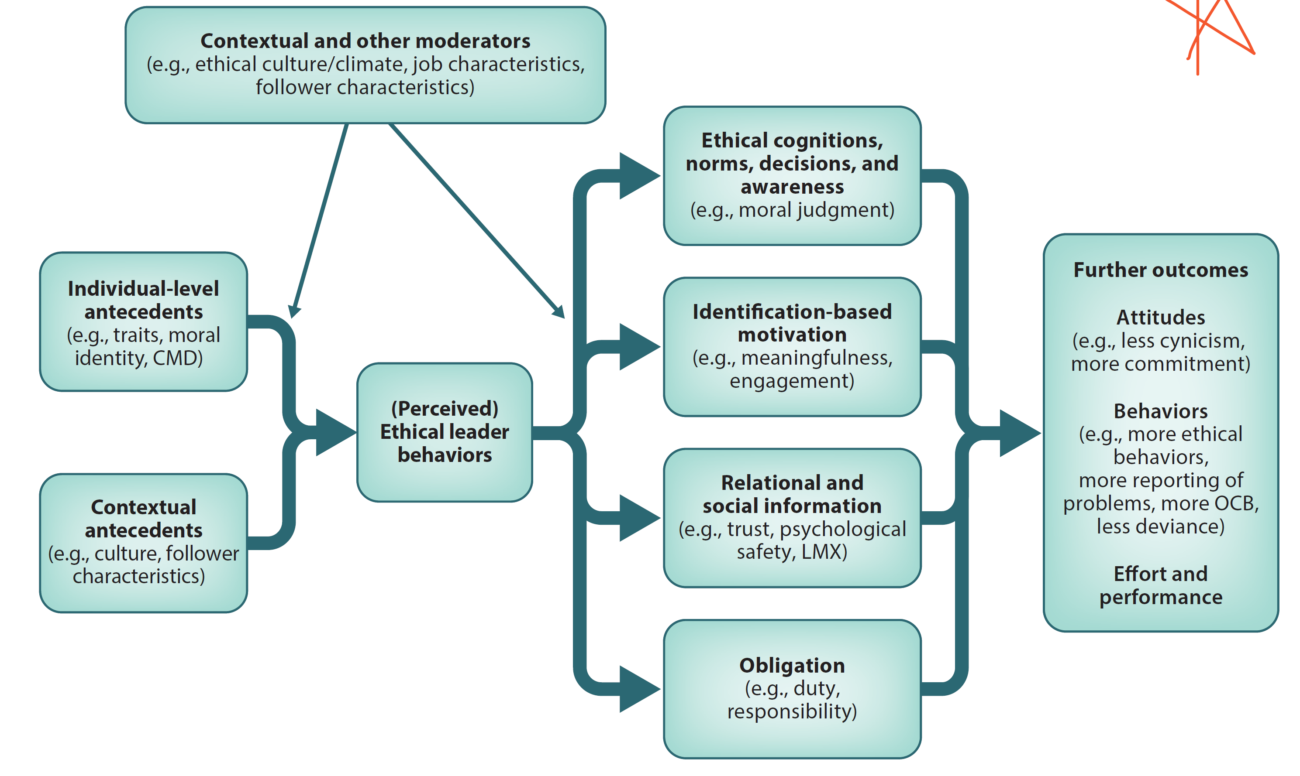

**Challenges and criticism**

Tautological issue: some DVs are followers ethical attitudes and behaviors, which are defined in ethical leadership. Similarly, many authors propose that trust is a proximal outcome of ethical leadership; yet trust is also used as part of the construct and measurement of ethical leadership. Thus, the findings on trust may be inflated because the wording of some items for measuring ethical leadership includes the term trust.

It is not yet sufficiently clear about which outcomes and correlates are more generally related to good or effective ethical leadership and which are more uniquely or strongly related specifically to leader ethical behavior. E.g., LMX also occurs for several other leadership styles.

Whether one must always be a moral person to be seen as an ethical leader? If leader intention is important, how can they be better incorporated into measurement with minimum social desirability issue?

It is unknown whether the follower perceptions always correspond with intended leader behavior. Perceptions may be biased so such an ambiguity questions: *whether we are measuring leader behavior itself or follower perception of it.*

Much of the current work is cross-sectional field work, leaving us with too little knowledge on how the process unfolds over time and on the direction of causality.

Nonlinear effect of ethical leadership is possible (Miao et al., 2013).

# *Destructive Leadership

**Definition**

Destructive leadership (Krasikova et al., 2013)is defined as volitional behavior by a leader that can harm or intends to harm a leader’s organization and/or followers by (a) encouraging followers to pursue goals that contravene the legitimate interests of the organization and/or (b) employing a leadership style that involves the use of harmful methods of influence with followers, regardless of justifications for such behavior.

**Key components**

(1) as harmful behaviors perpetrated by the leader and imbedded in the process of leading 🡪 distinguish DL from other harmful behaviors that could be performed by any employee regardless of his or her leadership status. If not influencing followers, then that harmful behavior is not destructive leadership.

(2) manifested in (a) identifying *destructive goals* and fostering followers’ pursuit of those goal and/or (b) using *destructive actions or methods* to mobilize followers to attain goals (e.g., a leader who bullies followers to make them focus on greater product safety has used a DL style)

(3) as volitionally harmful behavior to avoid the confusion between the terms “intent to harm” and “goal to harm”, thereby emphasizing that such harm-doing is *not* the leader’s goal in itself (although could be in some cases), but rather the leader’s choice to pursue a goal or enact behavior that is harmful in nature. Thus, there is no presumption that destructive leaders will necessarily view themselves, their goals, or their actions as harmful (although this is also possible).

**Related leadership**

abusive supervision – engaging in the sustained display of *hostile verbal and nonverbal behavior* excluding physical contact (destructive action but salient about goals)

petty tyranny – playing favorite, using authority for personal purposes and belittling followers (destructive action but salient about goals)

pseudo-transformational leadership - display inspirational behavior but are driven by self-interest, manipulation, and personal gain rather than ethics, morality, and collective welfare (destructive action and destructive goals)

personalized charismatic leadership - charismatic leaders who are driven by self-interest, dominance, and personal power, using followers as tools to achieve their own goals (destructive action and destructive goals)

strategic bullying - intentional, planned, and goal-directed bullying behaviors used to achieve specific strategic objectives (destructive action but destructive or constructive goals)

managerial tyranny - chronic pattern of oppressive, harsh, and domineering managerial behavior characterized by control, coercion, intimidation, and disregard for employees’ dignity, autonomy, and well-being (destructive action but destructive or constructive goals)

Ineffective leadership: demonstration of a leader’s natural *inaptitude* and/*or low motivation* to lead, while DL does not necessarily imply a leader’s incompetence or low motivation. Rather, it embodies a leader’s choice to lead followers toward goals that harm or intend to harm an organization or to adopt a harmful style of leading followers.

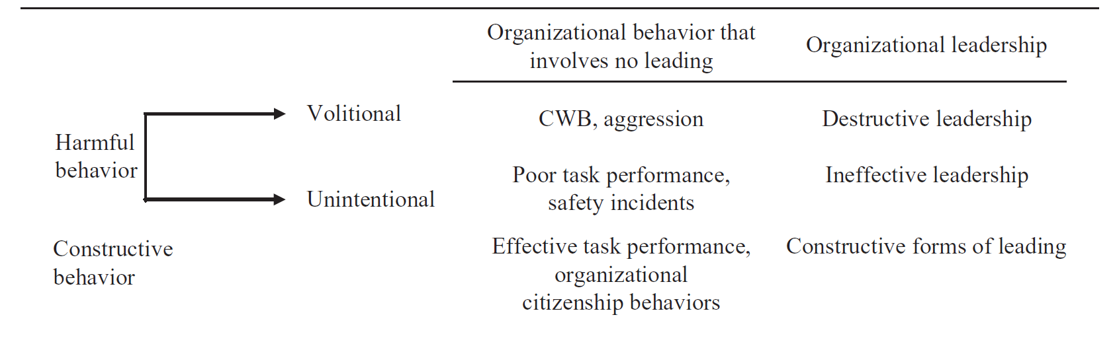

**Propositions**

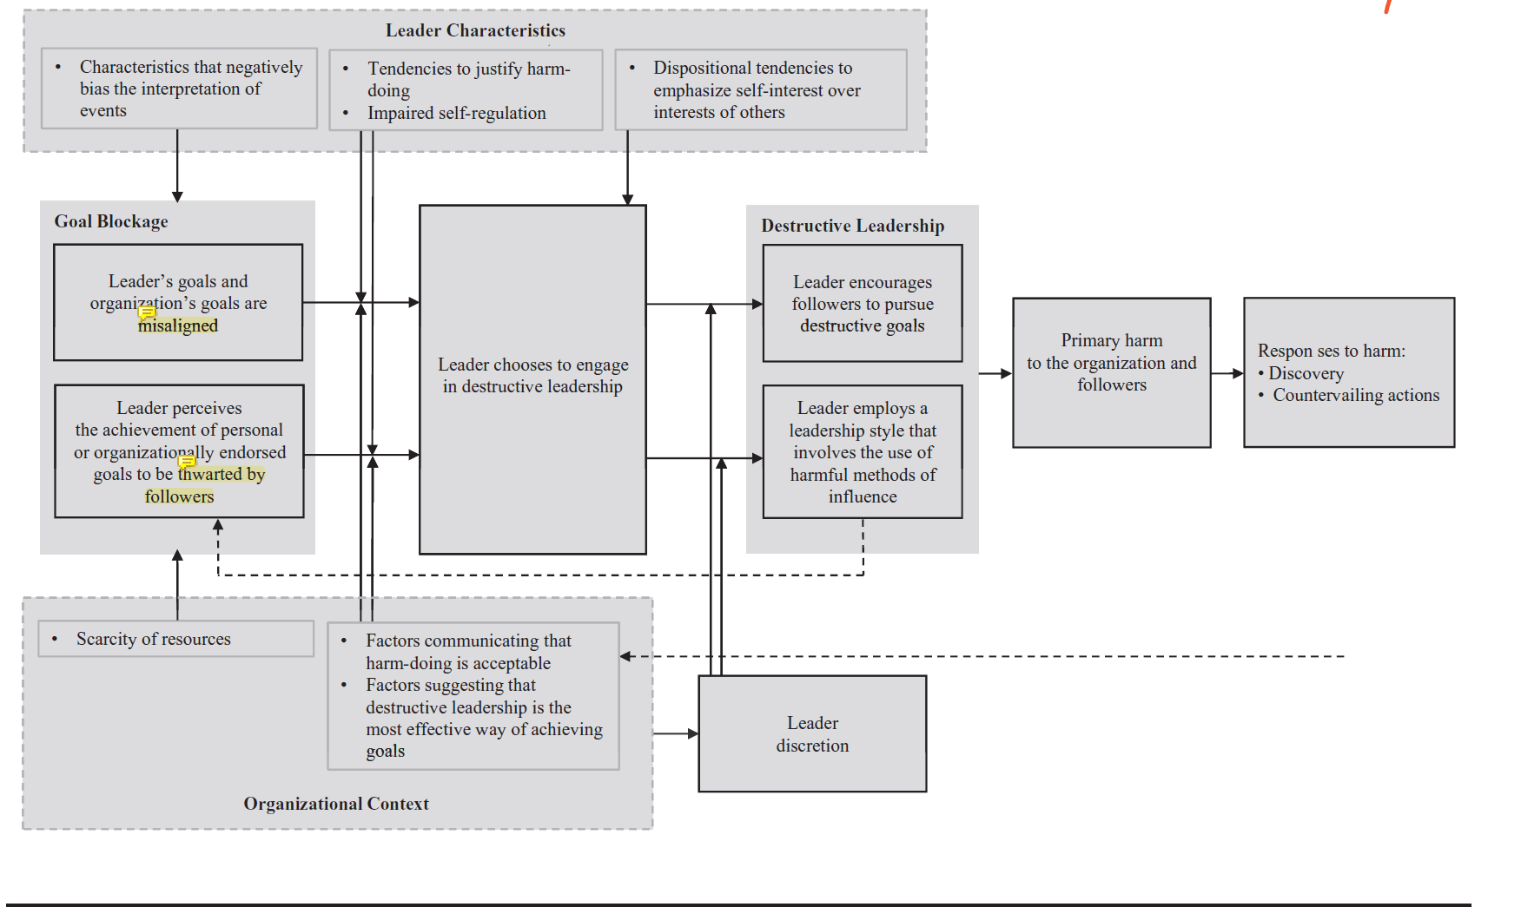

*Proposition 1*: The more a leader perceives his or her *personal goals to be* *misaligned with organizational goals*, the more likely he or she is to encourage his or her followers to pursue destructive goals.

misalignment 🡪 strain 🡪 to engaging deviant behaviors to alleviate strain or as compensation; Different from agency theory which assumes that managers/leaders are self-interested or they prioritize their self-interests.

*Proposition 2*: The more a leader perceives that the achievement of his or her *goals* (personal or organizational) is *being thwarted by followers*, the more likely he or she is to employ a DL style to influence followers.

Being thwarted by immature followers 🡪 frustration, threatened self-image and professional competence

*Proposition 3*: Leaders’ characteristics that negatively bias interpretation of events (e.g., implicit motive to aggress, negative trait affectivity, and paranoid tendencies) are positively related to leaders’ **perceptions of goal blockage.**

Hostile attribution bias (impute hostile and malevolent intent into the behavior of others); Victimization bias (see oneself as the victim of inequality, exploitation, and injustice); Paranoid tendencies (skeptical and argumentative trait)

*Proposition 4*: Contextual factors that limit leaders’ access to resources needed for goal achievement (e.g., the organization restricts availability of resources, the organization is short of resources, followers are incompetent, unmotivated, or intentionally uncooperative) are positively related to leaders’ **experience** of goal blockage.

*Proposition 5*: Leaders’ dispositional tendencies to **justify harmful behavior** in situations when their interests are violated (e.g., positive attitude toward revenge, external locus of control, and hostile attributional style) moderate the positive relationship between goal blockage and leaders’ **choice to engage** in DL such that leaders with higher scores on such characteristics are more likely to react to goal blockage by choosing to engage in DL.

*Proposition 6*: Leaders’ temporary or **dispositional self-regulation impairment** (e.g., depletion of resources, low self-control, trait anger) moderates the positive relationship between goal blockage and leaders’ choice to engage in DL such that leaders with greater self-regulation impairment are more likely to react to goal blockage by choosing to engage in DL.

Availability vs. scarcity of psychological resources to resolve the situation of goal blockage in a constructive way (emotional labor, deliberate processing of relevant information in order to find a constructive solution)

*Proposition 7*: Factors communicating that **harmful behaviors are acceptable in the organization** (e.g., leaders’ or other employees’ previous success using DL, and lack of punishment mechanisms) moderate the positive relationship between goal blockage and leaders’ choice to engage in DL such that when such factors are present, leaders are more likely to react to goal blockage by choosing to engage in DL.

Social learning experiences to leadership style

*Proposition 8*: Factors suggesting that **harmful behavior is the most effective** way of achieving leaders’ goals (e.g., “immature” or uncooperative followers, organizational reward structures deemphasizing ethical standards, competition for rewards) moderate the positive relationship between goal blockage and leaders’ choice to engage in DL such that when such factors are present, leaders are more likely to react to goal blockage by choosing to engage in DL.

*Proposition 9*: Leaders’ dispositional tendencies to emphasize self-interest over interests of others and at the expense of others (e.g., Machiavellianism, narcissism, and psychopathy) are positively related to leaders’ **choice to engage in DL.**

*Proposition 10*: Leaders’ choice to engage in DL is more likely to **translate** into DL when their discretion is higher.

when they have actual or perceived control over their behavior

*Proposition 11*: The **proximal outcome** of leaders’ pursuit of destructive goals is likely to be negative consequences for the **organization** (e.g., exhausting organizational resources, thwarting the accomplishment of organizational goals, and creating legal problems for the organization).

*Proposition 12*: The proximal outcome of leaders’ use of destructive methods of influence with followers is likely to be negative consequences for leaders’ **followers** (e.g., impaired physical and psychological well-being, low job and life satisfaction).

*Proposition 13*: Organizations are more likely to **discover** leaders’ use of destructive methods of influence with followers than leaders’ pursuit of destructive goals.

Abusive behaviors are often associated with heightened emotions and thus tend to be more spontaneous, harder for the leader to control, and more likely to occur in the presence of witnesses. Destructive actions represent behaviors that are salient and vivid, which increases their attentional pull. A leader’s use of destructive methods of influence is more likely to be reported by followers to organizational authorities than his or her pursuit of destructive goals. It is common for the leader to use deception and information manipulation to hide their intent and goals from followers. If a leader’s goals are hidden from others, reporting of that behavior is not possible.

*Proposition 14*: Organizations are more likely to take **countervailing** actions against leaders when they encourage followers to pursue destructive goals than when they use destructive methods of influence with followers.

*destructive methods of influence* is more justifiable that leaders can argue that they are used instrumentally to meet organizationally sanctioned goals or to prompt better performance by followers, so the methods may be tolerated or even encouraged by the organization.

**Future research**

determining if a leader’s goal pursuit or behavior is volitionally harmful is a sensitive research topic, rife with problems, including (a) social desirability bias, (b) inferring intentions (an internal state of the leader) from data collected from or about that leader, and (c) the threatening nature of such research, which could have potentially serious implications for the leader.

to validate the distinction between these two manifestations by studying their differential predictors.

refine this model by considering additional factors affecting leaders’ engagement in DL and its consequences.

empirically examine the proposed processes underlying leaders’ choice to engage in DL as they develop over time.

examine the role of followers in the processes underlying DL by incorporating the effects of followers’ individual differences, such as followers’ responses to manifestations of DL, and the effect of DL on follower performance.

Understand how broader social context affects DL.

future empirical research originating from our framework will likely require development and validation of a measure of DL that takes into account the defining features of the construct.

# Perceived Organizational Support

**Definition**

Perceived organizational support (POS) refers to employees’ perceptions that the organization values their contributions and cares about their well-being (Eisenberger et al., 1986).

Evolution: Prior research emphasizes employees’ commitment to the organization, but not taking the organization’s commitment to employees into consideration.

**Theoretical framework**

Organizational support theory (Eisenberger et al., 1986): employees view the organization as a living being, having purpose and intention; so employees infer organizational motives the same way they infer motives from a person.

Personification: because organizations have: (a) responsibility for the actions of its agents, (*b*) continuity provided by organizational culture and norms, and (*c*) considerable power exerted, through its agents, over individual employees.

As an outcome of personification, POS meets employees’ socioemotional needs (e.g., approval, affiliation, esteem, and emotional support) and indicates the potential benefits of exhibiting greater efforts on the organization’s behalf.

公司有人情味？

A major determinant of POS concerns whether employees attribute perceived favorable treatment to the voluntary choice of the organization or to external factors that forced the favorable treatment. E.g., the policy of increasing wages can be construed as organization’s voluntary decision with altruistic motive VS. an involuntary decision influenced by coercive pressure, normative pressure, and mimetic pressure.

**Common antecedents**

Fairness: distributive, procedural (transparency and consistency), and interaction justices

Leader support: LMX, perceived supervisor support, transformational leadership. Organizational support theory views supervisor as embodying the organization because they act as agents of the organization; supervisors’ POS was positively related to subordinates’ perceived support from their supervisor which, in turn, was related to the subordinates’ POS (trickle-down effect: managers 🡪 subordinates 🡪 customers; why happen: supervisor’ felt obligation and supervisors believe that is what the organization expects and desires)

Human resource practices and work conditions: personalized developmental opportunities, family supportive organizational practices, job enrichment, autonomy, generous benefits, i-deals (symbolizing organization’s concern for individual employee’s need and wellbeing)

**Common Mechanisms**

Social exchange processes: POS 🡪 trust, indebtedness, reduced cynicism, feelings of obligation 🡪 affective commitment, OCBs, and job performance

Affect theory of social exchange (Lawler, 2001): POS (good exchange) 🡪 affective uplift, positive emotions (happiness, satisfaction, gratitude, trust), perception of being concerned 🡪 loyalty, relational commitment, willingness to sacrifice, strengthened social bond (higher relationship quality), cooperative motivation

Self-enhancement processes: POS 🡪 pride, feeling of valued, perceived relational value, important, satisfied *socioemotional needs* (respect, acceptance, esteem, belonging, emotional support, approval) 🡪 enhanced self-efficacy

**Common Outcomes**

Affective (emotional attachment, identification with) vs. Normative (ought to stay) vs. Continuance (cost if leave) organizational commitment

Work engagement (vigor, dedication, absorption; Bakker, 2008), Job engagement

Low withdrawal behavior (absenteeism, intention to quit), more OCB-O than OCB-I, less CWBs,

POS 🡪 organizational identification, expectation of future reward 🡪 creativity

POS 🡪 felt obligation 🡪 task performance

Aggregated POS 🡪 safety climate 🡪 safety-related behavior, less workplace accidents

POS 🡪 psychological safety, job security, relieving the stress associated with fear of failure 🡪 acceptance and utilization of new technology

POS 🡪 organizational identification, fulfilling socioemotional needs 🡪 deep acting over surface acting (emotional labor theory) 🡪 service quality to employees, employee wellbeing

POS 🡪 reduce strain 🡪 less burnout, improved health, job satisfaction, wellbeing

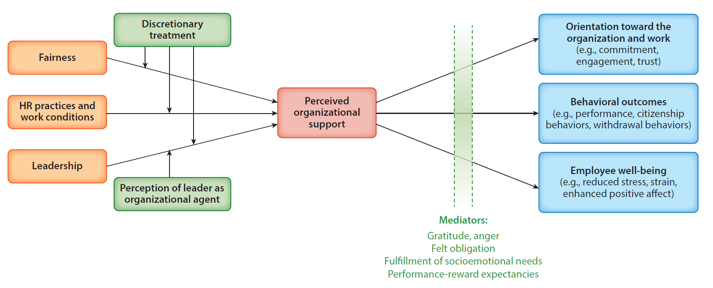

**POS as moderator**

Stressor X POS 🡪 strain 🡪 wellbeing

POS can hardly serve as a buffer if stressors are immediate and acute or are very specific to one’s job

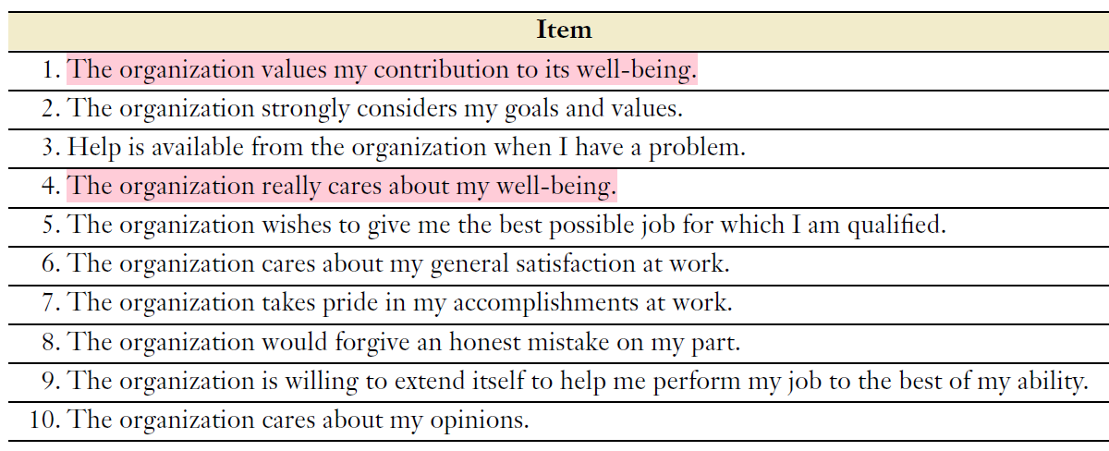

# Psychological Contract

**Definition**

The psychological contract is defined as “an individual’s *beliefs* regarding the terms of conditions of a *reciprocal exchange agreement* between the focal person and another party” (Rousseau, 1989).

“what the employee owes the organization and what the organization owes the employee”.

**Key components**

(1) Rousseau (1989) shifted the terms of the exchange agreement from *expectations* to *promises*, accentuating the role of the organization in creating psychological contracts, whereas the prior emphasis on expectations captured numerous influences unrelated to the organization.

(2) Promissory nature of the exchange relationship includes both explicit and implicit promise making. Explicit promises result from employee interpretations of verbal and written agreements, whereas implicit promises refer to interpretations of consistent and repeated patterns of exchange with the employer.

(3) a Subjective perception that is not necessarily shared with the other party so employers and employees may have different views of the terms of their psychological contract and the degree to which they believe each party has fulfilled their obligations.

**Related Concepts**

Psychological contract fulfillment is defined as “the extent to which one party to the contract deems the other has *met its obligations*” (Lee et al. 2011, p. 204).

Psychological contract breach is defined as “the cognition that one’s organization has failed to meet *one or more obligations* within one’s psychological contract in a manner *commensurate* with one’s contributions” (Morrison & Robinson 1997, p. 230).

Psychological contract violation is described as an intense *reaction* of outrage, shock, resentment, and anger, and captures the emotional and affective response that may *arise from a breach.*

Psychological contract fulfillment and breach capture an individual’s cognitive judgment and evaluation, whereas violation captures the emotional reaction.

**Dimensions of contracts**

Relational contract: refers to *socioemotional resources* (e.g., approval, affiliation, esteem, and emotional support), long-term, loyalty-based obligations that reflect a relationship of mutual support and trust. In exchange for loyalty, the employee is provided with promotions to ensure career development and/or job security to remain with the organization.

In transactional contracts, the focus is instead on the economic resources. In exchange for flexibility and career self-management, employees are provided with training and career development to ensure their employability.

These two contracts are differentiated on the basis of their focus, time frame, stability, scope, and tangibility.

**Ideological currency**

Research in psychological contract has historically focused almost entirely on economic and socioemotional exchanges, overlooking that many employees also care about *contributing to a valued cause*. Past research is too narrow and misses an important class of obligations that organizations may implicitly promise employees—*supporting a social, moral, or ideological mission*.

~~Thompson & Bunderson (2003) defined ideological currency as “credible commitment to pursuing a valued cause or principle (not limited to self-interest) that are implicitly exchanged at the nexus of the individual-organization relationship” (p. 574).~~

Ideological currency is the symbolic exchange of shared values and meaning between employers and employees that creates loyalty, influence, and commitment beyond material incentives.

~~Ideological (psychological) contract: obligations tied to shared values, moral purpose, identity and calling, ethical alignment, organizational mission and vision, and the organization’s higher purpose.~~

Ideological contrast fulfillment was found to explain additional variance beyond relational contract fulfilment in predicting extra-role behavior (OCB; Bingham 2005; Bal & Vink 2011)

**Common antecedents of psychological contract breach**

Prior breach experience: Individuals who experience breach with one employer are more likely to experience breach with a subsequent employer, due to their increased *vigilance*.

(in)Similarity of the cognitive styles between supervisor and subordinates, incongruence between supervisor and subordinates,

Neuroticism and external locus of control

Initial trust in the employer, employer renege, organizational politics, organizational change, perceived organizational support, job resources and demands

Contextual factor: Organizational restructuring and downsizing (uncertainty and unpredictability), job insecurity 🡪 makes employees more vigilant and hence more likely to perceive a breach in their psychological contract

**Common outcome of psychological contract breach**

Lower commitment, lower job satisfaction, decreased organizational trust, lower trust, more organizational cynical attitudes, more CWBs, less OCBs, lower job performance

Wellbeing: Physical health (fatigue, sleep problem, and headache), Mental health (psychological distress, downhearted, blue feeling), Burnout, Emotional wellbeing (stress, sadness, anxiety)

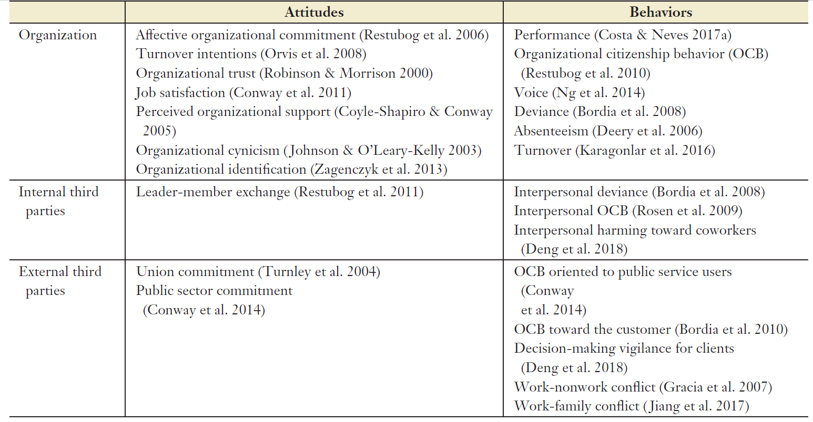

**Common Mechanisms**

Social exchange theory: psychological contract breach/fulfilment 🡪 trust, felt obligation, fairness, a lack of reciprocity 🡪 DVs

Organizational identification theory: psychological contract breach 🡪 reduced organizational identification (sense of rejection, reduced organizational attachment, re-evaluate the organizational values and importance to self-concept) 🡪 DVs

Affective event theory: psychological contract breach (as negative event) 🡪 negative emotions (dissatisfaction, anger, disappointment, sadness, betrayal) or (guilt, shame) 🡪 CWBs, retaliation, withdrawal behavior, silence

Job demands-resources model (health impairment process): psychological contract breach (as job demand) 🡪 effort and energy expenditure → burnout → health problems (worsened wellbeing) → reduced performance and withdrawal

Job demands-control model: psychological contract breach (low in job control & high in job demand) 🡪 more stress, strain 🡪 less OCBs

Effort-reward imbalance model: psychological contract breach (imbalance between effort and reward) 🡪 strain 🡪 wellbeing

Conservation of resource theory:

(a) psychological contract breach (negative work-related stressor) 🡪 strain, depleting resource 🡪 unable to self-regulate and may engage in unintentional behaviors such as harming behaviors toward coworkers.

(b) Psychological contract breach 🡪 less OCBs in order to conserve resources

Control theory: psychological contract breach 🡪 loss in control 🡪 retaliation, aggression, withdrawal, disengagement, reduced motivation to OCBs

*When outcomes are directed toward supervisors and coworkers*

Depending on who was judged to be responsible for a psychological contract breach

Organizational support theory: supervisor is as embodying the organization; so employees are likely to blame their supervisor 🡪 decreased LMX

Displaced aggression: since employees cannot express aggression toward the organization, so they redirect that aggression toward coworkers who are safer, more accessible, and less threatening targets.

Psychological contract breach may produce negative outcomes toward unions, clients, and family through trickle-down effect.

**Moderator**

Cross-cultural differences:

power distance orientation: when breach, lower orientation 🡪 voice and exit; higher orientation 🡪 deviance

horizontal-individualistic culture: strengthen breach 🡪 lower trust, than vertical-collectivistic culture

**Future research**

Do individuals recover from psychological contract violation? If so, how? What is the role of time in the recovery process?

does ideological currency explain different outcomes? Empirical studies are needed that examine (*a*) potential mechanisms to explain why breach or fulfillment of ideological obligations would affect employee outcomes and (*b*) how these explanations might differ from the traditional norm of reciprocity explanation.

Does the breach experience (event based or the accumulation of minor transgressions) have a differential effect on health outcomes?

Is there a link between psychological contracts and employee psychological and physical health?

What role do psychological needs play in understanding psychological contracts? Do psychological needs influence the formation and development of psychological contracts?

Are macroeconomic, cultural, and societal contexts important to understand psychological contract breach? What dimensions of culture and society impact psychological contract breach reactions?

# Job Embeddedness

**Definition**

Job embeddedness is the extent to which an employee is enmeshed within a larger social system as a result of combined on-the-job and off-the-job forces, including their connections (links), their fit with their job and community, and the sacrifices they would make if they left.

**Evolution**

History: Before the conception of job embeddedness, the scholarly conversation primarily centers around “why do people leave?”, overlooking “why do people (voluntarily & involuntarily) stay?”.

Derivative:

Organizational embeddedness (on-the-job) focuses on aspects of the organizational environment that embed the individual (e.g., pension, promotional opportunities)

Community embeddedness (off-the-job) focuses on aspects of the community that embed the individual (e.g., family-oriented environment, quality of available leisure activities) (Lee et al. 2004).

**Three key aspects**

(1) Links: the extent to which people have connections to other people or activities,

(2) Fits: the extent to which their jobs and communities fit with the other aspects in their life spaces, and

(3) Sacrifice: they would give up if they left, especially if they had to physically move to other cities or homes.

**Criticism on Conceptualization**

Initially, it is conceptualized as a causal indicator (formative) model (Mitchell et al., 2001) but lateral on she realized that the internal consistency and factor analysis cannot be applied to formative model.

Later on, Crossley et al. (2007) developed the seven-item Global Job Embeddedness Scale (perception of overall job embeddedness) as a reflective model.

But the measure of job embeddedness is still an ongoing issue, mainly because (a) we do not yet know what are the key forces that operate and embed employees in a given setting, organization, industry, or profession {formative model}; and (b) the reflective model does not encourage us to study the dimensions *of organizational and community* embeddedness or the *subdimensions* of links, fit, and sacrifice across organizational and community embeddedness.

**Common antecedents**

Negative affectivity

**Common outcomes**

Less voluntary turnover, job search, retirement intention (-),

Higher organizational commitment, job satisfaction, job performance, and OCBs (+),

Ng & Feldman (2010): innovation-related behaviors, spread of innovations, implementation of new ideas;

Ng & Feldman (2010): dark side of **OE** 🡪 declines in social and human capital development over time (decrease efforts at building capitals)

Ng & Feldman (2012): OE & JE 🡪 work-to-family and family-to-work conflict

Across nations and culture:

Tanova & Holtom (2008) found in Denmark and in Italy, only organizational embeddedness predicted turnover, whereas in Finland and in Spain, both organizational and community embeddedness predicted turnover.

Expatriation and repatriation:

Tharenou & Caulfield (2010) found both career and community embeddedness 🡪 host-country dissatisfaction and intention to repatriate (+)

Kraimer et al. (2012) found expatriate community embeddedness 🡪 international employee identity

Community embeddedness 🡪 unwillingness to overseas relocation

**Common moderators**

Sekiguchi et al. (2008): JE (link & fit) X higher LMX 🡪 more job-related information and supervisory support

**Common Mechanisms**

Conservation of resources theory: JE (resource gain) 🡪 intensified work effort 🡪 job performance

**JE as Moderator**

Shock events, Job search 🡪 turnover; stronger for low embeddedness

Job satisfaction 🡪 reduced turnover intention; stronger for high embeddedness

LMX, organization-based self-esteem 🡪 OCBs; stronger for high embeddedness

**JE as Mediator**

Lev & Koslowsky (2012): conscientiousness 🡪 JE 🡪 performance

**Contagion effect**

Felps et al. (2009): Coworkers’ job embeddedness 🡪 reduced voluntary turnover intention of a focal employee,   
after controlling for focal employees’ job embeddedness, organizational commitment, job satisfaction, local unemployment rate, and coworker’s job satisfaction and organizational commitment

**Future research**

The empirical issue (formative vs. reflective model)

Research on job fit is extensive, but little focuses on links and sacrifice.

the idea of trajectories for job embeddedness has not yet been examined.

do people project themselves as being more or less embedded in the future?

Gig worker?

The definition of links is unclear, we do not know who the people in the links are. Links vary in importance, frequency of contact, and location in networks. Some people are likely strategically placed whereas others are not. Being embedded by links in the community might increase or decrease ones’ productivity at work.

# CET vs. SDT in Pay for Performance

**Background**

The idea that PFP does not work, or is even harmful (e.g., to intrinsic motivation and creativity), has been widely communicated:   
(a) including excessive risk taking, excessive competition within the firm;   
(b) focusing too much on performance that are included in the plan (e.g., sales and stock returns).   
(c) focusing too little on performance measures not included in the PFP plan (quality, service, long-term performance);

PFP can be detrimental based on Maslow’s need hierarchy theory, Herzberg’s motivation-hygiene theory, and Deci & Ryan’s cognitive evaluation theory

PFP can be motivation based on Self-determination theory: When rewards are administered in an autonomy-supportive climate, they are less likely to undermine intrinsic motivation and, in some cases, can enhance intrinsic motivation.

**Cognitive evaluation theory**

Categorize motivation as intrinsic (inherently interesting or enjoyable) vs. extrinsic (separable outcome)

Ryan & Deci (2000) does not care what causes intrinsic motivation, but cares what elicit and sustain, vs. subdue and diminish that.

Under CET, the controlling aspect suggests performance-contingent extrinsic rewards can undermine intrinsic motivation because it induces an experience of controlling, such that people can only receive reward by performing in particular way, particular time, and particular place.

**Why it is complex**

In contrast, the informational aspect suggests that it depends on whether the performance-contingent extrinsic reward signals a positive or negative message about the experienced competence, and thus intrinsic motivation.

Performance-contingent rewards provide a tangible symbol of achievement (a cue value) that can intensify the affective significance and importance of accomplishment, making competency information more salient.

There is a lack in CET literature regarding using the performance as an outcome.

Intrinsic =/= performance:

(a) a behavior may reflect a mix of intrinsic and extrinsic motivation

Prior studies typically focus on autonomous and controlled motivation. It used a forced-choice format. Respondents (students) had to choose whether they were intrinsically or extrinsically motivated. So they may view intrinsic motivation and extrinsic motivation as opposites and not as complementary or able to occur simultaneously.

(b) intrinsic motivation may produce positive outcomes in long run.

(c) The definition of extrinsic motivation implied by the actual items is overly narrow, focusing only on the negative aspects (e.g., coercion, guilt, shame, avoiding trouble). As a result, that part of motivation will indeed prove itself to be of lower quality.

(d) the positive effect of extrinsic motivation may outweigh the negative effect on intrinsic motivation

Many employees wish to succeed in their jobs and their careers for both intrinsic and extrinsic reasons and these may not be distinct in their minds. Many of the extrinsic reasons are positive: They wish to have economic security and the freedom that comes with it, which allows them to choose how they spend their time, as well as the financial wherewithal to help others, whether it be to provide a comfortable and secure life for their family or to engage in philanthropy.

the more autonomous the motivation, the higher its quality and the more authentic it is.

(e) Pay for Performance may operate at (a) individual level, e.g., incentives and sales commission; or (b) group level, e.g., profit-sharing and stock plans

(f) All the studies appear to have been conducted at the *individual level of analysis and to have used employee perceptions of PFP*. Yet there is no reason to expect that employees working in the same job in the same unit or company work under different PFP systems. In other words, there should not be huge difference in the PFP across individuals. Thus, such designs would appear incapable of telling us whether different organization-level or unit-level PFP policies hinder or enhance creative behavior in organizations.

What is needed is a multilevel design that includes both variance between employees within organizations and variance between organizations in PFP and other factors thought to influence creativity.

**When Creativity as DV**

A primarily intrinsic motivation to engage in an activity will enhance creativity, and a primarily extrinsic motivation will undermine it.

Amabile (1993): Rewards can actually enhance intrinsic motivation and creativity when they confirm competence, provide useful information in a supportive way, or enable people to do something that they were already intrinsically motivated to do.

Hennessey & Amabile (1998, p. 675): when working adults feel that incentive systems signal the value of their contribution, their motivation and creativity of performance can be enhanced.

Hennessey & Amabile (2010): intrinsic motivation is not so fragile and not so easily subdued and diminished as argued by Ryan & Deci (2000).

**Criticism**

The typical way to measure creativity is to use a supervisory rating. Evidence of *discriminant validity* of the creativity rating from an ordinary supervisory rating of performance is not provided. Thus, it would be helpful to see better evidence from the jobs being studied that (a) employees have the latitude to display different levels of creativity and do, and (b) supervisors can assess creativity with sufficient independence from other aspects of performance.

**Self-determination theory**

Instead of focusing on intrinsic motivation versus extrinsic motivation and their different consequences for experienced autonomy/control, SDT focuses primarily on the distinction between autonomous (self-determined) and controlled (non-self-determined) motivation.

When rewards are administered in an autonomy-supportive climate, they are less likely to undermine intrinsic motivation and, in some cases, can enhance intrinsic motivation.

People identify with the value of a behavior for their own self-selected goals, which leads to people experiencing greater freedom and volition because the behavior is more congruent with their personal goals and identities.

This form of extrinsic motivation is characterized not by the person being interested in the activity for its own sake, but rather because the activity is perceived as being instrumentally important for personal goals.

Amotivation – lack of control

External regulated motivation 🡪 low control, compliance, external rewards and punishment

Introjected motivation – self-control, ego-involvement, internal rewards and punishments, “Because I would feel guilty if I did not do well”.

Identified motivation – internal importance, value, “Because it is the type of work I have chosen to attain certain important objectives.”.

Integrated motivation – self-concept, “Because my work is a big part of who I am”.

Intrinsic motivation – interest, enjoyment, “Because I experience pleasure and satisfaction while learning new things”.

SDT now says that performance-contingent pay does not undermine intrinsic motivation if pay is “instrumentally important for other goals” and if goals are not perceived as forced on them.

**Challenges for SDT**

(a) Address construct validity issues and quality of motivation.

Probably low discriminant validity between intrinsic motivation and more autonomous forms of extrinsic motivation (identified and integrated).

SDT nevertheless still seems to distinguish between the quality of extrinsic and intrinsic motivation in some cases (e.g., predicting persistence on uninteresting but effort-driven tasks).

Social desirability issue: That intrinsic motivation appears to be more socially desirable.

**Future research**

Determine the quality of motivation. Do different types of motivation (extrinsic, intrinsic; autonomous, controlled) differentially predict effectiveness outcomes (e.g., performance, creativity)?

To what degree does the influence of PFP on effectiveness outcomes depend on how intrinsically motivating a job is?

How does PFP influence goal choice (e.g., among tasks that vary in intrinsic interest)?

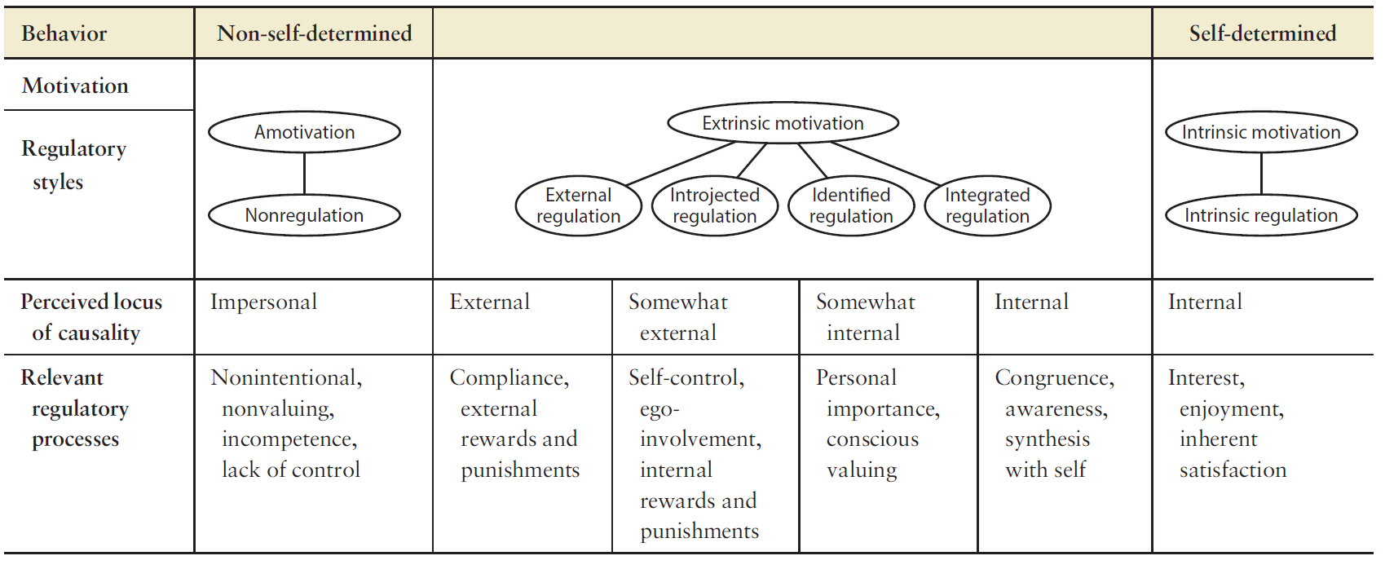

# Workaholism

**Definition**

Workaholism is a strong, uncontrollable inner compulsion to work excessively hard and for long hours, driven by internal pressures rather than external demands, and despite negative consequences with personal health, interpersonal relations, and social functioning.

**Controversy / Debate**

Emotional experiences of workaholics at work: low vs. high enjoyment?

Some scholars argue that work engagement should be a core feature defining workaholism. But some argue a workaholic may not necessarily enjoy his or her work, but may still experience *fleeting* moments of an addictive rush.

Whether external pressures (e.g., organizational cultures or requirements) can foster employee workaholism has been discussed in the literature,

but has yet to be adequately examined empirically. Part of the difficulty stems from the lack of longitudinal research, as cross-sectional research can establish only relationships between workaholism and various external pressures (e.g., job demands, workaholic organizational cultures), but not necessarily whether one *caused* the other.

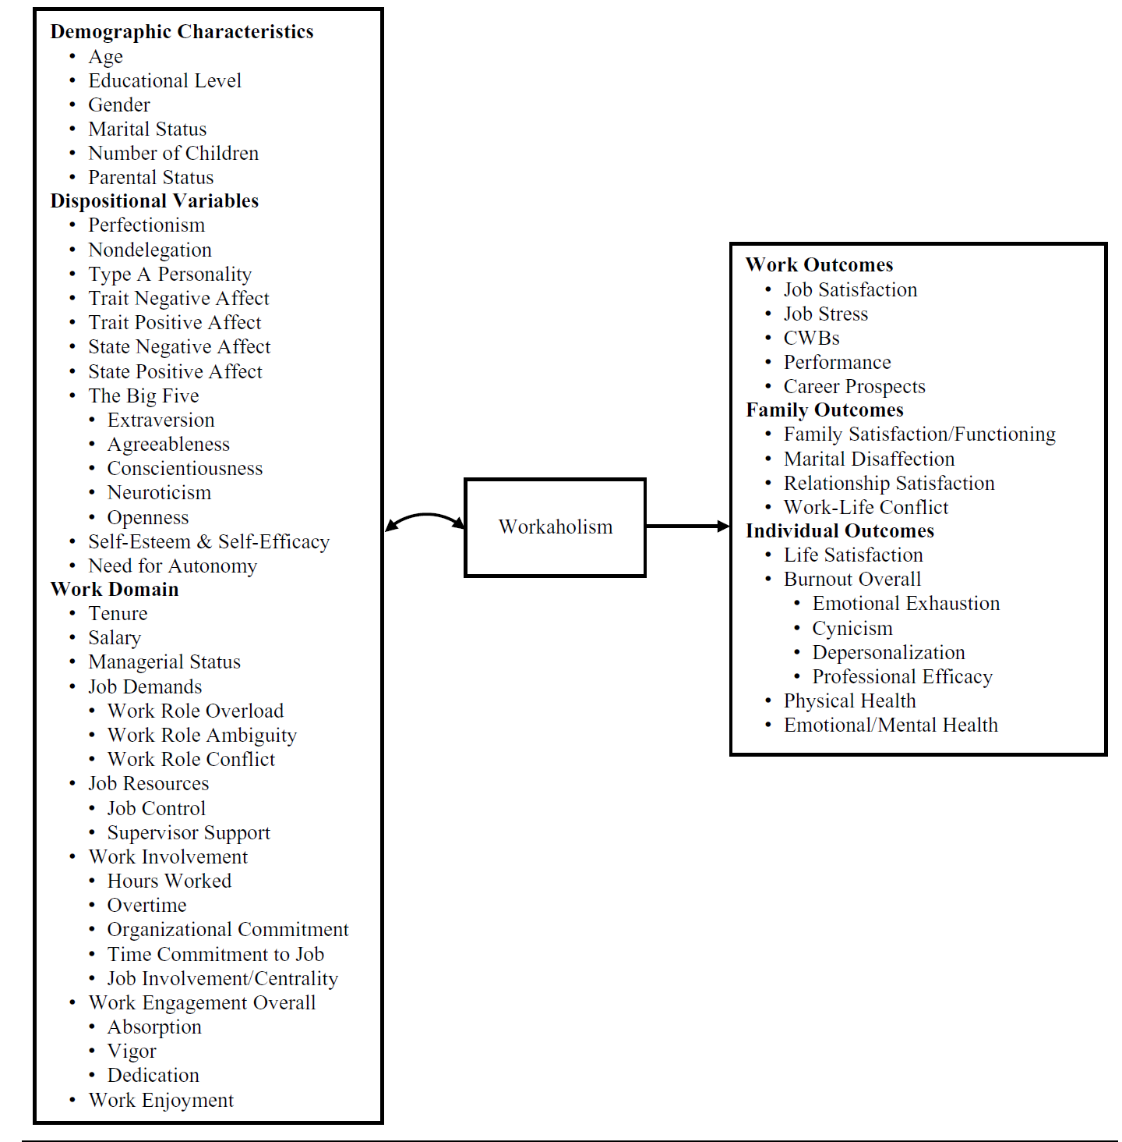

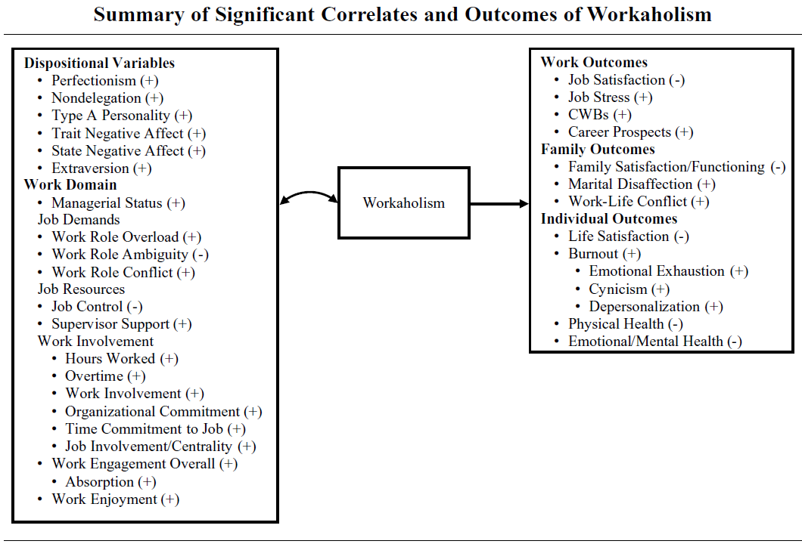

**Key Findings**

workaholism is not significantly related to work performance,

None of the demographic variables were significantly related to workaholism. Rather, achievement-oriented traits, such as perfectionism and Type A personality related to workaholism. This substantiates the idea that workaholics are driven to work not because of financial or family needs (e.g., pressure to support a spouse or children), but because of some internal compulsion to work.

It is important to note that gender was not related to workaholism, contrary to predictions based on sex role theory (Pleck, 1977) and societal norms that men are more invested in work and women are more invested in family because of traditional roles (Blair-Loy, 2003).

A positive relationship was found between extraversion and workaholism, which was surprising given that extraversion is often highly correlated with trait PA.

Workaholism had strong positive relationships with the job demands of work role overload and work role conflict, but a negative relationship with work role ambiguity.

(a) highly demanding jobs encourage individuals to engage in workaholic behavior, (b) workaholics are actually creating more work or role conflict for themselves in an effort to continue working, (c) workaholics are attracted to companies and jobs that have high job demands, or (d) workaholics may attribute their heavy work investment to various job demands due to a self-serving attribution bias.

**Criticism**

No well-established and consensually agreed measure. Common scales are: (a) the Workaholism Battery (Spence & Robbins, 1992): driven + work involvement + work enjoyment; (b) the Work Addiction Risk Test (WART; Robinson, 1989): compulsive tendencies, control, impaired communication, self-absorption, inability to delegate, and self-worth; (c) and the Dutch Workaholism Scale (DUWAS; Schaufeli, Shimazu, & Taris, 2009): working excessively + working compulsively

Some may solely use work hours to represent workaholism would be misleading and does not take into account the reasons workaholics tend to work long hours; it is possible that they are motivated by financial rewards.

**Research GAP / Future research**

the majority of variables were measured through self-reports. Obtaining objective measures of these to understand whether workaholism is actually related to increased organizational performance.

Future empirical research should also consider examining workaholism using other methodologies (e.g., experience sampling) and with longitudinal data. It is important to test the propositions put forth by Ng and colleagues (2007) that workaholism may lead to positive outcomes in the short term but negative outcomes in the long term.

Although workaholism has largely been considered a stable individual difference variable, recent studies using a momentary approach (e.g., experience sampling, day reconstruction) suggest that there is merit to studying individual variability in workaholic behavior.

# Psychological Empowerment

**Definition**

Psychological empowerment draws on self-efficacy work (Bandura, 982) and refers to a cognitive state rather than organizational intervention or dispositional trait that employees believe that they have control over their work in terms of meaning, competence, self-determination, and impact (Spreitzer, 1997).

Structural empowerment ~~builds upon job design and job characteristics research (Hackman & Oldham, 1980),~~ focuses on the transition of authority and responsibility from upper management to employees, whereby power, decision making, and formal control over resources are shared.

Structural empowerment is not necessarily an antecedent of psychological empowerment because of empowering leadership, proactive personality, supervisor-trust, lower power distance culture.

**Key components**

Meaning: fit between one’s work goals and beliefs or values

Competence: capability to skillfully perform their work activities

Self-determination: sense of autonomy or control over immediate work behaviors and processes and reflects choice in initiating and regulating action.

Impact: the work has significant influence on operating outcomes.

Two-dimensional view: delegation of authority and responsibility

**Antecedents of Individual-Level Psychological Empowerment**

Structural empowerment: delegating authority and responsibility; employee representation in strategy meeting or committee, Flexible scheduling policy, remote work autonomy policy,

Individual characteristics: positive self-evaluation traits, learning goal orientation

Work design: job characteristics theory (Hackman & Oldham, 1980), skill variety, task identity, task significance, autonomy, and feedback; information privacy,

Leadership: transformational leadership, LMX, cognitive and affective trust in supervisor

Organizational support: level of formalization and decentralization

**Outcomes of Individual-Level Psychological Empowerment**

Performance: managerial effectiveness, job performance, OCBs,

Affective reactions: job satisfaction, organizational commitment, lower strain, lower turnover intentions

**Future research of Individual-Level Psychological Empowerment**

Composite vs. separate dimensions

Three-way interaction among autonomy, competence, and impact

Psychological empowerment primarily as mediator; can it be a moderator?

**Team-Level Psychological Empowerment**

Team-level empowerment (Kirkman & Rosen, 1999): Potency (collective belief in competence), Meaningfulness, Autonomy, and Impact;

not simply because teams have control, by design, over their work (i.e., *structural empowerment*) but rather because members collectively believe that they possess authority and responsibility.

change referents in items from “I” to “the team”

**Antecedents of Team-Level Psychological Empowerment**

Team characteristics: team size (-), team member race heterogeneity (-), faultline (-),

Work design: task complexity, feedback, workload, task interdependence,

Leadership: external leader vs. team empowerment (feel threatened?); transformational leadership,

Organizational support: access to resources from other teams and departments, socio-political support

**Outcomes of Team-Level Psychological Empowerment**

Performance: team effectiveness, productivity, customer satisfaction, innovation, and decision making, team process improvement, team’s adherence to schedule and delivery targets (-)

Affective reactions: team involvement, team proactivity, team satisfaction, team commitment,

**Future research of Team-Level Psychological Empowerment**

More longitudinal research: whether the impact of psychological empowerment on performance strengthens or diminishes over time.

~~little is known regarding what factors may serve as moderators and mediator to both the links between the various antecedents and empowerment, as well as the relationship between empowerment and outcomes.~~

Is the relationship between empowerment and various outcomes mediated by team cognition, team identity, or commitment

to explore the effects of team virtuality, faultlines, task characteristics, and support derived from outside of the organization on team psychological empowerment

**Organizational-Level Psychological Empowerment**

**Antecedents of Organizational -Level Psychological Empowerment**

Structural empowerment: high involvement system, decentralization, participative leadership, transparent sharing of financial results, open information systems,

Work design: complementary work design

Leadership: empowering leadership across levels

Organizational support: alignment with the organization’s and industry’s cultures, job enrichment at the organizational level, selection for proactive, self-directed employees

**Outcomes of Organizational -Level Psychological Empowerment**

Performance: financial outcomes,

Affective reactions: positive affects

**Future research of Organizational -Level Psychological Empowerment**

how sustainable are empowerment effects over time? Or, do they grow stronger as people acclimate to the new ways of doing work and become second nature to future generations of employees?

organizational-level empowerment efforts are often comingled with other initiatives (i.e., job enrichment, involvement, and teams). It is hard to discern its unique effects.

if empowerment is part of a bundle of initiatives, is it advantageous to introduce it before or after other parts of the package?

Do skill-based selection and training need to be in place so that employees have the requisite knowledge, skills, abilities, and willingness to take on additional duties and responsibilities?

**Multilevel Empowerment**

**Antecedents of Multilevel Psychological Empowerment**

Structural empowerment: work unit empowerment climate 🡪 individual perceived psychological empowerment 🡪 job satisfaction and performance

Individual and team characteristics: team member age, gender, and employee human capital (e.g., knowledge, skills, and abilities) 🡪 individual perceived psychological empowerment

Leadership: team-level leadership climate and empowerment 🡪 individual-level LMX and performance;

Work design and organizational support: team autonomy 🡪 individual-level psychological empowerment 🡪 wellbeing; unit innovative climate 🡪 team empowerment 🡪 individual OCBs

**Future Research of Multilevel Psychological Empowerment**

little work has considered the multilevel nature of empowerment itself and whether being empowered at one level enhances, complements, neutralizes, or compensates for empowerment effects at other levels.

**Criticism**

a formative or reflective model, and distinction for two-dimensional vs. four-dimensional model (which one is better in what situations?)

Additive model (sum or average) vs. Group-referent Direct Consensus model vs. Individual-referent Direct Consensus model vs. Referent-shift consensus model vs. Dispersion model (team diversity)

Lack of knowledge about the difference and effects between operationalizing psychological empowerment as a composite and separate dimensions over time.

Mono-method issues: When predictors and criteria are collected using the same methods, observed relationships between them are subject to inflation by any common measurement or percept–percept biases.

81% of the individual-level studies and 88% of the team-level studies employed cross-sectional designs, respectively, lack of causality and how it evolves over time.

*Multilevel Measurement and Analysis Issues:* aggregated individual-focused measures do not necessarily adequately represent the parallel collective phenomenon.

Little is known about how psychological empowerment can be moderators, and what are the potential mediators of psychological empowerment on focal outcomes.

# Impression Management

**Definition**

Create, maintain, protect, or otherwise alter an image held by a target audience.

Jones and Pittman’s (1982) taxonomy of IM tactics: ingratiation, self-promotion, exemplification, supplication, and intimidation.

**Measures**

Wayne & Ferris (1990): supervisor-focused, vs. self- focused vs. job-focused IM. Commonly used but researchers only use subset of original items within each component.

Kumar & Beyerlein (1991) Measure of Ingratiatory Behavior in Organizational Settings (MIBOS): other enhancement (praise, compliments), opinion conformity, self-presentation, and favor rendering (doing favors to create obligation). But the four-factor structure is not valid and robust. Convergent and discriminant validity are not established too.

Bolino & Turnley (1999): ingratiation, self-promotion, exemplification, supplication, and intimidation. Support for psychometric properties.

Andrews & Kacmar (2001) Impression Management by Association Scale: boasting (exaggerate or emphasize their accomplishments), blurring (make performance information ambiguous), blaring (publicly broadcast information about their achievements), and burying (obscure negative performance information). Difficult to distinguish between blaring and burying.

Levashina & Campion (2007) interview-faking behaviors: slight image creation, extensive image creation, image protection, and ingratiation. Good for controlling social desirability.

**Antecedents 🡪 use, usefulness, and effectiveness of IM**

High self-monitoring (+), Machiavellianism (+), self-esteem, need for power, and job involvement (+),

perceived organizational support (-), affective commitment (-), altruism (-), emotional stability (-)

**Outcomes**

Trust (+),

hiring decision, starting salary, perceived qualification, interview performance, interviewer confidence, perceived suitability, interviewer liking, increased recruiter perceptions of PJ fit, actual job offer,

supervisor-focused IM tactics 🡪 Supervisor liking (+), perceived similarity (+), ratings of employee performance or favorable performance appraisal (+), procedural justice evaluation,

**Criticisms on the literature**

Over focus on two contexts: job interviews and performance appraisals.

Measures for particular tactics have been inconsistent.

IM tactic labels have proliferated, and the result is redundancy.

Hard to distinguish the IM from similar constructs, such as self-monitoring, political skills, and influence tactics.

Too much emphasis on ingratiation or supervisor-focused tactics and self-promotion or job-focused tactics to the exclusion of others. Other assertive tactics, such as exemplification, supplication, and intimidation have been addressed far less frequently.

Extant studies tend to emphasize actors rather than targets of IM or bystanders.

Most of the work in this area is still cross-sectional.

Overuse on self-reported IM, no objective measures.

**Organizational Impression Management**

has been defined as any action that is intentionally designed and carried out to influence an audience’s perceptions of the organization.

In a 2*2 matrix: Direct vs. Indirect; Assertive vs. Defensive

Assertive: proactive and attempt to enhance the organization’s image in some particular way.

Defensive: reactive in nature and are adopted in response to situations that threaten to damage the organization in some way.

**Five themes**

how organizations use IM tactics *defensively to restore legitimacy* in the wake of controversial or image-threatening events.

how organizations use IM tactics *assertively to increase acceptance* of controversial decisions or practices.

how organizations use a wide variety of IM tactics in an effort to *create a specific image to accomplish a specific goal*.

examined the role played by the *audience (stakeholders) and their reactions* in attempts at organizational IM.

organizations use IM in an attempt to *harm the reputation of competitors*.

**Key findings**

defensive IM could be used to draw attention away from illegitimate actions while focusing attention on more broadly accepted social goals.

acknowledgments were more effective than denials in restoring organizational legitimacy.

hospitals used assertive IM tactics preceding a change in organizational structure to increase acceptance of the change.

Illustrative IM tactics focus on things like pictures or broad generalizations in an attempt to create the desired organizational image.

demonstrative IM tactics provide facts or details regarding the organization’s specific activities.

**Criticisms**

OIM research is very scattered.

wide variety of methodologies used in the OIM studies, from theoretical essays to longitudinal case studies, making replication virtually impossible.

The actor in the OIM process is not constant, such as CEOs, public relations personnel, recruiters, written publications, and even the corporate Web site. The targets of these various IM attempts also differ. So, it is hard to study the OIM at micro level.

**Overall future research**

There are often multiple tactics discussed under one label but it is inappropriate to conclude that multiple studies that use similar terminology actually are comparable.

Similarly, a more systematic evaluation of existing scales is needed.

integrate IM research across levels to identify relationships and effects that may reside at multiple levels of analysis, including *cross-level and multi-level effects*; Compositional model (aggregated model); how individual level IM might influence group-level or organizational-level outcomes.

Developing new theories and testing existing theories of IM; given that IM is a dyadic process, theories that incorporate both the actor and the target would be especially appropriate, such as relationship communication theory

giving greater consideration to the measures and labels used in IM research; the extant labels given to IM tactics tend to *outnumber* the range and diversity of actual or distinct behaviors described.

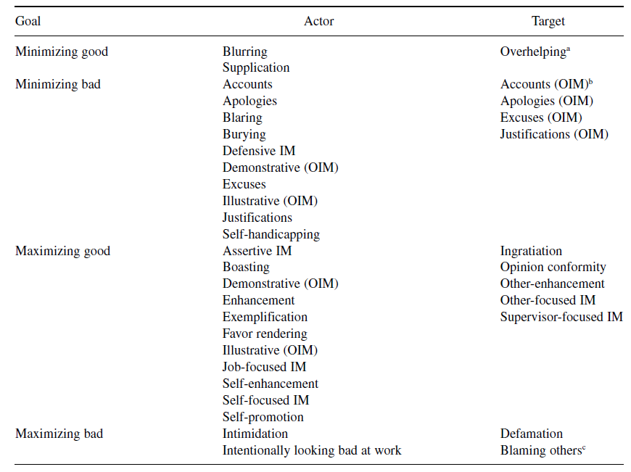

| **Category** | **Tactic** | **Core Goal** | **Typical Behaviors** |
| --- | --- | --- | --- |
| **Self-Focused IM** | **Self-Promotion** | Appear **competent** | Highlight achievements, emphasize expertise, claim credit |
|  | **Ingratiation** | Appear **likable** | Flattery, compliments, agreeing, doing favors |
|  | **Exemplification** | Appear **dedicated / moral** | Staying late, volunteering, acting like a “model employee” |
|  | **Supplication** | Appear **needy** to gain help | Emphasizing weaknesses, requesting assistance |
|  | **Intimidation** | Appear **powerful / threatening** | Dominance displays, assertiveness, subtle threats |
| **Relationship-Focused IM** | **Other-Enhancing** | Gain favor through valuing others | Complimenting, supporting others, affirming their value |
|  | **Relationship-Building** | Build alliances / networks | Networking, forming coalitions, socializing strategically |
|  | **Upward IM (Supervisor-Focused IM)** | Influence **supervisor evaluations** | Directed ingratiation, self-promotion toward boss |
|  | **Coworker IM** | Influence peer impressions | Friendliness, cooperation, helping |
| **Defensive IM** | **Excuses** | Reduce responsibility | Blaming external factors or constraints |
|  | **Justifications** | Reframe actions as appropriate | Providing rationalizations, “I had good reasons” |
|  | **Apologies** | Repair image after wrongdoing | Admitting mistakes, apologizing sincerely |
|  | **Disclaimers** | Prevent negative evaluation beforehand | “I’m not an expert but…”, “This may sound odd…” |
|  | **Self-Handicapping** | Protect reputation from future failure | Claiming obstacles, creating barriers to excuse poor performance |
| **IM in Organizational Settings** | **Job-Focused IM** | Appear good at the **job** | Emphasizing diligence, describing task competence, highlighting work quality |
|  | **Supervisor-Focused IM** | Gain favorable boss evaluation | Flattery, aligning opinions, offering help selectively |
|  | **Self-Focused IM (OB version)** | Enhance one’s personal traits | Asserting confidence, stressing reliability or responsibility |
|  | **Coworker-Focused IM** | Maintain positive peer relationships | Cooperation, informal helping, being agreeable |
| **Reputation-Oriented IM** | **Signaling** | Convey desirable attributes via **observable signals** | Credentials, certifications, consistent performance, symbolic actions |
|  | **Identity Management** | Maintain or project a valued **identity** | Acting ethical, tough, caring, humble depending on role expectations |
|  | **Branding / Professional Image Construction** | Build long-term reputation | Grooming online presence, curating professional achievements, consistent role behavior |

# Organizational Politics

**Themes**

Older organizational framework: Political skills, political behaviors, perception of organizational politics (Ferris & Treadway, 2012)

But such a categorization may limit research to unnecessarily narrow conceptualization, hindering valuable investigations that cut across these three domains and incorporation with other related domains.

New organization framework: political characteristics, political actions, political outcomes (Ferris et al., 2019). These three topics can influence each other in a parallel manner.

**Political characteristics**

individual differences related to people’s action and understanding of politics.

***(1) political skill***

Mintzberg (1983) the acumen at engaging in political behavior successfully.

~~Pfeffer (1981): political skill is the social effectiveness or style to effectively execute influence mechanisms to gain power.~~

~~McAllister et al. (2018) characterized political skills as reflecting opportunity recognition, opportunity evaluation, and opportunity capitalization to more specifically delineate the underlying dimensions of the core construct.~~

~~Thus, politically skilled individuals’ ability to recognize, evaluate, and capitalize on opportunities better than those lacking political skill, provides the~~ *~~theoretical justification~~* ~~of why political skill predicts a multitude of workplace outcomes, such as pay, promotions, and job performance.~~

Outcomes: (a) political skills 🡪 better use and effectiveness of influence tactics (ingratiation and rationality) 🡪 higher supervisor-rating job performance (stronger predicatory power than emotional intelligence, self-monitoring, and leadership self-efficacy);

(b) promotion potential, but depends on the perceived insincerity;

(c) recruiters’ political skills -> quality and quantity of recruits;

(d) leaders’ political skills 🡪 perceived organizational support, trust in leader, reduced cynicism, enhanced job satisfaction 🡪 follower’s organizational commitment;

(e) political skills 🡪 sense of control and personal security 🡪 less strain; political skills 🡪 reduced role overload 🡪 less strain;

(f) political skills 🡪 effectiveness of ingratiation and rationality 🡪 supervisor liking, perceived less manipulated by supervisor, perceived similarity

***(2) political will***

Mintzberg (1983): motivation to engage in political behavior

~~Post (2010): willingness to expend energy and resources toward some political beahvior~~

Treadway (2012): it was a multidimensional construct composed of instrumental motivation, relational motivation, concern for self, concern for others, and risk tolerance. *Political behavior is not an inherently selfish action and can be used for prosocial means.*

Kapoutsis et al. (2017) 8-item measure of Political Will Scale: self-serving + benevolence

Antecedents: (a) women managers (functional efficacy, ethicality, emotionality of engaging in political behavior); (b) need for achievement and need for power as proxy of political will

Outcomes: (a) political will x political skill level 🡪 strategies of marginalization, separation, assimilation, and integration for expatriate acculturation; (b) political will x political skill level 🡪 use of configuration of impression management tactics (passive, aggressive, positive)

***(3) expansion***

Machiavellianism, Narcissism, Proactive personality

characteristics that relate to political behavior and political outcomes, as well as the relationship between them, the field benefits from a greater understanding of organizational politics through a broader range of investigation.

political acts often are described as tactical or strategic goal-directed behavior, they are somewhat proactive in nature.

**Political Actions**

***(1) General political behavior***

Weick (1995): Individuals interact with their environment and in doing so *consolidate resources and power* within the organization to *achieve their objectives.*

Lepisto & Pratt (2012, p. 74) organizational politics represents an individual’s or group’s self-interested, goal-directed power and social influence actions, by means that are not officially sanctioned.

There is no consensual agreed measure of political behavior. No one measure has been subject to the necessary levels of rigorous testing that well-established measures normally endure.

Outcome: (a) in-role performance, engender favorable coworker and supervisor appraisals;

***(2) influence tactics***

Ingratiation and rational persuasion had the greatest impact on work outcomes.

Antecedents: Machiavellianism, self-monitoring, external locus of control

***(3) expansion***

Organizational citizenship, since it is not illicit, unsanctioned, or not officially sanctioned; craft a certain impression or create a sense of indebtedness to facilitate an exchange.

voice,

issue selling (employees try to get managers or top leaders to pay attention to and prioritize specific issues)

**Political Outcomes**

***(1) Perceived organizational politics***

As an individual’s *subjective* evaluation about the extent to which the work environment is characterized by coworkers and supervisors who demonstrate self-serving behavior.

Literature often mixes up this concept with the terminology of the broader organizational politics construct.

Antecedents: quality feedback, observing political actions,

Outcomes: decreased job satisfaction and affective organizational commitment, less work engagement, lower task performance, increased job distress, frustration, job tension, depressed mood at work, turnover intention

Moderator to POP: need for achievement (+), age (+), negative affectivity (+), rumination (+), supervisor political support (-), perceived organizational support (-), perceived resources (-)

POP as moderator: LMX x POP 🡪 reduced work effort;

***(2) Reputation***

Personal reputation as mediator between workplace behavior and outcomes

Accountability 🡪 OCBs 🡪 reputation

Job performance 🡪 reputation, only among those high in political skills: reputation is not only malleable but that it almost requires some active maintenance and care to fully manifest.

Need an overarching theoretical framework capable of placing reputation in a finite space within the constellation of factors comprising organizational politics.

Need to examine not just how political skill can aid in the development of reputation but also if and how reputation can be used to achieve desired goals

***(3) Expansion***

Social network: these are structural indications of an individual’s potential influence within an organization.

Power

**Future research**

theories on the antecedents of political skill and political will are noticeably absent from the literature.

Even the nature of what constitutes an act of influence is lacking, as is a theory that addresses more precisely *how and why individuals select influence tactics.*

The use of *multilevel modeling* will allow us to evaluate within- and between-level variance. CEO or aggregated firm-level political characteristics and actions could be measured to predict organizational-level outcomes or used within a multilevel model to examine their effect on lower-level relationships.

Political behavior lacks a widely accepted psychometrically validated *measure* that appropriately captures the more neutral aspects of the construct as well as its multiple dimensions.

to understand the *nature of politics in* *multicultural* organizations as well as the ability for individuals to adapt to potentially different political influence norms when working in new cultural contexts.

Research should consider whether and how organizational politics affects gig workers.

# Ostracism and Incivility

**Definition**

Incivility: is characterized by low-intensity social *interactions* that violate workplace norms of *respect* and yet are ambiguous as to whether they are meant to harm the target of the incivility.

Ostracism has been defined as either “the extent to which an individual perceives that he or she is ignored or excluded by others” (Ferris et al. 2008, p. 1348) or “when an individual or group omits to take actions that engage another organizational member when it is socially appropriate to do so” (Robinson et al. 2013).

**Commonality**

Low intensity, ambiguity in intention, produce negative outcomes, common in workplace

Incivility includes “silent treatment”, showing little interest in other’s opinions

Common antecedents: competitive mindset,

**Differences**

ostracism as representing the noninteractive components of incivility

no feedback worse than negative feedback: Ostracism can be more harmful as individuals prefer being argued with or berated, simply because it would acknowledge their existence and give them some sense of control over the situation; suicidal thoughts.

Ostracism predicts psychological wellbeing better than incivility (having one’s privacy invaded, being gossiped about, or minor forms of hostility).

**Measures**

Workplace incivility scale (Cortina et al., 2001)

Workplace Ostracism Scale (Ferris et al., 2008)

**Different Theories**

Need to belong: survival in evolutionary perspective; satisfaction of the need via other sources may mitigate the negative effects of ostracism. But incivility does not threaten need to belong.

Incivility spiral: incivility between perpetrators and targets can spiral up into more explicit and violent forms of mistreatment toward each other by engendering feelings of unfairness and negative emotions. But the concept of ostracism spirals has not yet been suggested or investigated.

interdependence theory: interdependence seems to play a critical role in determining both whether to engage in and how to react to ostracism; competitive goal interdependence, job mobility; but incivility literature less relies on interdependence theories.

**Themes**

Third-party reactions: perpetrators of ostracism differ from reactions to perpetrators of incivility, and secondary spirals of ostracism may be less likely to occur. Target of ostracism is untrustworthy social exchange partner. So observer may not punish the perpetrator.

Contagion effect: Observing incivility semantically primes rudeness concepts in the observer; but it is less likely to happen to ostracism. It seems unlikely that people will begin ostracizing unrelated others.

Prosocial outcomes: People experiencing ostracism will engage in prosocial behavior in an attempt to reintegrate with the group in some situations, such as high self-esteem, low job mobility, long-term orientation, etc. But none of studies has examined the effect on prosocial behaviors in incivility literature yet.

Gender-related incivility, Much of this work conceptualizes incivility as a form of modern sexism, where incivility is a socially acceptable way to discriminate against others. The ostracism literature has typically not examined the topic of gender in depth.

Ostracism has a variety of subfields, such as linguistic ostracism, cyber ostracism; but not so for incivility.

incivility instigation is an antecedents of experienced ostracism.

The incivility literature has examined and moved beyond personal characteristics of the target and has also examined how behaviors of the target [e.g., engaging in deviance (Meier & Spector 2013)] or attitudes of the perpetrator (e.g., fairness perceptions) lead to experiencing incivility.

**Future research**

Silence is golden? When is ostracism tolerated? Role-prescribed ostracism is more tolerated in collectivistic culture?

what leads individuals to choose to engage in ostracism over incivility, vice versa.

Is gender-based incivility more harmful than nongender-based incivility? Think about norm of respect and norm of equality.

Is ostracism the omission of positive attention, while incivility involves the commission of negative attention?

Both literatures overlook the role of perpetrator. Pre vs. after-math? After: to retaliate or seek justice; pre? It could be stressful for perpetrator; ambivalence, still feel bad even if the behaviors is not malicious in nature; they are putting themselves at risk of being excluded or aggressed against by others.

Ostracism and incivility or any retaliatory behaviors may not be encouraged in high power distance culture.

Happen in China, characterized as a country of high value in face and harmony. Will there be a new form of ostracism: individual may be spoken with but not taken seriously or not involved in decision making.

When ostracism is defined as “being excluded”; is it about physically exclusion or subjective feeling of being exclude? Being ignored =/= being excluded.

Past studies found extraverts and powerful individuals are more affected by ostracism than neurotic individuals or those with low power. What about incivility, as which involves the presence of negative attention, should it be most impactful for those with an avoidance temperament?

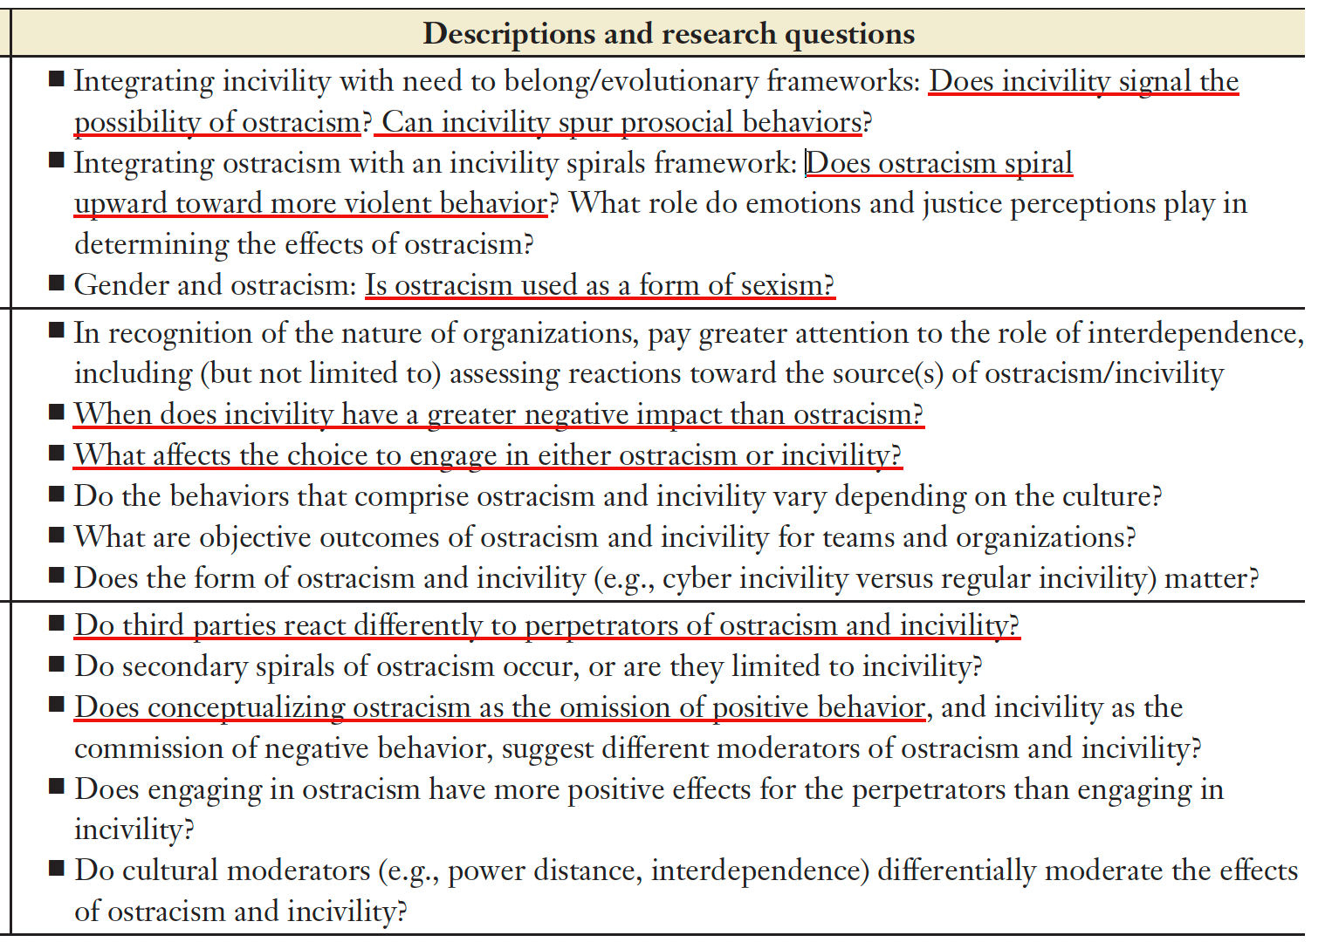

# Creativity

**Definition**

Amabile (1988): Creativity is the production of ideas, solutions, processes, or products that are both *novel* (original, unique) and *useful* (feasible, appropriate, valuable).

Shalley & Zhou (2008): operationalizes creativity in terms of novelty, fluency (no.), flexibility (different categories), and originality; by judges.

Creativity focuses on idea production, innovation includes both idea production and implementation.

Prior literature primarily focuses on actor-centered approach, e.g., stable differences in creative ability and personality.

Joint consideration: actor and context?

Woodman et al. (1993): interactionist account of creativity = stable or transient characteristics + contextual factor

An interactionist perspective inherently entails more than the joint, additive co-determination of workplace creativity through actor and context. It additionally acknowledges the complementary and countervailing effects that they have on each other. The combination of high levels of two or more positive or negative factors does not reliably yield the highest or lowest levels of creativity. In some cases, individually positive or negative actor factors cancel each other out in their effects or jointly create an effect of the reverse direction.

***Synergistic enhancing gains vs. Synergistic diminishing gains***

Synergistic diminishing gains: e.g., nonwork support provides little additional value for employees with high level creative personality; High support + high creative personality → too many ideas, low implementation, deviation.

high autonomy * high proactive employees 🡪 work overload, burnout, over-commitment

High psychological safety + highly extroverted employee → too much talking, reduced efficiency

***Antagonistic enhancing loss vs. Antagonistic diminishing loss***

Antagonistic enhancing gains: e.g., aggressive personality + aggressive and competitive climate 🡪 P-O fit

***Promotive remedial vs. Inhibitory remedial***

e.g., job dissatisfaction * coworker support 🡪 creativity

***Configural***

Neutral factors * actor/context 🡪 promote/hinder creativity

**Common Antecedents of creativity 🡪 creativity, creative process engagement**

*Specific:*

Promotion focus, creative self-efficacy, optimism and hope, openness to experience, number of weak ties,

team diversity, team member perspective taking, task interdependence, member socializing, participatory decision making,

chronic job control (+), time pressure (~), creativity-contingent rewards, creativity-supportive climate,

*General:*

Positive affect, Self-concept, supportive climate, transformational leadership, informational justice, interactional justice, prosocial motivation,

*Confusing:*

help seeking,

**Actor & Context: Complementary & Countervailing**

***High-High = Positive actor * supportive climate***

team-member exchange quality; team member diversity; supervisor support; supervisor openness to experience

Specific: cognitive team diversity * creative self-efficacy; performance prove goal orientation * supervisory support; team-member exchange quality * team-member diversity; member’s performance approach goal orientation * team learning behavior;

General

Transformational leadership * conservation value; promotion focus * leader intellectual stimulation; team identification * leader inspirational motivation; positive affect * supervisory support; positive affect * recognition and reward

Educational specialization heterogeneity * transformational leadership; team creative self-efficacy; * transformational leadership;

***Low – High = Negative actor * supportive climate***

Prevention focus, conformity value, need for closure; psychological strain, job dissatisfaction,

Low creative personality * Less supervisor monitoring * creative coworker; strain * LMX quality; negative affect * high job control;

***High – Low = Positive actor * unsupportive context***

knowledge hiding; close monitoring; team dispersion; perceived organizational politics, routinization (-),

LMX * high LMX differentiation; Conscientiousness * close monitoring / unhelpful coworker; members with high creative personality * team conformity pressure; LMX quality * low communication frequency; LMX * high team dispersion

***Low – Low = negative actor * unsupportive context***

Knowledge hiding * competitive environment; performance avoid goal orientation * hierarchical organization structure (centralization and formalization)

**Future research**

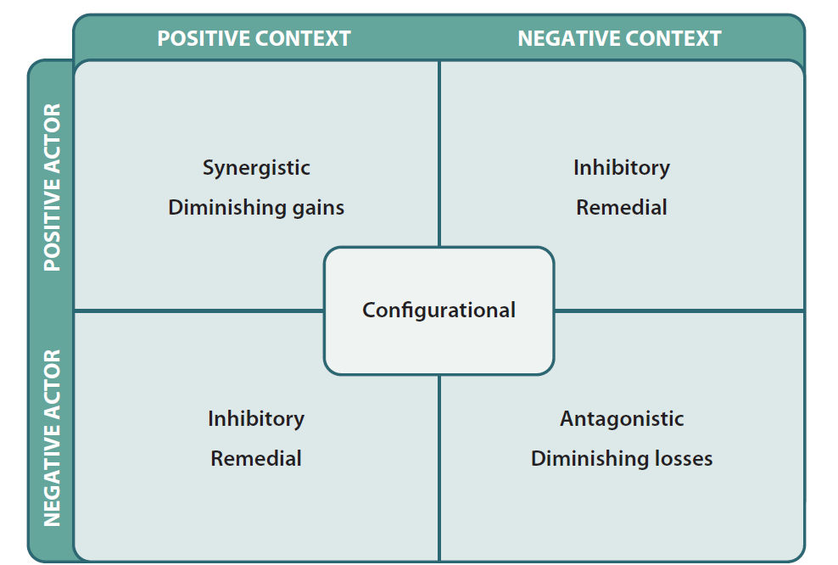

# Voice & Silence

**Definition**

Morrison (20014): as informal and discretionary communication of ideas, suggestions, concerns, problems, or opinions about work-related issues, with the intent to bring about improvement or change.

Extra-role behavior, internal and upward voice behavior

Silence: when employees withhold ideas, information about problems, or opinions on work-related issues.

Voice and silence are distinct, they reflect different underlying regulatory systems: Voice reflects the behavioral activation system (BAS), and silence reflects the behavioral inhibition system (BIS). Differences in the extent to which they are triggered will lead to differing frequencies of voice and silence, respectively.

**Key components of voice**

(1) Informal, through face-to-face direct communication instead of suggestion systems or grievance procedures.

(2) discretionary

(3) change oriented with prosocial or constructive intention, improving or addressing a problem / concern

**Other related conceptualizations of voice**

Maynes & Podsakoff (2014): Destructive voice (badmouthing, unfounded criticisms) & Defensive voice (stubbornly arguing against changes); But they are contrary the key component of the conceptualization by Morrison, that is the change oriented and constructive in intent. Other two voices are supportive voice and constructive voice.

Barry & Wilkinson (2016): in industrial relations and employment relations, voice is conceptualized as a means by which employees can express and protect their interests, such as direct channels, unions, arbitration, grievance procedures.

**Measures**

Liang et al. (2012): Promotive and Prohibitive Voice Scale

Silence:

Tangirala & Ramanujam (2008), Detert & Edmondson (2011), Knoll & van Dick (2013), and VanDyne et al. (2003).

Acquiescent silence (resignation), Quiescent or defensive silence (fear), Prosocial silence (not embarrass others);

Limitations: they are not mutually exclusive to other similar constructs which exhibit silence.

**Antecedents of voice**

Specific:

Latent opportunity to voice, have the idea to share, perceived supervisor open-minded, psychological safety, self-perceived status, cultural intelligence, voice self-efficacy, participative decision making, moral emotion of guilt stemming from unethical pro-organizational behavior,

Promotion focus (cognition) 🡪 promotive voice; Prevention focus 🡪 prohibitive voice

Approach orientation (trait) 🡪 promotive voice; Avoidance orientation 🡪 prohibitive voice

Need for affiliation 🡪 promotive voice; Contextual communication orientation 🡪 prohibitive voice

Power distance (-) 🡪 promotive voice; Superficial harmony (-) 🡪 prohibitive voice

Job autonomy (-) 🡪 promotive voice; Job security (-) 🡪 prohibitive voice

General:

Self-efficacy, proactive personality, conscientiousness, prosocial motive, prosocial emotion, extraversion, job satisfaction, felt obligation to organization, perceived organizational support, felt overqualification (-), person-organization fit, affective commitment, emotional exhaustion, distress, empowering leadership, transformational leadership, leader behaviors of directing, coaching, and supporting, leader humility, leader integrity, leader narcissism (-), LMX (inverted U), feeling respect from coworker, coworker support, hindrance stressor (-)

**Outcomes of voice**

Specific:

adoption of the voice, rejection of the voice, resource loss, give credit for voice, voice recognition, voice endorsement, leader emergence

Promotive voice 🡪 promotability; prohibitive voice 🡪 reduce promotability

Promotive voice 🡪 reduce depletion; prohibitive voice 🡪 increase depletion

Promotive voice 🡪 pride; prohibitive 🡪 anxiety

Group promotive (vs. prohibitive) voice 🡪 supervisor positive (vs. negative) appraisal 🡪 reduce (vs. increase) supervisor’s emotional exhaustion

**Future research for voice**

How can other team members help to keep seemingly rejected ideas alive to reach implementation? Voice amplification?

Can voice be a collective and dynamic process, rather than a one-time dyadic event?

Perceived quality of employees’ voice message: novelty, rationale, feasibility, organizational-focus (Brykman & Raver, 2021); incompetence as low quality voice (Ng et al., 2022).

How does voice unfold over time?

Ethical voice, speaking up ethical issues? Shifting from pro-organizational to pro-social.

how informal voice behavior, and the cognitions that drive it, is affected by the presence or absence of formal voice channels.

**Antecedents of Silence**

perceived organizational politics, leader narcissism, abusive supervision, emotional exhaustion, strain,

Low-activated negative emotion (depression, disappointment, dejection), low perceived power

**Outcomes of Silence**

Increase burnout, anger, fear, deviance, abusive supervision,

decrease creativity, job satisfaction

**Future research**

More outcomes need to be studied, how silence affects the workgroup and how, at the collective level, it impacts organizational performance.

# Job performance variation in short timeframes

**Definition**

as employee behavior that is relevant to the accomplishment of organizational goals (Campbell, 1990). It includes task performance, organizational citizenship behaviors, counterproductive work behaviors, creative behaviors, adaptive behavior, and proactive behavior.

Adaptive behaviors refer to behavioral modifications made in response to the demands of a new or changing environment, or situational demands.

Effectiveness as the results of performance.

**Evolution**

Job performance: static vs. dynamic 🡪 dynamic over not just long but also short timeframes (within-performance performance variance over short timeframes, e.g., minutes, hours, days, at most weeks)

Two components of job performance

Stability (1-year time lag) vs. temporal consistency (daily differences)

**~~Scope~~**

~~1) excluding studies of effectiveness~~

~~Effectiveness measures (e.g., task performance) are usually~~ *~~end states~~*~~, not moment-to-moment behaviors, and can be influenced by many other factors.~~

~~2) level of analysis 🡪 within-person~~

~~Between-person level conflates that level with all higher levels (e.g., the between-team level) to isolate the effects of factors (e.g., contagion effect)~~

**Importance of within-person job performance variation in short timeframes**

1) people show meaningful behavioral fluctuations in very short intervals; Individuals differ in the characteristic amount of their short-term variability.

2) short-timeframe variability helps explain why performance ratings differ from actual performance

actual performance level =/= performance rating (can be biased, peak-end rule, memory of an experiences declines sharply within hours)

**Related theories of Personality (antecedents)**

Cognitive–Affective Personality System (Mischel & Shoda 1995): People behave consistently *within certain situations*, but behavior can vary dramatically across different situations due to their *personality* through which they may interpret and process those situations differently*.*

Density distributions theory (Fleeson 2001): Traits are distributions of states that a person expresses in daily life. So, people differ not only in average levels of traits but also in how wide their distribution is (variability) and how situation-dependent their behavior is. {Narrower and higher vs. Broader and lower conscientiousness}

Personality strength theory (Dalal et al. 2015): how predictably a person’s thoughts, feelings, and behaviors reflect their trait level. People with strong personality expressions show high *coherence* between trait level and behavior, high cross-situational *consistency*, low within-person variability for behaviors linked to that trait.

**Related theories of Affect (antecedents)**

Affective event theory (Weiss & Cropanzano, 1996): Discrete *events* cause discontinuities in one’s mood cycles (e.g., a sudden increase in negative or positive affect). These discontinuities, in turn, influence employee performance. AET was intended as an organizing framework rather than as a source of precise predictions regarding structures, processes, and timeframes (Weiss & Beal 2005).

**Future research**

Emphasize individual difference variables resulting from within-person variability: What is the impact of the many possible v*ariability-related individual differences* in personality and affect (e.g., instability, inertia, spin, attractor strength, daily cycle) on job performance?

is the within-person structure of job performance the same at multiple timeframes: minutes, hours, days, weeks, months, years, and decades?

Reconceptualize the chronic and transient situations in different dimensions, the difference between situational content vs. situational strength, and the cross-level effects of situations on within-person performance variability. Compare the extent of within-person variability in performance versus effectiveness that is attributable to situational factors.

Consider job performance as an antecedent (rather than only as an outcome), the reciprocal and feedback loop effect.

Articulate the Antecedent-performance causal cycle: What are the timeframes during which an increase in the antecedent leads to the following in the performance construct: no change, an increase, an equilibrium, and a decrease back to baseline?

Understand the role of the situation in explaining short-timeframe within-person job performance variability: What are the ways in which work situations (in conjunction with personality and affect) influence momentary job performance?

Explore alternatives to self-report data: To what extent do differences reflect various explanations: for instance, same-source bias versus the appropriateness of various approaches for measuring job performance components.

Within-team performance variability research could more precisely estimate the proportion of performance variability that is located within teams, as well as to explain the factors that increase or decrease this estimate.

# Aging Workplace

**Definition**

Older workers refer to workers approaching retirement age and those who may be working a bit beyond the standard retirement age, such as late 50s in US.

Aging literature emerges because (a) people appear to be aging more slowly, and (b) working later in life is no longer unusual.

Working longer because of (a) rise in legal retirement age; (b) insufficient retirement saving or financial need.

**Topics**

(a) Wellbeing and health; (~~b) quality of life;~~ and (c) relationships among workers of different ages; (d) motivational differences; (e) age stereotypes, age meta-stereotypes; (f) age diversity climate (inclusive HR practices); ~~(g) family caregiving responsibility;~~ (h) age in team or group diversity (faultline)

**Age-related Changes**

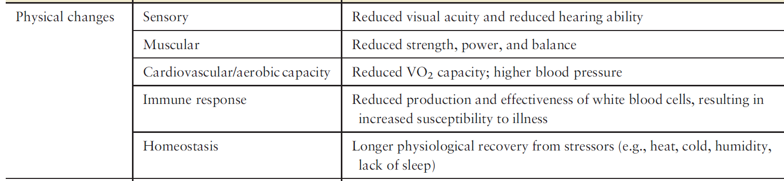

Older workers possess fewer individual resources and require more resources to adjust work demands and recover from stressful events. For example, they may perceive higher difficulty in physically adjusting to night shifts and they need more recovery time from sleep disturbances.

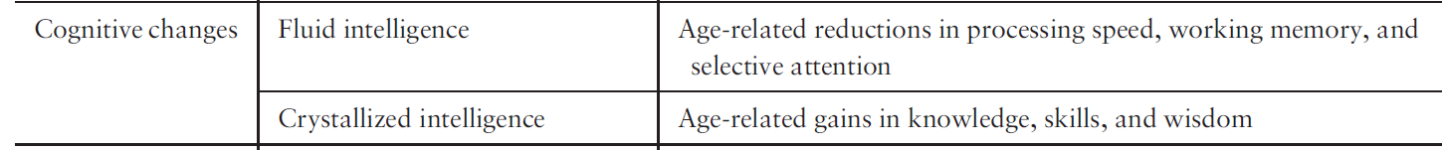

Depending on the task nature, older workers may feel more exhausted for a task that requires more fluid intelligence.

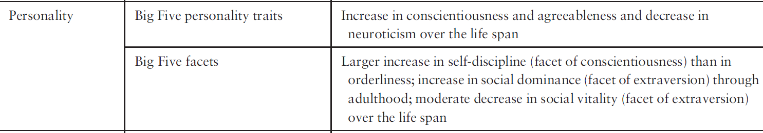

There is debate in the personality literature regarding the degree to which the changes in personality result from biological aging or from the environment.

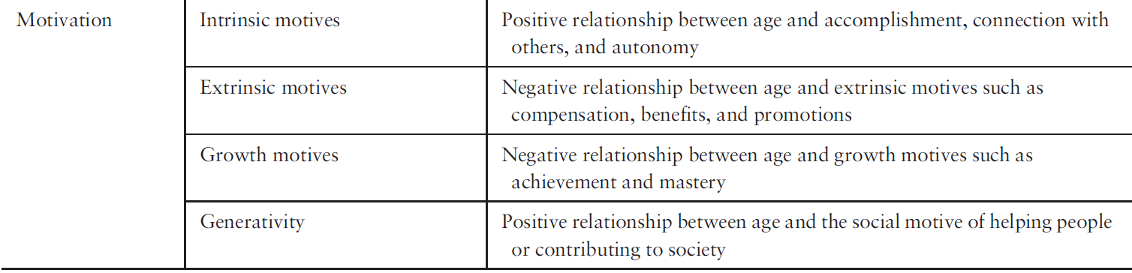

**Related theories**

*Cognitive aging theory (Salthouse, 2009):* fluid intelligence decreases but crystallized intelligence increases, when people age.

*Continuity theory (Atchley, 1989):* As people age, they strive to maintain: familiar patterns of behavior, stable self-concepts, consistent lifestyles, and established social roles. For example, older (vs. younger) IT technicians 🡪 higher resistance in gradual (vs. radical) changes 🡪 creativity

*Socioemotional selectivity theory:* an individual’s perception of time induces social goal selection and pursuit (Carstensen et al. 1999).

For older people, when they perceive time is constrained, they will (a) prioritize goals that are emotionally satisfying and meaningful and (b) therefore pursue more positive-emotion experiences but ignore or avoid negative experiences (Reed & Carstensen 2012). In contrast, younger people may be more mastery goal oriented and achievement driven, and focus more on information gathering and develop a larger scope of social connections.

Similarly, younger employees are more likely to engage in diverse types and forms of learning and absorb a variety of information and knowledge from different sources. In contrast, older workers are more likely to intentionally select and reflect on their learning content to optimize their leaning experiences.

*~~Selection, optimization, and compensation (SOC) theory~~*~~: to explain how people adapt to changes in abilities, goals, and resources across their lives—including at work (Baltes & Baltes, 1990).~~

~~Selection occurs involves narrowing or focusing efforts on specific goals because people cannot pursue everything simultaneously. (a)~~ *~~Elective selection~~*~~: choosing goals based on desires or opportunities; (b)~~ *~~Loss-based selection~~*~~: adjusting goals due to resource decline.~~

~~Optimization refers to investing time, effort, and resources to improve performance or maintain success.~~

~~Compensation involves the process of searching for and implementing strategies to offset age-related declines to maintain a certain level of performance.~~

Kanfer & Ackerman (2004) four patterns of adult development that affect work motivation: Loss, Growth, Reorganization, Exchange.

Loss refers to age-related declines in individual resources, such as fluid intelligence.

Growth describes cumulative life-span gains related to resources and experiences such as crystallized intelligence.

Reorganization is related to life-span changes in the organization and the structure of characteristics not related to ability, including affect and emotion.

Exchange describes changes in the action tendencies or the shift in the salience of particular action motives through the life span, such as changes in personality, self-concept, interests, and values.

..

Age may also influence (a) the types and frequency of work events encountered, (b) initial appraisal and response to affective work events (emotion generation), and (c) the management and coping of affective work events (emotion regulation).

Strength and vulnerability integration theory: use of strategies to avoid or limit exposure to negative events.

**Individual differences in aging**

Some older adults do not experience substantial declines in their abilities until a very old age, and there is considerable variability in trajectories of age-related change. Individuals do not have the same aging trajectories but change at a different pace and in different ways.

Successful aging =

Conceptualizations of successful aging from biomedical perspective approaches: the absence of disease or illness, descriptions in terms of longevity, lack of disability, and maintain physical, cognitive, social, and emotional functioning as they grow older.

Conceptualization of successful aging in the psychological perspective refers to individual’s adaptation, control, social competence, mastery, and cognitive efficiency to the age-related changes.

**Age Stereotypes**

General perception of older people = high on warmth but low on competence

Negative stereotypes: lower performance, lower ability to learn, less interested in training, being resistant to change, and being more costly.

Positive stereotypes: more conscientious and less neurotic, higher reliability

Younger types of jobs: physically demanding, skill-light, high intensity

Age meta-stereotypes: what do older worker think that younger colleagues think about them

**Age discrimination**

Negative outcomes: advancement, selection, overall evaluation

Age in team: faultline literature, but the effect of age is smaller than sex and race, and the effect of age may dissipate over time.

**Work-family interventions across life span**

Many policies: Unpaid leave, flexible start and end times, reduced workload, permanent part-time positions, telecommuting, compressed work weeks, job sharing, phase back from work leave, dependent childcare and eldercare assistance programs, and access to resources and services such as employee assistance programs

None has focused on the effects of these policies on older workers, especially for the psychological process that can explain what kind of interventions would benefit older workers.

For interventions, older workers should NOT be seen as a single group with the same age-related trajectories; rather, individual differences among them should be considered as well.

**Future Research**

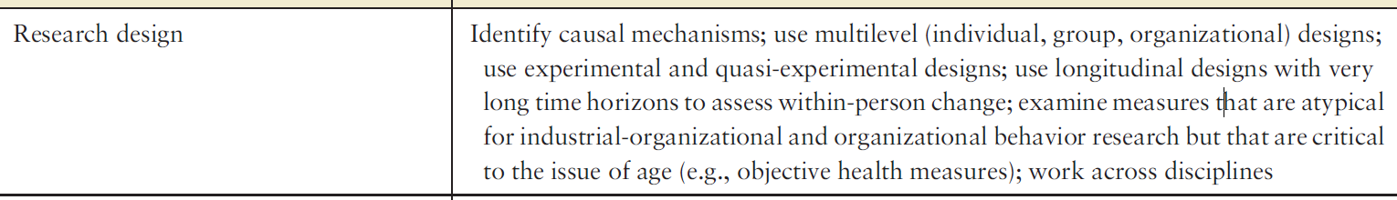

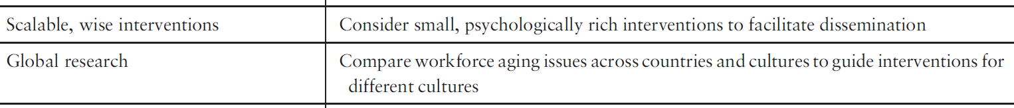









Age is not just a control variable in recent studies, but a better understanding of what chronological age is and how it affects employees attitudes and behavior is needed.



# Gender stereotypes

**Definition**

Gender stereotypes: they not only depict what women and men *are* *like* (descriptive) but also entail prescriptions about what women and men *should be* *like* (prescriptive).

Descriptive gender stereotypes bring about bias and discrimination by promoting *negative expectations* about women’s performance. Prescriptive gender stereotypes bring about bias and discrimination by eliciting penalties for *norm violation*.

Two categories: (a) Agency, a set of attributes that is most strongly associated with men, encompasses task orientation and goal achievement. (b) Communion, a set of attributes that is most strongly associated with women, encompasses kindness and concern for others.

So, stereotypes about men depict them as bold, dominant, assertive, independent, self-confident, competitive, and ambitious (agentic). Stereotypes about women depict them as sociable, relationship oriented, helpful, sensitive, nurturing, affectionate, and sympathetic (communal).

Gender stereotypes also depict men as lacking in communality and women as lacking in agency.

**Criticisms**

There is a lack of consistency regarding how agency and communion are operationalized. For example, scholars vary in using different sets of facets to measure the agency. Abele et al. (2016) separated agency into competence and assertiveness. Schaumberg and Flynn (2017) subdivided agency into self-reliance and dominance. Ma et al. (2022) created a six-factor measure: competence, ambitiousness, dominance, diligence, independence, and self-assurance. Similarly, regarding communions, Abele et al. (2016) divided it into morality attributes and community attributes. Henschel et al. (2019) separated it into three components, including concern for others, sociability, and emotional sensitivity. 🡪 lower theoretical and construct clarity & lower synthesis validity (different facets; systematic vs. random noise)

Meanwhile, while extant studies use agency and communions to operationalize gender stereotypes, they tend to focus on the positive valence and aspects of social desirability. Yet, they omit to capture the nature of negative traits that embed the gender stereotypes, such as arrogant, egotistical, and aggressive (for men), as well as passive, insecure, and compliant (for women).

**Future research**

While there are more women participating in the workforce than ever before and women have increasingly pursued traditionally male careers, societal roles for both men and women have clearly become less rigid; gender stereotypic beliefs seemingly have changed less than societal changes, or job segregation and gender stereotypes still persists. Women are still concentrated in occupations considered to be female in gender type.

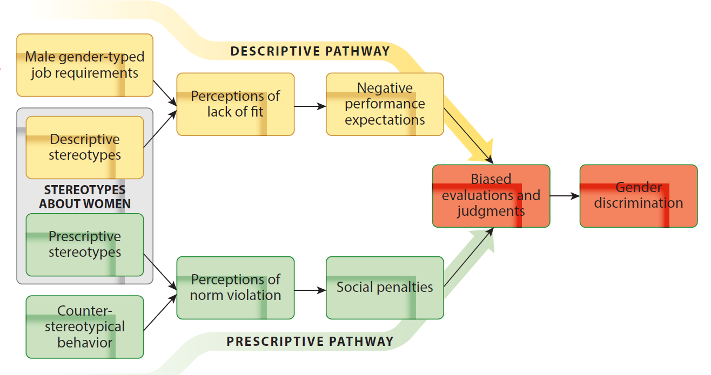

**Descriptive Gender Stereotypes**

The lack of fit model (Heilman 1983) and role congruity theory (Eagly & Karau 2002): gender bias emerges from a *perceived mismatch* between stereotypes about women and the requirements of jobs and fields considered to be male in gender type. (stereotype-based performance expectations)

Women are perceived as feminine and therefore lacking “the right stuff” that they are expected to *succeed* in male gender-typed work contexts.

XX conditions 🡪 perceived lack of fit 🡪 negative performance expectations 🡪 bias and discrimination

Conditions influencing the use of gender stereotypes:

(a) Personal qualities: motherhood status and physical attractiveness

(b) Numerical scarcity: the presence of women is rare and unusual

(c) Information about the target of evaluation is lacking 🡪 more relying on stereotype. E.g., stakeholders lack proximity or access to individualized information about the top female leader. Or the evaluation information lacks job relevance or is not diagnostic of success.

Conditions influencing whether the job or field is gendered (vs. gender-neutral):

(a) perceived work demands associated with masculine and agentic attributes

(b) numerical representation of women vs. men: Occupations that are numerically dominated by men are those in which women are evaluated more negatively.

Moderators: enabling evaluators to direct their ratings in line with their preconceptions.

(a) ambiguity in performance criteria: subjective, abstract, and vague evaluation criteria

(b) ambiguity in weighting and integrating multiple pieces of performance information

(c) source ambiguity: who is most responsible for team’s success or failure.

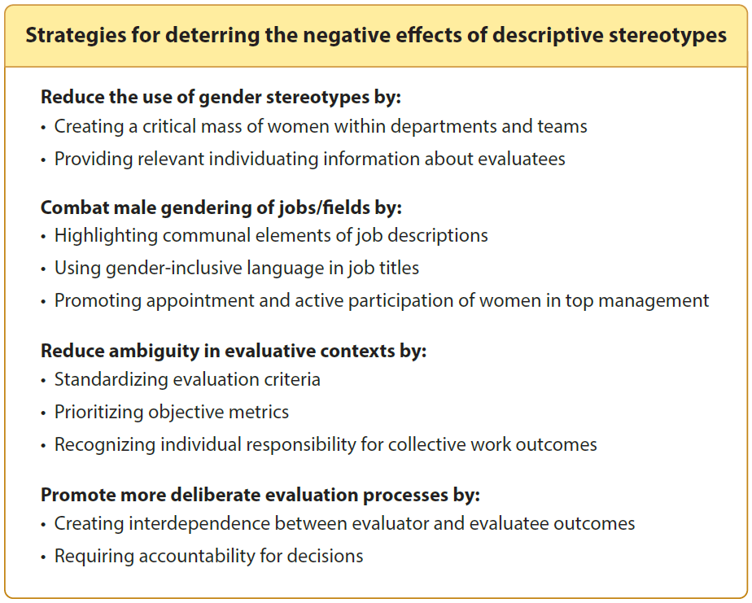

**Prescriptive Gender Stereotypes**

“Should” & “Should not”

People who violate the prescriptive stereotypes will be penalized. For example, Women are disliked and personally derogated both when they *enact their “should nots”* by engaging in stereotypically masculine behaviors (e.g., making decision, behaving independently) and when they *fail to enact their “shoulds”* by not engaging in stereotypically feminine behaviors. They will be most penalized when they engage in behaviors that represent the negative aspects of the masculine stereotype (e.g., being aggressive, arrogant, or egotistical)

“Should Nots”: behaviors that signal dominance, ambition, assertiveness, arrogance, and overly confidence, anger, pride, and being impolite or disrespecting others.

Outcomes for engaging in “should nots”: less socially appealing, perceived less hirable and promotable, lower effectiveness evaluation, receiving more severe punishment, more negative performance ratings, described as too aggressive, contempt and distain reactions from audience, viewed as more unacceptable, receiving less support,

“Shoulds”: caring and altruistic behaviors, behaviors that are compassionate, sympathetic, helpful, agreeable.

Outcomes for NOT engaging in “shoulds”: less favorable or more negative performance evaluations, less reward recommendations

Moderators mitigate the negative effect of prescriptive stereotypes:

(a) adding communality as a softener

(b) curbing internal attributions: directing attention from ambition and personal choice to unintentional or accidental matter.

**Criticisms**

There is no consistency regarding who should be the counterpart in comparison. Should the counterparts be the women who do not engaging in “should nots” or men who are allowed to engage in those “should nots”. In other words, it undermines the synthesis validity.

**Future research**

Women are not only penalized for violating the norm; but also for achieving success in traditionally male gender-typed fields and jobs. For example, even when women have unequivocal competence as the male counterparts, people may still hold negative judgment for or negative attribution to their success.

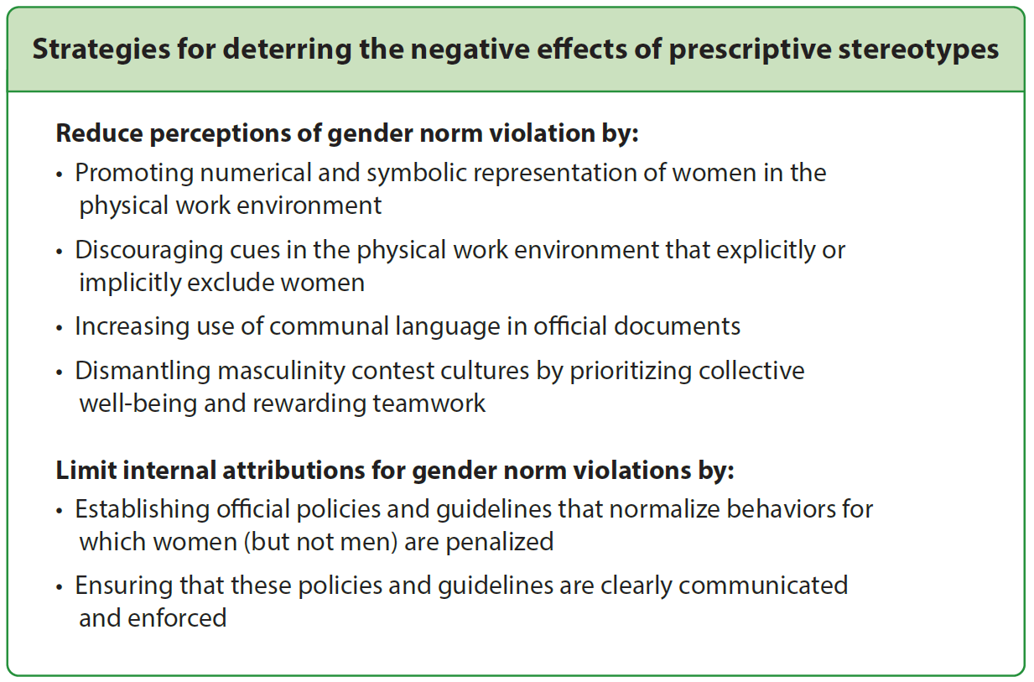

**Other factors**

Evaluator gender

Evaluator stereotypical beliefs, implicit gender stereotypes

Gender binary: people who do not adhere to the gender binary are also subject to discrimination arising from gender stereotypes.

Country’s core cultural values

# Racio-ethnic Differences through lens of justice

**Distributive justice**

Staffing decision: in hiring, White (vs. black) candidates receive more callbacks and job offers, even for Whites with criminal records. White (vs. minority) candidates receive more job referrals.

Performance evaluation: in salary negotiation, Whites (vs. minority) receive higher salary increases. In performance ratings, White (vs. Black) received lower evaluation by customers and supervisors, even controlling for objective performance.

Leader selection: White leaders remain overrepresented in management positions in US (60.1% of the population but 82.2% of leadership positions). Asian leaders were evaluated higher than White leaders when they occupied a stereotype consistent leadership role (e.g., engineering), but lower than White leaders when they occupied a stereotype-inconsistent leadership role (e.g., sales). Whites (vs. Blacks) have more promotion opportunities after controlling for social capitals.

**Procedural justice**

Organizational policies: adoption of accountability-oriented diversity management systems is positively related to increasing representation of non-White managers.

Performance management: Black employees received lower performance ratings than White employees.

Administrative inconsistency: White employees’ voices are more recognized and incorporated. lateness is more detrimental to perceived promotion material for Black than for White employees.

**Interactional justice**

Minorities reported less fair treatment, lower interpersonal justice, more abusive supervision, more bullying experiences, more incivility experiences, more perceive race/ethnicity-based discrimination and harassment, than White counterparts.

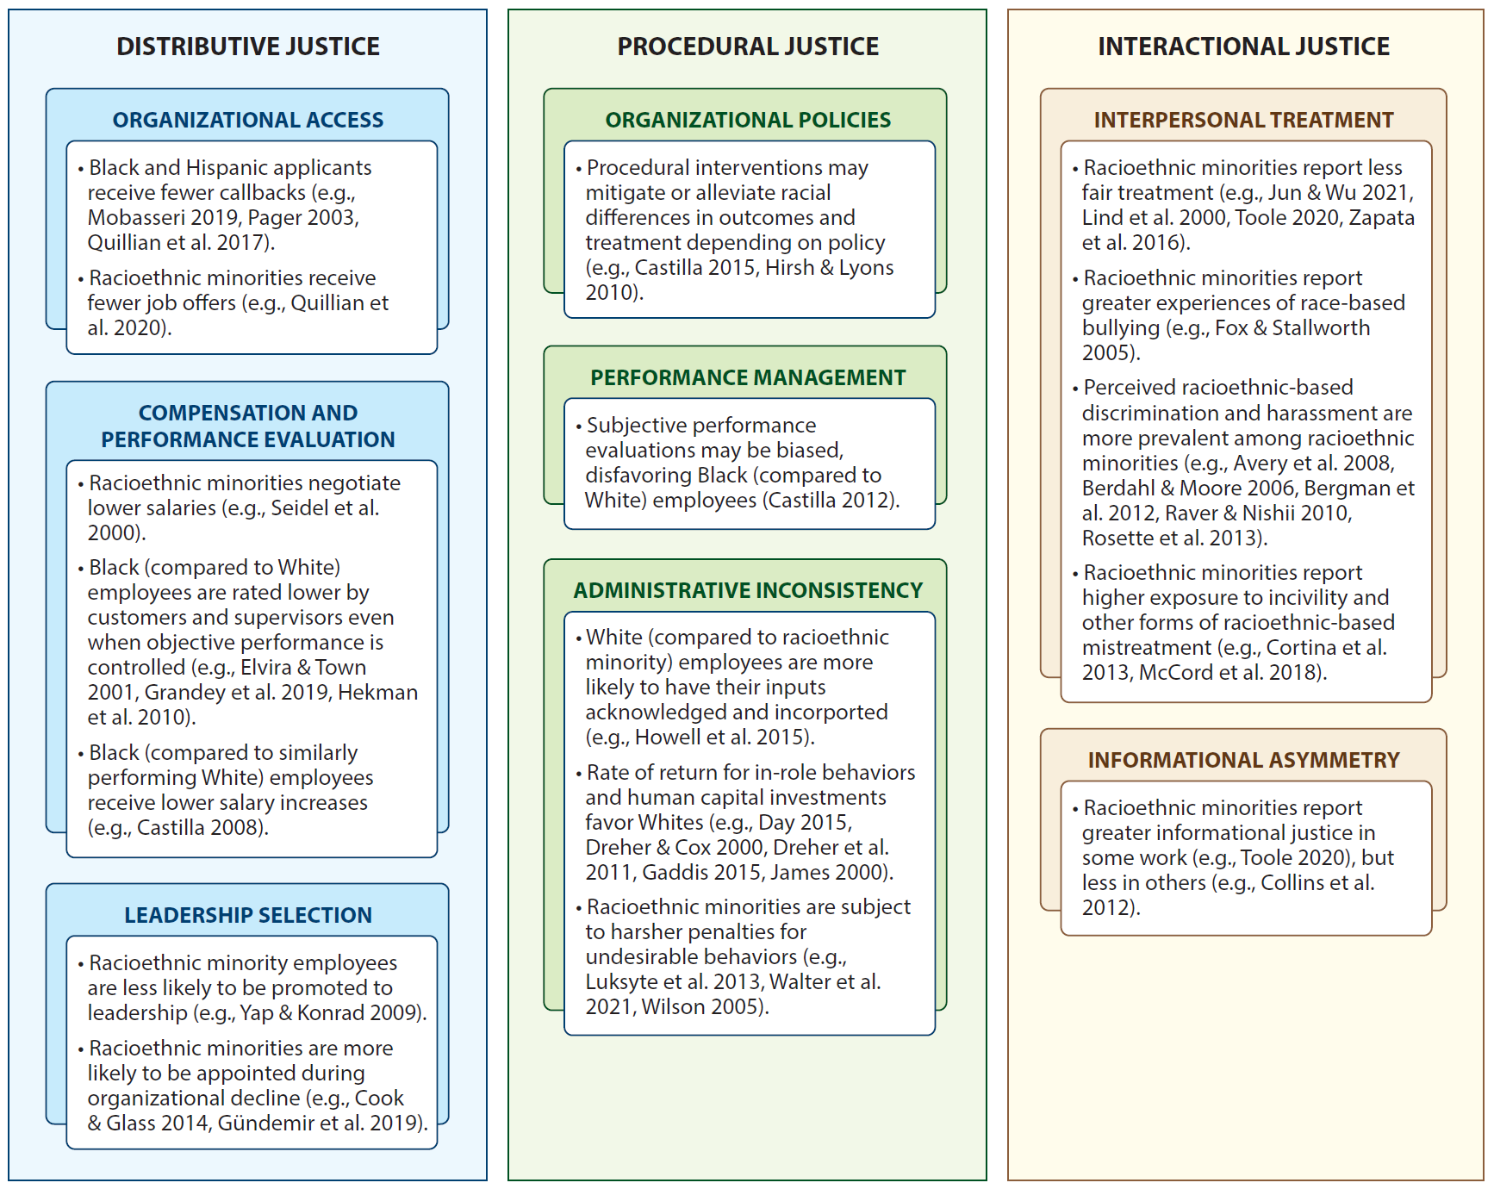

**Future research**

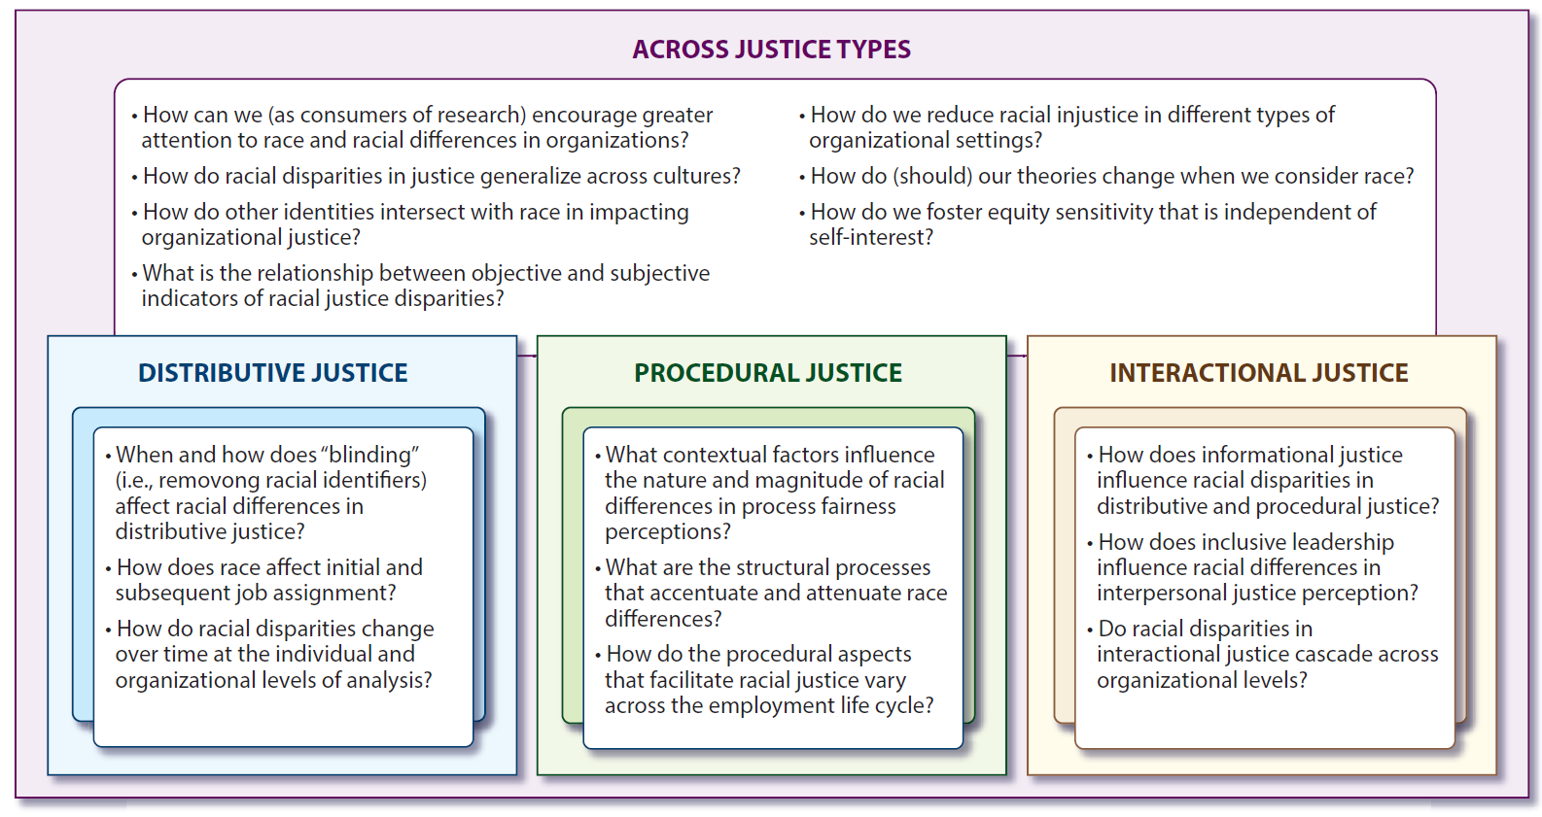

# *Discrimination

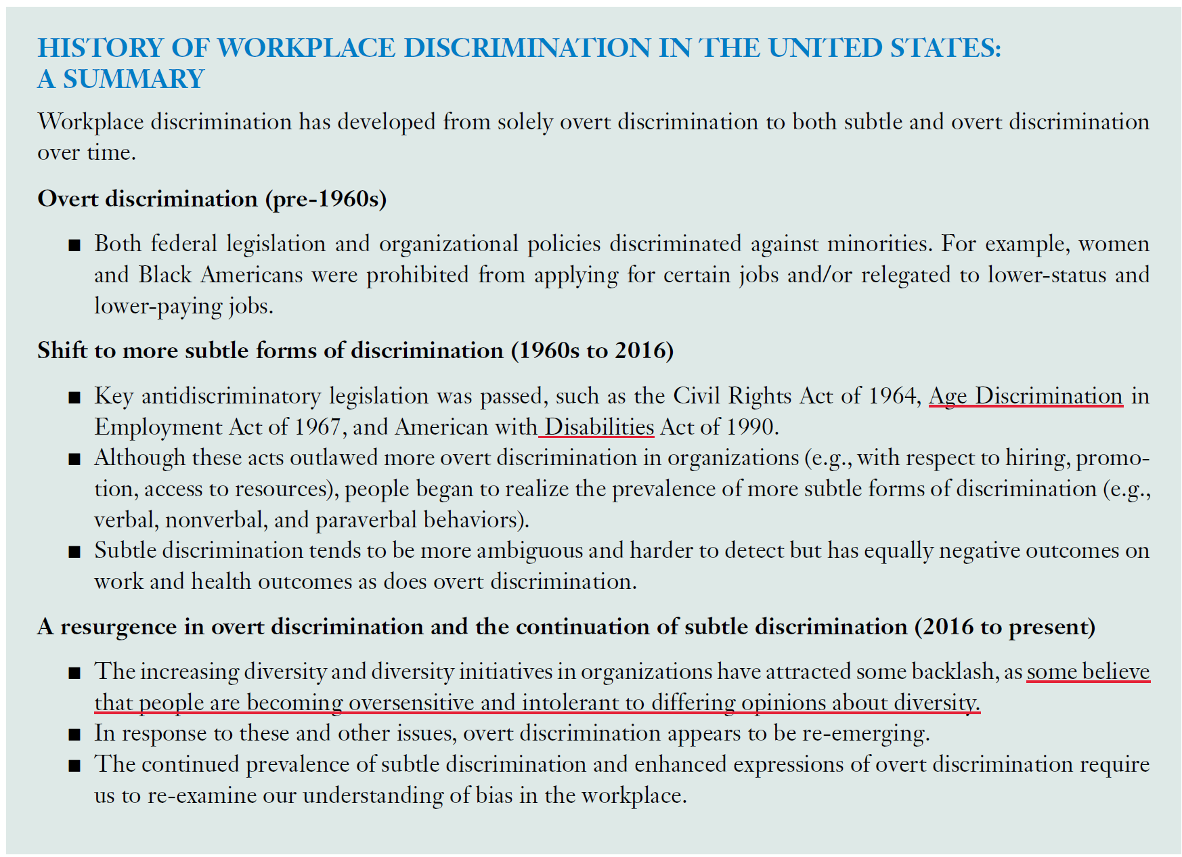

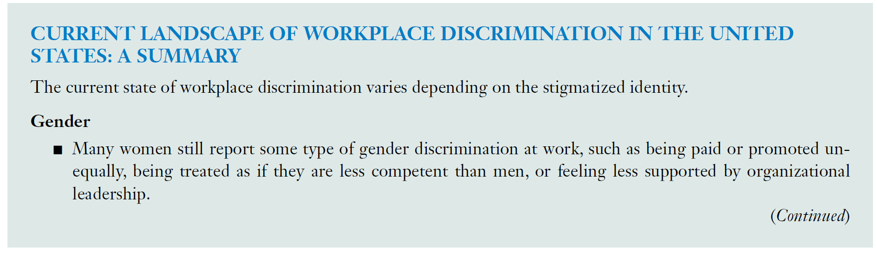

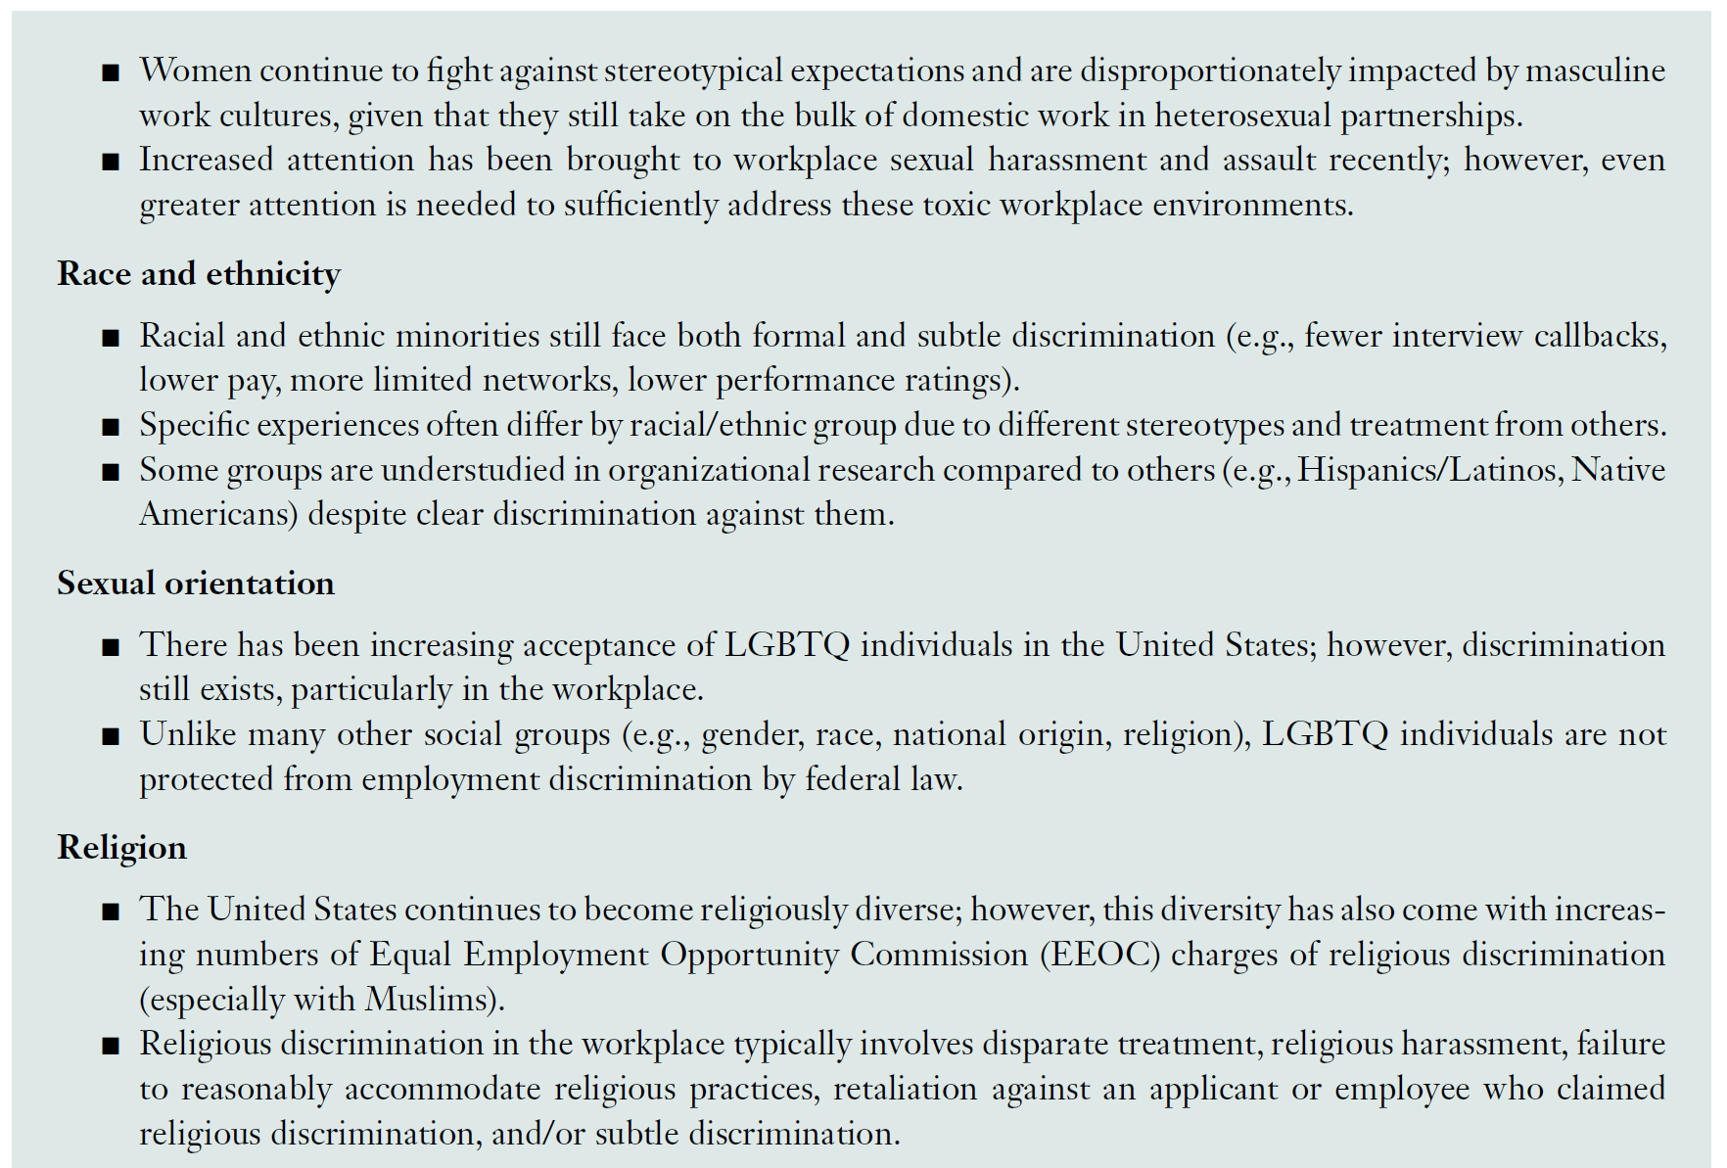

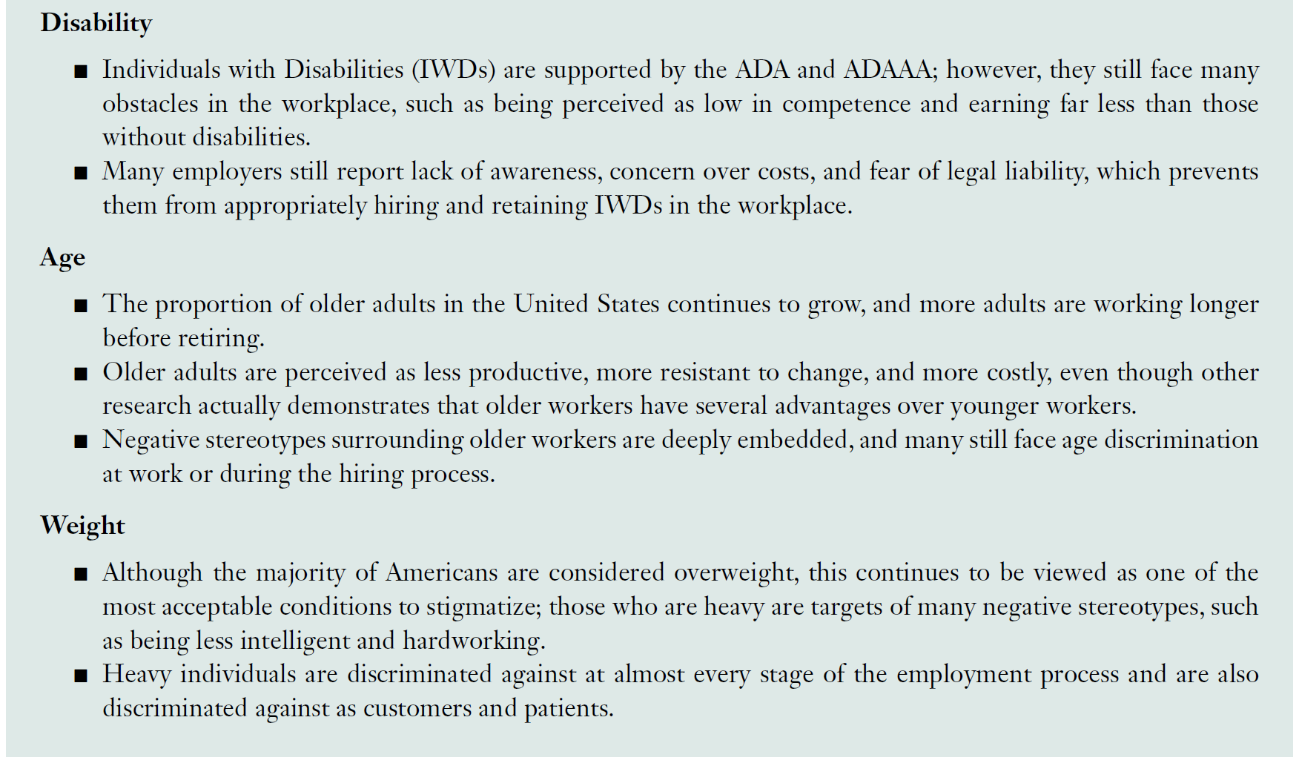

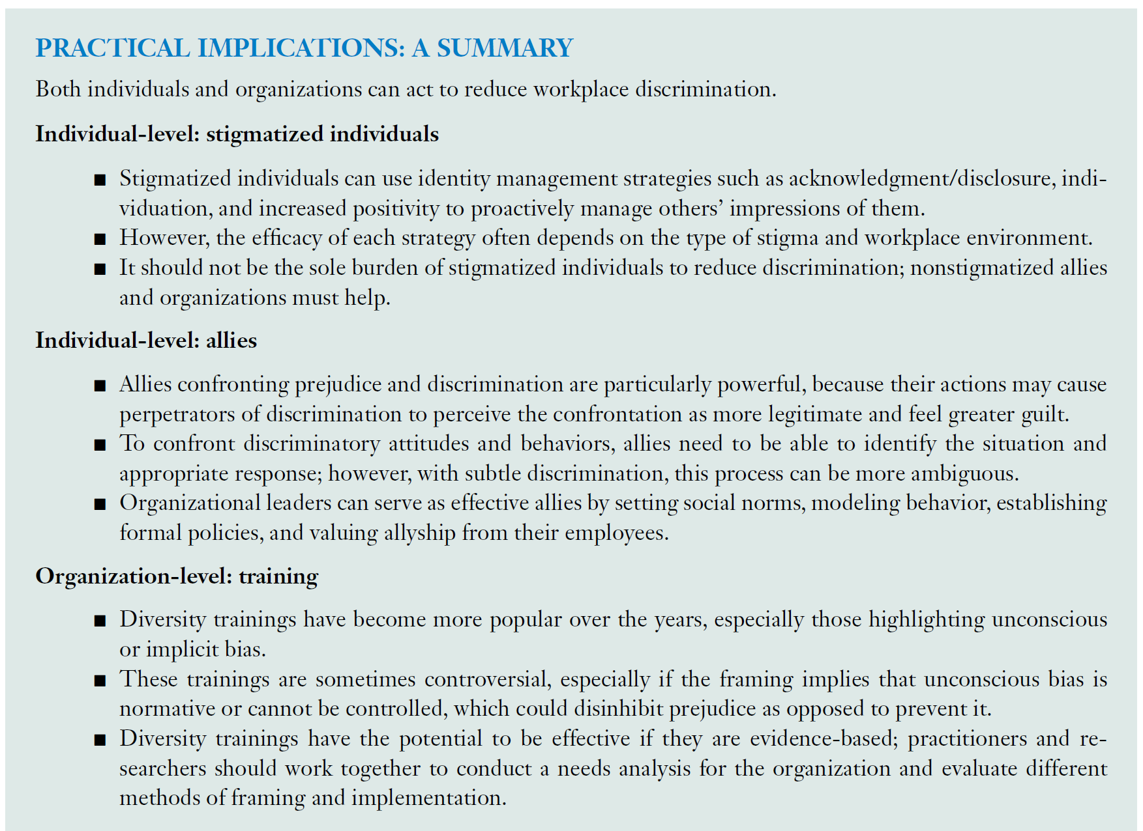

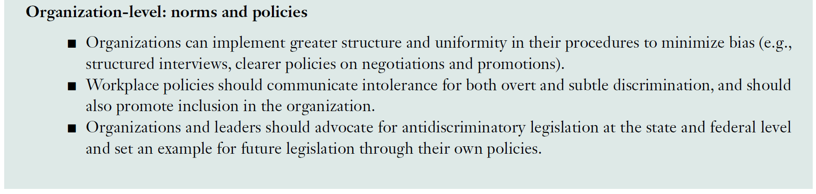

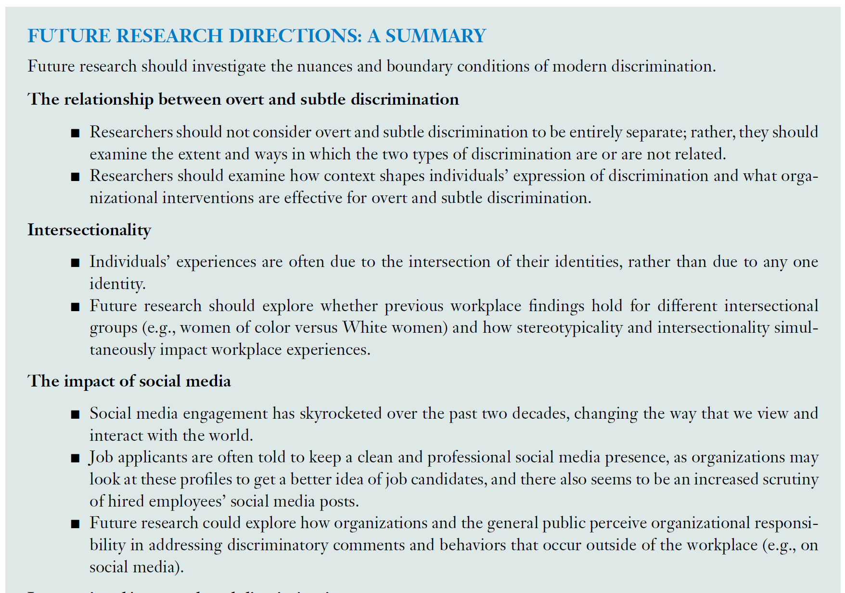  
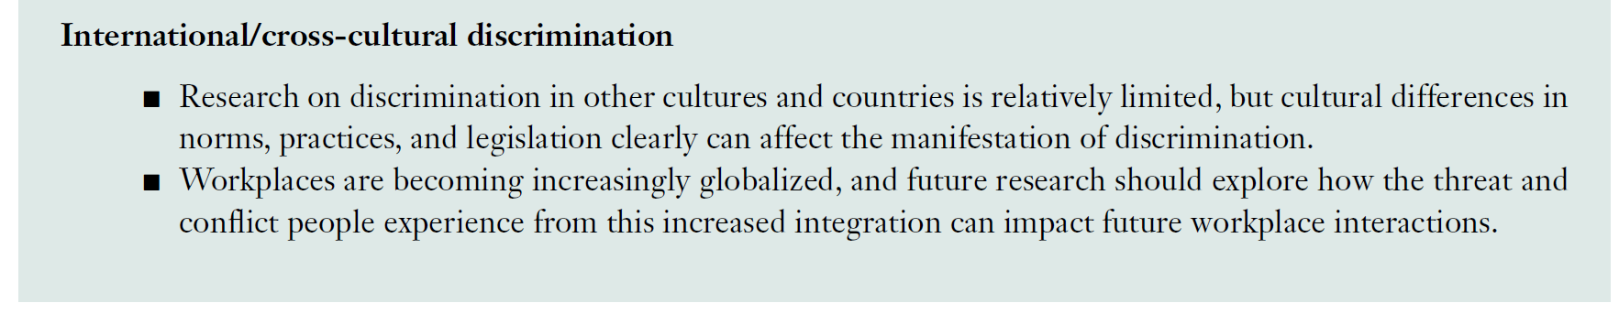

# *Individual Work-Family Boundary Dynamics

**Boundary theory**

Boundary theory focuses on the ways that people create, maintain, or change boundaries in an effort to simplify and classify the world around them. It can range from thick (separate) to thin (blending).

Ashforth et al. (2000): Macro transition (e.g., promotion) vs. Micro transition (commute from home to work) 🡪 frequency vs. permanent (recurring)

**Border theory**

Concerns the boundaries that divide the times, places, and people associated with work versus family roles.

Physical vs. Temporal (role-specific works) border

Domain members (border keeper) 🡺 what constitutes the border and where the borders between domains lie. E.g., supervisors do not permit personal calls

Strong vs. weak border

**Border/Boundary characteristics**

Domains are separated by boundaries.

Ashford et al. (2000): Permeability vs. Flexibility

Permeability (one domain intrude or interrupt another domain); “My family contacts me while I am at work”; permeability of family border, can result in more WFC.

Flexibility (spatial and temporal boundaries are pliable); “I am able to arrive and depart from work when I want”.

(a) spatial flexibility, e.g., telecommuting or flexplace

(b) temporal flexibility, e.g., flextime or scheduling

Extension:

(a) flexibility-ability refers to the perceived ability to contract or expand domain boundaries; “I am able to arrive and depart from work when I want in order to meet my family and my personal life responsibilities”; work flexibility-ability 🡪 less WFC; family flexibility-ability 🡪 less FWC

(b) flexibility-willingness refers to the motivation to engage in movement between domains; “I am willing to change plans with my family so I can finish a job assignment”; work flexibility-willingness 🡪 less WFC

Symmetrical vs. Asymmetrical permeability: direction and prevalence of movements, e.g., WFC more prevalent than FWC

Clark (2000): Blending vs. Strength

Highly Flexible & permeable 🡪 blending

Strong border 🡪 inflexible & impermeable

Moderators for permeability and flexibility 🡪 WF conflict:

(a) similarity of the work and family domains; (b) degree that an individual thinks, acts, and presents him/herself in a similar way in each domain; (c) common features that the role identities between domains share

Spillover effect:

work-to-family enhancement (e.g., skill transfer, positive mood spillover, income as resource, confidence spillover) 🡪 work flexibility-ability and family flexibility-willingness

**Work-family conflict**

Inter-role conflict occurs when role pressures associated with membership in one group conflict with role pressures associated with membership in other groups (Kahn et al. 1964).

Greenhaus & Beutell (1985) define work–family conflict as a specific form of inter-role conflict in which work and family roles are mutually discordant in some respect.

Work-to-family conflict denotes conflict originating from the work role that interferes with the family role.

Family-to-work conflict denotes conflict originating from the family role that interferes with the work role.

**Integration vs. Segmentation**

Refers to an individual difference that captures the extent to which one favors keeping work and family roles merge or separate from one another.

Segmentation (inflexible and impermeable role boundaries); segmentors; “I prefer to not talk about my family issues with colleagues”

Integration (flexible and permeable role boundaries); integrators; “I take care of personal needs at work during my lunch hour”.

Continuum from full segmentation (no conceptual, physical, or temporal overlap) to full integration.

Outcomes:

(a) Creation and maintenance of role boundaries; i.e., How clearly roles are separated or blended; e.g., role blurring

(b) role interruptions and transitions; i.e., Events where roles intrude or require switching

(c) psychological work-family conflict (time- vs. strain- vs. behavior-based conflict); i.e., Negative outcomes from incompatible demands; e.g., psychological detachment, work-family balance

Measures

(a) actual behaviors (“I keep work life at work”)

(b) subjective preferences; work–family role integration–blurring scale (Kossek et al., 2006)

**DV: Role Blurring**

as uncertainty or difficulty in distinguishing one’s work role from one’s family role.

Measure: Work-Family Integration-Blurring Scale (Desrochers et al., 2005)

Positively related to role blending.

**DV: Interruption**

Measure: (a) number or type of interruptions, e.g., distracted by thoughts, respond personal calls during work; (b) reactions to interruptions, e.g., feeling upset or annoyed when interrupted by xx.

**DV: Psychological detachment**

Preference for segmentation 🡪 detachment from work

Preference for integration 🡪 difficulty for spouse’s detachment from work

**Related Constructs: work and family role transitions**

Transition styles: anticipatory, discrete, and lagged

Anticipatory: concerned with the domain of destination *prior* to physically leaving the current domain

Discrete: concern with the domain of destination *starts upon arrival* there.

Lagged: concern with the newly entered domain does not begin until the individual has been present in the new domain for a period of time.

workaholics use anticipatory style when moving from home to work; and use lagged style when moving from work to home.

**Future research for Boundary Management**

Role blurring is redundant with integration enactment or inter-role interruption.

Measures of interruptions should also separate experience from reaction to the experience, e.g., personal calls vs. internally generated interruptions (distraction, preoccupation).

Flexibility-willingness construct overlaps with integration/segmentation preferences.

Parse flexibility-availability (interpretation of the environment) and boundary control (self-efficacy).

**Boundary management Tactics**

Kreiner et al. (2009): behavioral vs. temporal vs. physical vs. communication tactics

Behavioral tactics: e.g., using technologies, getting help from others.

Temporal tactics: e.g., blocking off segments of work time, finding respite

Physical tactics: e.g., reducing physical distance between work and home

Communication tactics: e.g., telling violators about your boundaries

**Boundary management Styles**

Kossek & Lautsch (2008): integrators vs. separators vs. volleyer (with boundary control)

Bulger et al. (2007): boundary management profiles to measure boundary strength (flexibility and permeability).

**Future research for boundary management tactics/styles**

Develop measure that more precisely capture and distinguish the physical, behavioral, and psychological aspects of segmentation and integration.

**Overall Future Research**

More event-based ESM that record transition moments or the dynamic nature of boundary management.

Self-regulation perspective involved in boundary management.

integration/segmentation could be considered a value at the cultural level, e.g., the spatial flexibility across countries: Canada vs. HK about the average number of living rooms per person in the home.

# Work-Life Balance

Examining the effects of work and life roles they have on each other as either depleting or enriching in shaping work-life balance.

Main research streams are: (a) spillover effect, highlighting the process that shapes work-life balance; and (b) global approach, such that work-life balance is a perception-level construct, and how it relates to role outcomes, e.g., turnover, satisfaction, and performance.

**Depletion perspective**

Stemming from role strain theory, the depletion perspective suggests that role resources and energy are limited (Goode 1960), such that these finite resources will be consumed and exhausted as people engage in role-related activities (Marks 1977). Thus, resources devoted to one role reduce the resources available for another role.

Assumption: the time and energy consumed in one role is important for effective functioning in another role.

Negative outcomes: worse wellbeing, lower engagement, and lower performance, more work-family conflict and tensions

**Enrichment perspective**

The enrichment perspective, rooted in role accumulation theory (Marks 1977), suggests that resources are expandable and the relationship between work and nonwork domains can be synergistic.

Dilemma: when there is work accomplishment, people flourish at home; when they are exhausted in work, they feel less able to recovery at home.

High-quality role experiences enhance affective, cognitive, and material resources such that they can later be directed toward other life roles.

Positive outcomes: wellbeing and quality of life, improved health, satisfaction, and performance

**Controversy / Debate**

No consensus about what “work-life balance” mean. A long-term perception, a state, a relationship?

The effect of work-life balance and life outcomes are also highly subject to how this construct is measured.

**Work-Life Balance & Time**

Variation of the enrichment and depletion process over time

How, when, and for how long the process is related to how, when, and for how long work-life balance.

Peak-End theory (Redelmeier & Kahneman, 1996): people’s long-term evaluation of work-life balance, influenced by most recent role experiences

Delayed Gratification (Mischel, 1974): putting off current enjoyment and making temporary sacrifices, which may be experienced as depleting in the near term, can be enriching in the long term, yielding future rewards. For long-term enrichment, temporary depletion is necessary and tolerable.

**Different configurations shape work-life balance**

Combining the spillover approach and the processes that shape work-life balance

We define work-life balance as the individual overall appraisal of the extent to which work and life roles and experiences are largely compatible, with minimal or temporary incompatibility.

(a) Presence of depletion and Absence of enrichment 🡪 Minimal Balance

as long as the last minute is without depletion.

(b) Absences of depletion and enrichment 🡪 No balance

Full segmentation, no spill over effect

(c) Presences of depletion and enrichment 🡪 Balance

Enrichment effect offset the negative effect of depletion

(d) Absence of depletion and Presence of Enrichment 🡪 Balance / Flourishing

Not creating strain and resources loss

Flourishing: having positive emotion, high levels of engagement, satisfactory relationships, and experiencing meaning (purpose in life) and accomplishment (Seligman 2012). This is predicted by emotional wellbeing (positive affect and satisfaction) and positive role functioning (personal growth, purpose in life).

Yet, a momentary experience of enrichment without depletion may not be sufficient to overcome the cumulative effects of depletion on the perception of work-life balance.

**Individual difference in process (facilitating enrichment and preventing depletion)**

(a) Work-life ideologies (Leslie et al., 2019):

view role demands and resources 🡪 “fixed-pie” ideology or “expandable-pie” ideology

Problems of work-life ideologies: polarized ideology may promote confirmation bias; fail to recognize the roles can be synergistic or draining on one another.

(b) Segmentation and Integration boundary management strategies

Preferences and ideologies

Segmentation 🡪 reduce both depletion and enrichment

(h) socio-economic status and males: have less household and caretaking, more financial remuneration

(i) organizational policies and practices, e.g., family supportive management practice

(c) intrinsic and extrinsic motivations

Intrinsic motivation makes role experiences less depleting

Extrinsic motivation may compensate for depletion

(d) family motivation:

desire to provide vital resources for family members

feel more enriched when their family value their work accomplishment

(e) caregiving ambition

Experience enrichment when their family and work roles allow them to fulfil their desire to care for others.

(f) job characteristics, e.g., job flexibility

(g) boundary control

**Future research**

Future research should develop appropriate scales that can capture daily or momentary within-person fluctuations, as well as dynamism in the enrichment and depletion phenomenon.

Future research should also undertake longitudinal studies that capture fluctuations in individual differences (e.g., work-life ideologies) that may occur during different life stages.

Cultural norms underlying what constitutes work-life balance may change across one’s life.

Future research should examine how people can create more mental boundaries where physical boundaries no longer exist.

Scholars should specify whether they take a global or a combined spillover approach in conceptualizing work-life balance and measure it accordingly. For instance, global approach 🡪 measure holistic experience of balance; spillover approach 🡪 capture the underlying enrichment and depletion

# Alternative Work Arrangements

“Gig work” is a type of contract work wherein the link to the client tends to be very short—minutes, hours, or days.

**Forces that fuel the growth of alternative work arrangement**

Firms’ increasing interests in hiring part-time or contract workers because of lower training cost, renumeration, benefit costs,

Technology empowers virtual collaboration, and remote monitoring when employees are not co-located.

People are keen to self-employed, more work flexibility and freedom

**Flexibility in the employment relationship**

(a) Direct employment beyond the standard employment relationship

Beyond Full-time regular employees: part-time workers, on-call workers, and seasonal employees

(b) co-employment/agency worker

(c) contract workers, freelancers

Less need for employment security

**Flexibility in the scheduling of work**

Less absenteeism, less work-family conflict,

**Flexibility in the location of where work is accomplished**

Increase feelings of autonomy, reduce stress, less work-family conflict, firms save real estate costs with smaller office footprint

But may increase felt loneliness, less work engagement, reduce knowledge sharing,

**Future research**

More studies on on-call, seasonal, and gig workers, especially for their psychological motivation and work experiences

What are the consequences of surveillance usage to monitor workers? What are the conditions under which workers interpret monitoring technology as good or bad?

How do the dynamics of virtual work change when peripheral employees become the core, or when everyone works remotely?

experience of high-end workers with specialized knowledge in demand by firms who compete for their talent VS. low-skilled workers who have more difficulty earning a living wage with job security.

How can employers effectively meet changing demands while also enabling workers to manage their schedules to increase feelings of control for part-time workers?

How does virtual work influence socialization and the maintenance of organizational culture?

How can flexicurity become a reality? How can workers create more feelings of income security even when they lack employment security?

What kind of corporate investments and public policy changes are needed to prepare workers for good jobs?

# I-deals

**Definition**

I-deals are “voluntary, personalized agreements of a nonstandard employment arrangements negotiated between individual employees and their employers regarding terms that benefit *each* party” (Rousseau et al., 2006, p. 978).

**Four key elements**

(a) bargain for personalized agreements individually (not standardized; one-on-one negotiation)

(b) result in within-group differences due to different needs, preferences and abilities

(c) mutually beneficial to both employees and employers

(d) differences exist in the scope of i-deals

**Related constructs**

(1) Job crafting

Commonality: Reflect employees’ predisposition toward proactivity and personal initiative.

Differences: (a) job crafting consists of cognitive changes by which employees redefine their jobs at work and the meaning of the work. Yet, I-deals consist of objective changes to the employment arrangements only. (b) job crafting is an autonomy while not formally legitimate initiative. Employees may be sanctioned if their employer does not permit or encourage some changes. However, I-deals are the production of negotiation.

(2) Negotiation

Negotiation is part of the process that results in I-deals.

(3) Psychological contract

Commonality: both are linked to social exchange theory.

Difference: psychological contract is a subjective perception of what the employer has promised explicitly or implicitly in the employment relationship. Yet, I-deals are objective terms of work arrangements.

Future I-deals (Ng & Feldman, 2010): Future i-deals are promises made by an employer to an employee regarding idiosyncratic employment conditions that will occur at a later date.

**Forms of I-deals**

(1) Timing

I-deals can be negotiated either during the recruitment process (ex-ante i-deals) or on the job (ex-post i-deals).

(2) Content

Rousseau & Kim (2006): flexibility, developmental, workload-reduction, and task (create or alter job’s content).

Rosen et al. (2013): schedule flexibility, task, location flexibility, and financial incentives.

**Key theories for the mechanisms**

(1) social exchange theory

Employees with i-deals are apt to feel obligated to reciprocate through positive work attitudes and behaviors that ultimately benefit the employer.

Operationalized: i-deals 🡪 organizational trust / perceived organizational support 🡪 voice

Flexibility i-deals 🡪 no change in motivation 🡪 work effort;

developmental i-deals 🡪 intrinsic motivation 🡪 work effort

(2) job characteristics theory

skill variety, task identity, task significance, autonomy, and feedback

i-deals 🡪 autonomy 🡪 job satisfaction, engagement

**Other related theories**

(1) social comparison theory

For the motives: self-enhancement (downward) vs. self-improvement (upward) vs. self-evaluation

how employee evaluate their own i-deals;

(2) justice theory

How coworkers react to others’ i-deals;

**Measurement**

Capture the extent to which employees have *successfully* negotiated special work arrangements with their employers, with their content or facets representing dimensions of i-deals.

(1) Rousseau & Kim (2006): scale to measure timing and content of i-deals, capturing flexibility, career developmental opportunities, work tasks, and workload-reduction.

Criticism of Rousseau & Kim scale:

(a) only asked for successful negotiation, cannot capture the difference between employees who do not ask for special arrangement and employees who fail in negotiation. It is important to add response options such as “not asked” and “not applicable”.

(b) do not differentiate “asking for special arrangement” and “asking for special arrangement that is ‘different from peers’”.

(c) do not test whether i-deals are mutually beneficial to both parties.

(2) Rosen et al. (2013): 16-item scale

Addressing the content validity and criterion validity issues in the scale of Rousseau et al. (2006)

Criticisms to Rosen et al. scale

(a) convergent and discriminant validity has not yet supported.

(b) only few items specifically capture the “negotiation” of specifical arrangement

(c) some items capture the arrangement itself while some capture the basis for “why the manager grants”. They should not be mixed. Basis can be merit-based or favoritism.

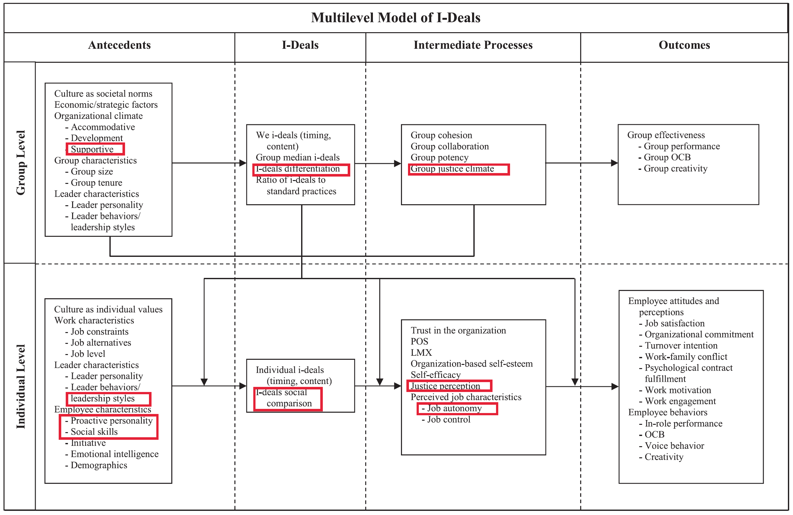

**Future research**

Amplification and Contagion effect: It is possible that the coworkers may be the beneficiaries of other’s i-deals. Thus, while the i-deals negotiation only involves the focal employees and employers, the success of such a negotiation may be partly attributed to the support of coworkers.

Any costs and risks for failure in i-deals negotiation?

Existing scales examined i-deals from the employee’s point of view, more research on supervisor’s perspective is needed. It is possible that supervisor has granted an employee for a special arrangement, but the employees are not aware of that.

Existing studies have not yet examined the importance and effect of who initiate the negotiation. This may implicitly assume that the i-deals are comparable in their effects. (a) we can study who benefit more. Is initiator getting more benefits? Yet, it is possible that the initiators can benefit more because they may possess more control over the content, more motivated. (b) we can study, for specific outcome, is employee initiating vs. employer initiating generating more advantages or lasting for longer time.

Longitudinal: whether the effect of i-deals diminishes or accumulates over time? Is it a general pattern that individuals have similar needs and preferences for some special arrangements when they age? Regarding the individual difference in the beliefs and attitudes for the i-deals (such as flexibility), how does it vary across employees’ life span? Will there be seasonal needs for special arrangement?

Extant discussion focuses on the ex-post i-deals; more research on ex-ante i-deals is needed.

Little is known about the process of i-deal negotiation. Will it be different from other general negotiation? What kind of tactics do both party use? Use of threats to quit?

Context: It is unknown in the conceptualization of i-deals about whether the i-deals should be communicated to other parties or it should be secretly kept.

# Employee Vigilante Behavior

**Definition**

Refers to unauthorized, proactive actions taken by employees to monitor, expose, confront, or sanction coworkers’ unethical or norm-violating behavior when formal controls are perceived as inadequate.

**Why it occurs? - Moral Identity Theory (Aquino & Reed, 2002; JPSP)**

Core idea: People care about others’ unethical behavior because it threatens their moral self-concept.

Vigilante behavior occurs when: (a) Ethical violations are salient; (b) The observer has a strong moral identity; (c) Inaction would create moral dissonance or guilt.

*“If I do nothing, I am complicit.”*

***Related Boundary Factors***

(a) moral identity (internalization + symbolization; Aquino & Reed, 2002)

High → stronger vigilante behavior; Low → indifference or avoidance

(b) moral courage

The willingness to take ethical action despite personal risk, cost, or potential negative consequences.

“Will I act, even if it may hurt me?”

High → action despite risk; Low → moral concern without action

(c) moral disengagement

I can justify my withdrawal of vigilante behavior 🡪 feeling less dissonance / guilt

High disengagement → less vigilante behavior

People justify inaction (“Not my job”)

(d) perceived moral clarity

Refers to the extent to which an individual perceives a situation as clearly and unambiguously right or wrong.

Clear violation → vigilante behavior

Ambiguous violation → restraint

**Why it occurs? - Social Control Theory (Uygur & Napier, 2024; JBE)**

Core idea: Groups survive because members enforce norms, even at personal cost.

Vigilante behavior occurs when: (a) Norms are violated; (b) Formal enforcement is weak or absent; (c) Employees perceive a duty to protect the group

*“If I do nothing, the group will collapse”.*

Boundary conditions

(a) group identification

(b) norm consensus

(c) peer support for enforcement

(d) age

Socioemotional needs 🡪 vigilante behavior for social harmony

More prevention focus 🡪 financial stable

More invisible legitimacy to enhance enforcement

**Why it occurs? - Justice Restoration Theory (Camps et al., 2020; JBE)**

Camps, J., Stouten, J., Euwema, M., & De Cremer, D. (2020). Abusive supervision as a response to follower hostility: A moderated mediation model. Journal of Business Ethics, 164(3), 495-514.

Core idea: People are deeply motivated to restore justice when they perceive unfairness.

Vigilante behavior occurs when: (a) Ethical violations signal injustice; (b) Official justice mechanisms are slow or untrustworthy; (c) Employees believe fairness must be restored now.

*“The system failed; I must restore fairness.”*

Boundary conditions

(a) trust in supervisor to restore the justice

(b) justice sensitivity (Schmitt et al., 2005; EJPA)

Schmitt, M., Gollwitzer, M., Maes, J., & Arbach, D. (2005). Justice sensitivity. European Journal of Psychological Assessment, 21(3), 202-211.

**Why it occurs? - Psychological Ownership Theory**

Core idea: People protect what they feel they own, even without legal rights.

This theory can explain why top manager or leader, when they perceive themselves as the organizational agency, engage in vigilante behaviors.

Vigilante behavior occurs when: (a) Employees feel strong ownership of: the organization, its values, its reputation; (b) Unethical behavior is seen as damage to ‘my’ organization.

**Why it occurs? - Collective Responsibility & Bystander Intervention Theory**

Core idea

People intervene when they: (a) Notice wrongdoing; (b) Interpret it as unethical or norm-violating; (c) Feel responsible; (d) Believe intervention will help; (e) Feel capable of acting.

Vigilante behavior occurs when: (a) Responsibility is internalized; (b) Diffusion of responsibility is low; (c) Moral clarity is high.

This theory explains: (a) Why some observers intervene and others don’t, and (b) Why moral clarity matters.

# Employee Vigilante Identity

**Definition**

A self-concept in which an individual sees themselves as a moral enforcer, watchdog, or protector of norms who takes responsibility for addressing wrongdoing—even without formal authority.

Key Promises: (a) enduring (not just situational); (b) self-referential (“this is who I am”); (c) legitimizing (“I *should* act”).

**Why it develops – Social identity theory**

Core logic: People define themselves by group memberships and take on roles that protect the group.

Vigilante identity develops when: (a) the individual strongly identifies with the group/organization; (b) group norms (e.g., integrity, fairness) are salient; (c) wrongdoing threatens group identity.

“I am one of us, and protecting us is part of who I am.”

**Why it develops – Moral Identity theory**

Core logic: Moral traits can become central to self-concept.

Vigilante identity develops when: (a) morality is central (high moral identity centrality); (b) enforcement of norms is seen as moral action; (c) failure to act threatens self-integrity.

“If I don’t intervene, I’m not who I claim to be.”

**Why it develops – Role Identity Theory**

Core logic: Roles become identities when they are: (a) repeatedly enacted; (b) socially recognized; (c) emotionally invested.

Vigilante identity develops when: (a) the individual repeatedly enacts enforcement roles; (b) others tacitly accept or rely on them; (c) the role gains emotional importance.

“People expect me to speak up.”

**Why it develops – Psychological Ownership theory**

Core logic: People protect what they feel they own.

Vigilante identity develops when: (a) employees feel ownership of the organization or its values; (b) wrongdoing is seen as damage to “my” organization; (c) intervention feels justified and necessary.

“This is my organization—I must protect it.”

# Theory

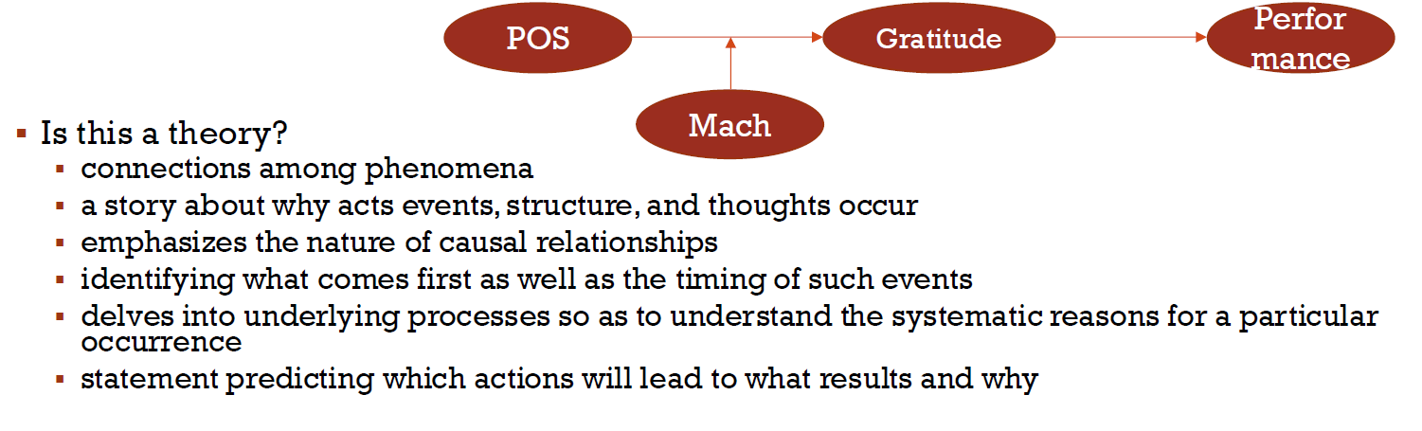

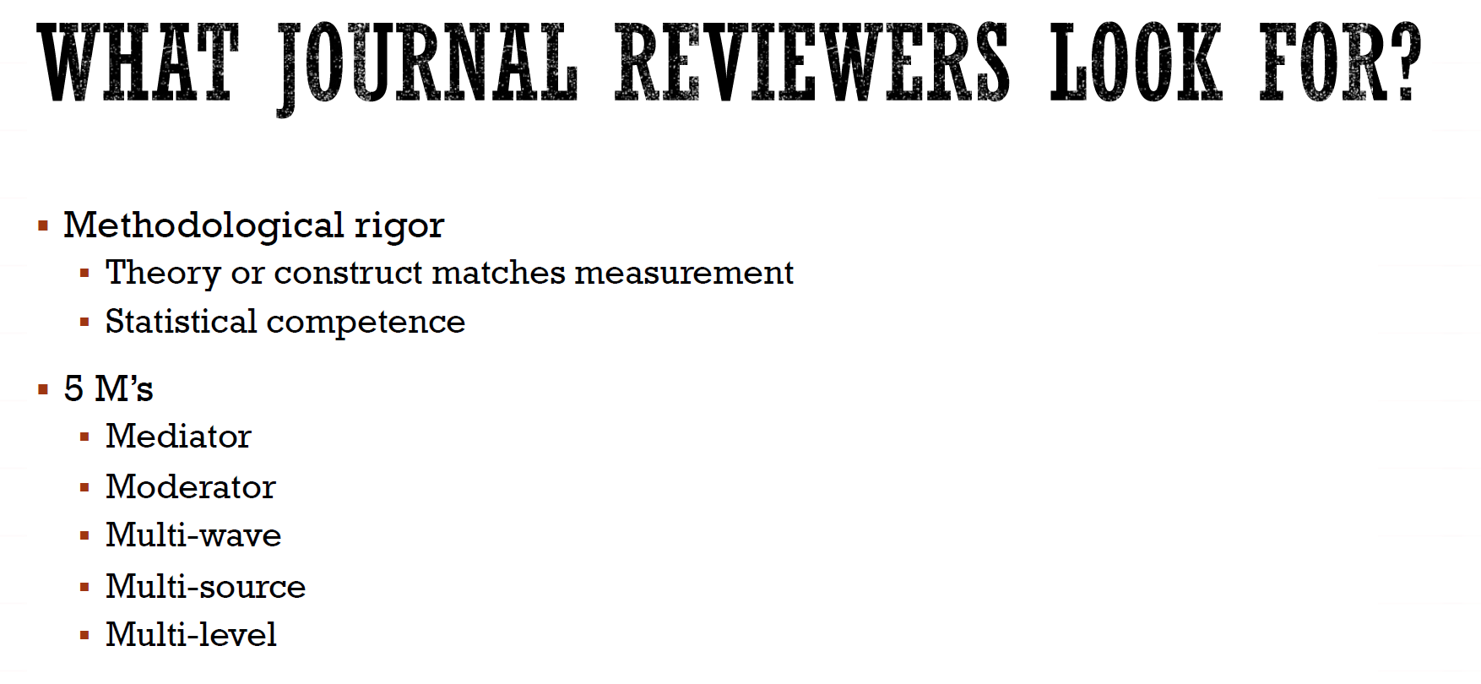

POS 🡪 resilience 🡪 performance

Two premises: (a) Performance requires effort. (b) Effort is costly.

In this case, resilience is important and POS can enhance resilience.

**Unethical research**

Lack of informed consent on data collection, risk, purpose of the study,

Collecting data without permission, invading the privacy,

not seeking ethics committee approval,

Not protecting confidential information, sharing the data with someone else without respondents and other data holders’ permission

Managing the data, and misleading the respondents to answer the questions in certain way or responses.

Modifying, removing, making up the data

Making up results, selectively reporting the result

P-harking

Plagiarism

AI use without personal thinking

Biased statement in content

Gift authorship

Ghost authorship, failing to credit someone who did meaningful work

Misrepresenting contributions, inflating someone’s role and contribution

Duplicate publication

Biased reviewing

Withholding relevant conflicts of interest

# Theoretical Necessity vs. Theoretical Sufficiency

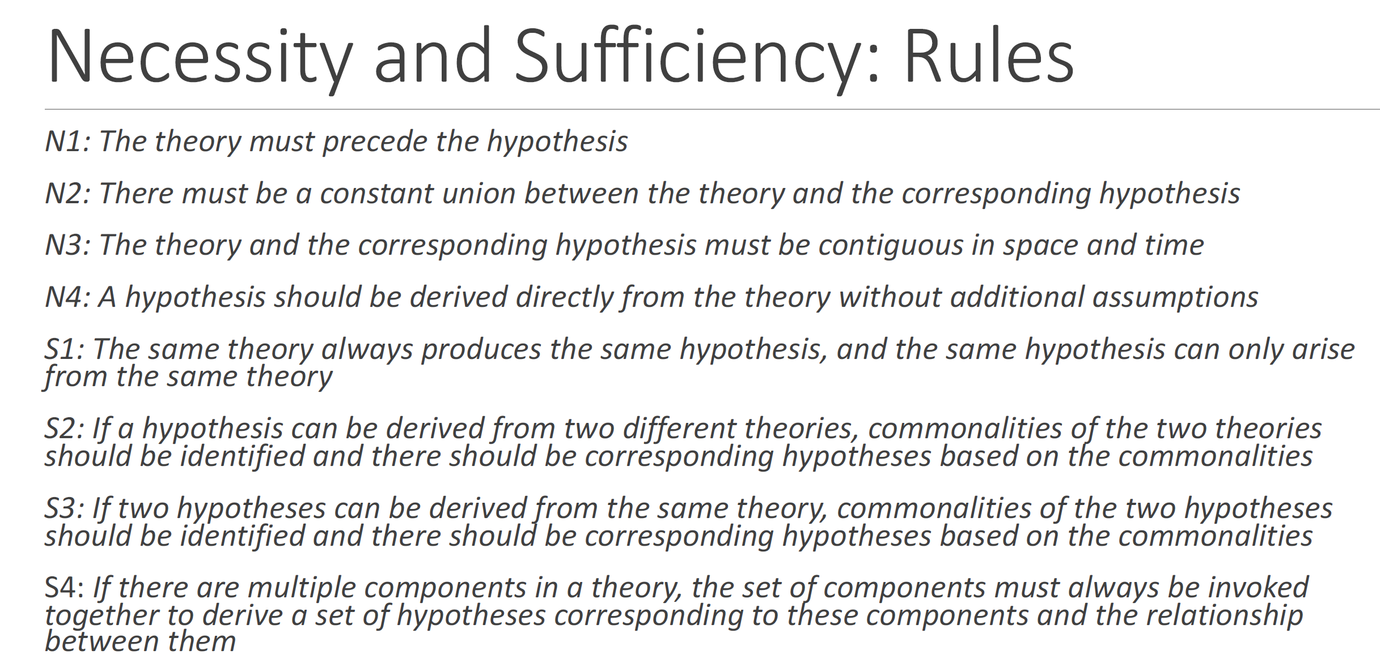

(Does the hypothesis logically follow from the theory?)

PJ 🡪 OCB (probably)

PJ 🡪 Recovery (not necessary)

(If the hypothesis is supported, does it validate or strongly support the theory?)

PJ 🡪 OCB (not sufficient)

PJ 🡪 reciprocity 🡪 OCB (sufficient; based on social exchange theory)

PJ 🡪 identification 🡪OCB (sufficient; based on organizational identification theory)

# Social Exchange Theory

**Homans** defined social exchange as the exchange of activity, tangible or intangible, and more or less rewarding or costly, between at least two persons.

Propositions:

(a) Success proposition (reward 🡪 perform)

(b) Stimulus proposition (present similar to past rewarded stimuli 🡪 present perform)

(c) Deprivation-satiation proposition (law of diminishing marginal returns; more provided 🡪 less valuable)

(d) Value proposition (valuable 🡪 perform)

(e) Rationality proposition (optimization)

**Blau** defined social exchange as the voluntary actions of individuals that are motivated by the returns they are expected to bring and typically do in fact bring from others.

Key in Blau definition: doing others favor because of the expectation of future return, which is not stipulated in advance.

Gouldner (1960) conceptualized reciprocity as (a) transactional pattern (LMX quality); (b) belief (reciprocal expectation); (c) individual difference (belief in a just world).

**Regulation of social exchange**

Homans (looks backward; mutual reinforcement process, deprivation-satiation) vs.

Blau (looks forward; norms and rules, detailed and understandable duties and obligations)

**DV**

Proximal DV: social and esteem needs, dignity

Distal DV: trust, loyalty, and mutual commitment

# Social Identity Theory

Self-concept and self-esteem derives from personal identity and accomplishment, status and accomplishments of the various groups.

Social identity: a sense of who they are based on their group membership.

Social comparison: positive (vs. negative) comparison 🡪 high (vs. low) prestige

**Principles:**

1. Positive social identity is established via favorable comparisons that can be made between the in-group and some relevant out-groups

2. Individuals strive to maintain positive social identity based on group membership

3. When social identity is unsatisfactory, individuals will strive either to leave their existing group or make their existing group more positively distinct

**Key proposition:**

1) people have emotional reactions to the failure or success of their group because their self-esteem is closely tied into the group’s performance

2) pressures to evaluate one’s own group positively through in-group/out-group comparisons lead social groups to attempt to differentiate themselves from each other.

**Functions / Processes**

(1) Social Identification

You begin to define yourself in terms of your group membership.

The group becomes part of your self-concept (“who I am”).

You internalize the group’s norms, values, and goals.

Based on Similarities, distinctiveness, status, uncertainty reduction

(2) Social Categorization

Process of categorization accentuates both (a) perceived similarities between stimuli (people, self, objects) belonging to the same category (b) perceived differences between stimuli belonging to different categories.

(3) Social Differentiation

Aim of differentiation: maintain or achieve superiority over an out-group on some dimensions.

At least 3 classes of variables that influence intergroup differentiation: (a). Individuals must have internalized their group membership as an aspect of their self-concept (b). Social situation must allow for intergroup comparisons so as to enable the selection and evaluation of the relevant relational attributes (c). Outgroup must be perceived as a relevant comparison group (as not all out-groups are worth comparing to)

**Outcomes**

Ingroup favoritism

Stereotype

Prototype: a fuzzy set that captures context-dependent features of group membership

Group prototype: minimize intra-category differences, maximize inter-category differences

**Limitations / Criticisms**

(1) Real-life identities are complex, multiple, and fluid. People hold overlapping identities (e.g., gender × occupation × team × family). SIT’s binary distinction (ingroup vs. outgroup) is too simplistic for modern diverse workplaces; some identity may be competing with each other. Similarly, SIT does not tell us which identity is really important and in what situation an identity becomes salient, dominant, and important. When it comes to a multifaceted identity, not all identities are equally important and meaningful.

(2) It does not always specify when or why certain identities activate. Real-world identity salience is influenced by context, norms, and cues, not accounted in classic SIT.

(3) Ignoring level-of-analysis issue of SIT. SIT is fundamentally a social-psychological theory (individual and group level). If researchers try to explain macro organizational phenomena (like industry-wide changes or organizational performance) purely in terms of social identities, they may be overextending it. Similarly, using SIT to interpret very micro-level phenomena (like one-on-one interpersonal relations or personal career choices) could be inappropriate since SIT does not account for personal relational dynamics or individual aspirations.

(4) Blurring of Theoretical Boundaries: some OB research has used “social identity” terminology in very broad ways, at times conflating it with other identity constructs. For instance, the term “organizational identity” is sometimes used to mean the organization’s distinct characteristics (a strategy or culture perspective) rather than an individual’s social identification with the organization.

(5) Related to the measure/operationalization. Less discussion on one’s identities that are assigned by others (through stereotyping, labeling, or status ascriptions), which can impact them regardless of their own self-concept. For instance, an employee might not consider their age or ethnicity salient, but colleagues or managers might categorize them by these attributes, affecting their opportunities and inclusion. In other words, SIT overfocuses on internal identifying social identity.

# Organization Theory

**Resource based view**

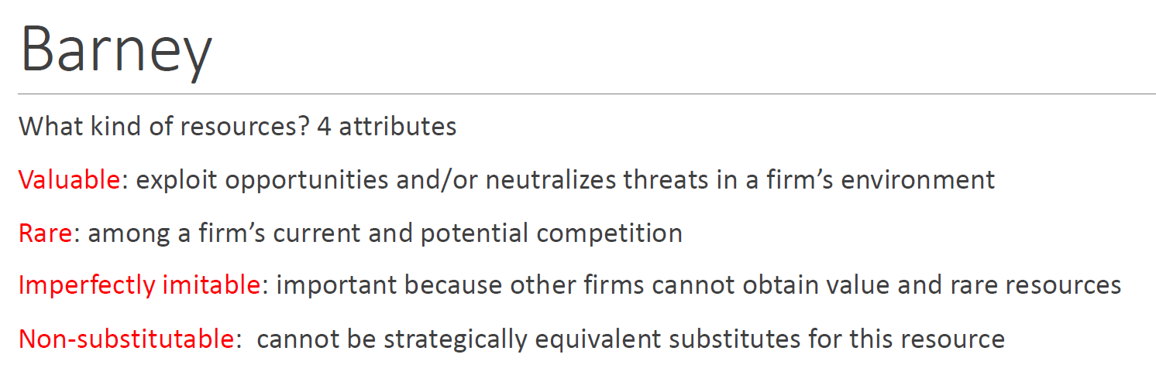

**Five forces model**

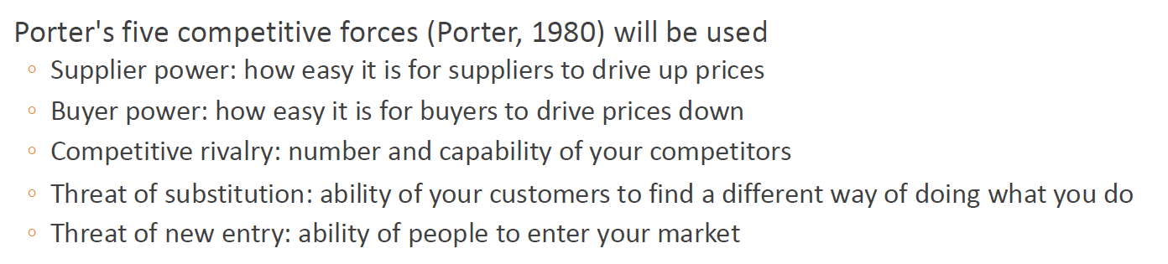

Institutional Theory

**New Institutional theory**

explains why organizations behave the way they do, not because it is efficient or rational, but because they face external social pressures, norms, and expectations.

Organizations want: (a) legitimacy; (b) acceptance; (c) survival

Focus on: (a) cultural norms; (b) symbolic structures; (c) meaning systems; (d) legitimacy

Three core pressures:  
(a) Coercive Pressures — “We have to” (e.g., laws**,** regulations**,** government mandates**,** powerful stakeholders); (b) Normative Pressures — “We should” (e.g., professional norms; industry standard or best practices; academic training); (c) Mimetic Pressures — “Everyone else is doing it”.

**Old Institutional theory**

Focus on: (a) embeddedness in social structures; (b) conflict and power; (c) habit and routine

# Construct Clarity

Suddaby, R. (2010). AMR

**Four basic elements:**

**(1) definitions**

Clarify the essential characteristics/features of the construct.

No tautological issue

Balance between parsimoniousness and relevance + generalizability

**(2) Scope conditions or contextual circumstances**

Level: individual construct? Team level? Organizational level?

Temporal: the effect of this construct is stable vs. transient?

Values: world view of the researcher

**(3) semantic relationship to other related constructs**

Nomological network

**(4) coherence or logical consistency in relation to the overall theoretical argument**

If it is a latent (multidimensional) construct comprising multiple attributes. E.g., recovery, burnout, OCBs, where each subdimension has distinct measures and vary somewhat across different contexts, the subdimensions should be coherent with each other, as well as the latent construct.

# END